EXECUTIVE SUMMARY
Overview of the Proposed Development
The Government of Rwanda considers the transportation sector to be a significant driver of economic growth. To attract both domestic and foreign investment in the country, it recognizes the importance of enhancing the quality and dependability of transport services while reducing costs. To this end, the government has implemented a comprehensive investment plan and capacity building program that includes expanding Kigali International Airport and other domestic airports, establishing a Center of Excellence for Aviation Skills (CEAS), providing air navigational services, constructing a new international airport, and supporting the growth of the national carrier, RwandAir.
It is in this context that the developer (Aviation Travel & Logistics ltd (ATL) through its subsidiary Akagera Aviation Ltd with Rwanda Development Board (RDB)) assuming overall coordination, intends to construct a Centre of Excellence for Aviation Skills (CEAS) that comprises an aircraft hangar capable of accommodating 8 Beechcraft King Air size aircraft at the Kigali International Airport, and a campus to serve up to 192 students. The CEAS will offer different aviation training/courses and partner with higher learning institutions to provide academic aviation courses.
Project Objectives
The aviation industry in Rwanda is experiencing rapid growth and has set its sights on becoming a leading center for aviation excellence. As part of this goal, the objective of the proposed Center of Excellence for Aviation Skills (CEAS) project is to provide training for pilots, maintenance staff, air traffic management personnel, and other related fields. The aircraft hangar will also serve as a shelter for aircraft and a facility for technical activities. The overall aim of these initiatives is to build local capacity and empower the labor force in the aviation industry not only in Rwanda but also in the region and beyond.
Project Location and Site Conditions
The proposed aircraft hangar will be located in Kanombe Sector close to the south apron and the campus situated within the airport buffer zone in Nyarugunga Sector. The project area is a highly modified urban and aviation environment dominated by existing airport infrastructure. Baseline conditions show limited natural vegetation, previously disturbed soils, managed drainage systems, and existing noise and air quality levels already influenced by airport operations. The main valued environmental and social components include air quality, noise, soil and drainage conditions, land use compatibility, traffic and community safety, occupational health, and local employment, which provide the basis for assessing project impacts and defining mitigation measures.
Project Categorization and Safeguards Classification

In accordance with the African Development Bank (AfDB) Integrated Safeguards System, the proposed CEAS project has been classified as a Category 2 project under Operational Safeguard 1 (OS1). This classification is based on the finding that the anticipated environmental and social risks and impacts are largely site-specific; reversible; manageable through known mitigation measures; and not expected to result in significant irreversible or regionally widespread impacts. Under Rwanda’s national ESIA framework, the project is also classified as Impact Level 2 (IL2), requiring a full Environmental and Social Impact Assessment and implementation of an Environmental and Social Management Plan (ESMP).

Project Activities and Phasing
The project is detailed below as per the activities and phases:
Preconstruction phase: Reconnaissance of the projected site; identification of alternative sites; pre-feasibility and feasibility studies of the chosen construction site.
Construction phase: It is estimated the construction will take a period of 24 months. Construction of the CEAS will involve; site fencing and managing site access and contact points; construction of the aircraft hangar and campus facilities, involving land clearing, excavation, foundation works, levelling, and finishing; soil preservation, Installation of plumbing and electrical fixtures.
Operation phase: Use of the aircraft hangar and campus facilities.
Decommissioning phase: Demolition of the aircraft hangar and campus facilities and management of debris formed during breakdown of the units. Reuse other construction materials without carelessly disposing of them.
The connection between the proposed project and Kigali International Airport.
The proposed project components will be connected to various existing facilities at the Kigali international airport. These facilities include:
- The existing runway, which is a designated strip of land that will be used for takeoff and landing of aircraft during training.
- The existing apron will serve as the area where aircraft will be parked, refueled, and boarded.
- The existing stormwater drainage system will be used for collecting and draining excess rainwater from the proposed facilities, ensuring that it does not interfere with the airport's operations.
Project Cost and Staffing
The project's total cost for establishing the infrastructure amounts to approximately 52,070,000 USD, inclusive of VAT. The construction phase will require up to 1000 workers while the operation phase takes up to 98 workers.
Project Alternatives
The project alternatives section evaluates options for the site, design, utilities, and waste management compared to a “no project” scenario. The “no project” option would forgo benefits such as job creation, aviation industry growth, and an investment of approximately 75.2 billion RWF, making it unsuitable. No alternative sites were considered since the proposed location is within existing airport-controlled land and designated buffer zones, aligning with the Kigali City Masterplan and connecting to existing airport infrastructure.
For water supply, the plan includes connecting to KIA and WASAC networks and using filtered rainwater harvesting to supplement needs. Power supply will rely on the KIA substation, backup generators, a dedicated transformer for the hangar, and solar panels for energy efficiency. Waste management involves segregation, transportation by private cooperatives, hazardous waste disposal at designated sites, and on-site wastewater treatment plants; ecosan toilets will be used during construction.
The design integrates sustainability and cost-effectiveness through features such as multi-pitch roofs with ridge vents, insulated cladding, natural lighting, shading screens, and green building technologies. These measures enhance energy efficiency, reduce environmental impact, and ensure compliance with local standards.
ESIA Rationale
Environmental and Social Impact Assessment (ESIA) is a process of meticulous assessment of environmental impacts. It was introduced for the purpose of identifying /evaluating the potential benefits or adverse impacts of development projects on the surrounding environment consisting of land, air, water, and biological factors, considering environmental, economic, social, cultural, and aesthetic considerations. For evaluating the impacts of the proposed Centre of Excellence for Aviation Skills CEAS) project, all activities associated with planning, design, site preparation, construction, operation, and maintenance within the proposed project site and area of influence were considered. All these considerations help decision makers & project planners to develop proper mitigation measures since the early stage of the project and during the different phases.
Objective of the ESIA Study
The objective of this study was to evaluate the environmental and social impacts of all works related to the construction of the Centre of Excellence for Aviation Skills (CEAS) that comprises an aircraft hangar and campus, in the Kicukiro District of Kigali City. The study has considered the pre-construction, construction, operation, and decommissioning phases of the proposed project.
ESIA Methodology
An ESIA scoping exercise was undertaken at the beginning of the project, during the preparation of the feasibility study (FS), which was the first stage in the assessment of E&S impact of the project. The scoping exercise involved review of literature and field visits that generated spatial dimensions and data on the zones of influence of the project.
Furthermore, to identify and predict the various impacts that may emanate from the project, various study methods and tools were incorporated. These included checklists, expert opinions, and observations. An in-depth analysis of public concerns from the interested parties was undertaken and views incorporated in the development of the ESMP. This involved discussions and dialogue with the key stakeholders including Ministry of Infrastructure (MININFRA), Rwanda Environment Management Authority (REMA), Rwanda Civil Aviation Authority (RCAA), Rwanda Development Board (RDB), Aviation Travel and Logistics Holding Limited (ATL), Kicukiro District, Akagera Aviation Ltd, Rwanda Airports Company (RAC), RwandAir, Local communities, and project engineers to mention a few.
Policy, Legal and Institutional Framework
This section details the policy, legal and institutional framework for the proposed project, covering national requirements as well as applicable international treaties and conventions, and AfDB Integrated Safeguards System commitments. The section discussed the compliance and alignment aspects of the CEAS project. It also described the current administrative arrangements for environmental regulation, enforcement, and management.
Most relevant policies are the Rwanda development Vision, 2050; National environment and climate change policy; National land policy; Kigali city master plan; Health sector policy; National energy policy; Rwanda Green growth and climate resilience strategy; Rwanda biodiversity policy; National occupation safety and health strategies; National urbanization policy; and National gender policy.
The most pertinent laws are the law on environment No 48/2018 of 13/08/2018; land law N° 27/2021 of 10/06/2021; law Nº 58/2018 of 13/08/2018 on mining and quarry exploitation; law N⁰ 064/2021 of 14/10/2021; ministerial Order No 003/MoE/25 of 19/08/2025; law Nº 028/2019 of 19/09/2019; Rwanda green building minimum compliance system; law No. 20/2018 establishing regulations governing civil aviation in Rwanda; Rwanda building code.
AfDB Environmental and Social Operational Safeguards
Stakeholder Engagement
Stakeholder engagement was undertaken in accordance with AfDB requirements and national ESIA procedures. Consultations were conducted with MININFRA, REMA, RDB, RCAA, RAC, Kicukiro District, local communities, aviation sector stakeholders, and technical experts.
Key concerns raised included traffic congestion; noise; wastewater generation; occupational safety; community safety; environmental pollution. These concerns have been incorporated into the ESMP and project design. A Stakeholder Engagement Plan (SEP) and Grievance Redress Mechanism (GRM) have been established for continued consultation during implementation.
Potential Impacts and Mitigation Measures
Positive Impacts
The study also assessed the positive impacts of the proposed development and proposed enhancement measures as well as ESMP. The positive impacts identified include creation of job opportunities, flow of income-or wealth-enhancing activities, economic development and revenue collection, promotion of gender equality, support to tourism and local business, technological change and innovation, stimulation of foreign investment and international trade, improved infrastructure and status of the area, enhanced maintenance and protection/safety of aircraft, capacity building, improved reputation of the aviation sector, promotion of green building practices, increased availability of skilled labor, locally, regionally and beyond.
Negative Impacts
This study identified the potential adverse impacts of the project in terms of the possible effect to the environment and on the interested parties. The baseline data collection was primarily investigated through desktop studies and sites visits, photographic capture and direct interviews with the interested stakeholders. The following is a summary of key issues that arise as of significance for this project’s environmental performance along with their mitigation measures, among others:
Environmental and social risks
Occupational health and safety risks:
- Develop and implement site-specific occupational health and safety (OH&S) Plan.
Accidental spills, leakage & discharge risks:
- The Contractor should ensure that the employees on site are aware of the company Spill Prevention, Control and Countermeasure (SPCC) Plan for dealing with spills and leaks.
Fire risks:
- Mark and provide sign boards for hazardous areas and areas for storage and disposal.
- Firefighting equipment should be provided at strategic locations to deal with any incident of fire.
Gender-related risks:
- Every worker should sign a code of conduct (CoC) covering issues such as zero tolerance of unacceptable conduct, GBV, sexual harassment, sexual exploitation, and abuse of children.
- Provide separate accommodation facilities and gender sensitive PPE for both women and men.
- Provide equal employment opportunities for both genders.
Influx of birds leading to bird strike hazards:
- Birds may find the airport the best place to breed, all nesting activities must be discouraged. This will be achieved through the landscaping plan that prioritizes species that do not produce food sources such as fruits or seeds, which could attract birds or other wildlife.
- Adhere to the existing KIA Wildlife hazard management.
Community health and safety risks:
- Installing noise barriers and conducting training during non-peak hours.
- Regular maintenance of aircraft and ground support equipment.
- Develop and implement an emergency response plan.

Environmental and social Impacts
Biodiversity loss:
- Minimize the removal of vegetative cover and carry out revegetation as much as possible.
Air pollution:
- Sprinkling of water during construction to reduce emission of dust.
Soil erosion and compaction:
- Stabilize slopes with appropriate retaining walls or other structures.
Noise Pollution:
- Disallow worker exposure to noise level greater than 85 dBA for a duration of more than 8 hours per day without hearing protection. The use of hearing protection shall be enforced actively.
Impacts associated with construction campsites
- It is proposed that the campsite be located at the campus site close to the exit, to avoid extending the campsite footprint outside the area of influence.
- A campsite management plan has been prepared and annexed to this report.
Micro-climate modification:
- All non-constructed areas must not be paved.
Waste generation:
- A Waste Management Plan (WMP) will be followed, with continuous monitoring and audits.
- Generation, recycling, and reusing materials where possible, and properly disposing of hazardous waste.
- Ensure the adequacy of the ecosan toilet facilities during construction, as well as that for the wastewater treatment plants during operations.
Impacts associated with storage or handling of hazardous materials:
  - The developer should implement and adhere to the existing KIA hazardous waste management plan. Hazardous materials should be stored in appropriately secured, segregated, and labeled containers and areas, to minimize the risk of leaks and spills.
- Develop spill response plans that include procedures for containing and cleaning up spills, as well as proper disposal of contaminated materials.
Environmental and Social Management Plan
Environmental and Social Management Plan (ESMP) and Environmental and Social Monitoring Plan (ESMoP) were created in the ESIA to ensure the successful implementation of proposed mitigation measures, parameter monitoring, and future audits.
The ESMP outlines practical measures to address impacts across all project phases. It covers areas such as air, water and soil quality, waste management, worker safety, and emergency response. Specific plans for occupational health and safety, waste management, community health and safety, campsite management have been developed as annexes. It includes responsibilities, monitoring indicators, reporting protocols, and budget estimates for mitigation actions. Training of staff, periodic audits, and engagement with stakeholders are integral components of the ESMP.
The overall budget for the implementation of the ESMP is estimated at 669,470,000 RWF.
Institutional arrangements in ESMP Implementation
The implementation of the ESMP involves several key institutions with defined roles. The contractor carries the main responsibility for implementing mitigation measures and monitoring compliance during construction, supported by the supervision consultant (Engineer), who ensures the CESMP is followed daily and enforces compliance through regular reporting. REMA acts as the lead regulatory body, conducting environmental audits and site inspections, while RDB provides oversight through its SPIU and issues certification at the initiation stage. Akagera Aviation Ltd, as beneficiary and the project developer, will ensure overall coordination and compliance with ESMP requirements throughout the project lifecycle. The project developer will assume responsibility for environmental, health, and safety monitoring during the operational phase. Kicukiro District contributes to routine monitoring through its Environmental Officer and ensures adherence to permits and environmental standards. Both the contractor and consultant are required to employ full-time environmental and social officers for effective monitoring. Local communities, although lacking technical capacity, play an important role in feedback and engagement and will benefit from temporary employment opportunities during construction and operation activities.

Conclusion and Recommendations
According to the ESIA study, most potential environmental impacts of the proposed CEAS project are of medium to low risk and can be effectively mitigated and managed without causing significant harm to the surrounding environment. Identified impacts can be controlled through proper implementation of the ESMP and compliance with relevant regulations. The study emphasizes that the socio-economic benefits far outweigh the associated costs and negative impacts. Therefore, it is recommended that the project be permitted to proceed, provided that the proponent adheres to all proposed mitigation measures and secures the necessary approvals from relevant authorities.

ACRONYMS
AFDB | African Development Bank
ATL | Aviation and Travel Logistics Holding Ltd
BLS | Baseline Survey
CEAS | Centre of Excellence for Aviation Skills
CO | Carbon Monoxide
CO2 | Carbon Dioxide
CPL | Commercial Pilot License classroom
EIA | Environmental Impact Assessment
EICV | Integrated Household Living Conditions Survey
ESIA | Environmental and Social Impact Assessment
ESMoP | Environmental and Social Monitoring Plan
ESMP | Environmental and Social Management Plan
GBV | Gender-Based Violence
GHG | Greenhouse Gas
GoR | Government of Rwanda
GWP | Global Warming Potential
HIV | Human Immunodeficiency Virus
HSE | Health, Safety, and Environment
IATA | International Air Transport Association
ICAO | International Civil Aviation Organization
ISS | Integrated Safeguards System
KIA | Kigali International Airport
kWh | Kilowatt Hour
LPG | Liquefied Petroleum Gas
MINALOC | Ministry of Local Government
MINIFRA | Ministry of Infrastructure
MIGEPROF | Ministry of Gender and Family Promotion
NBS | Nature-Based Solutions
NDCs | Nationally Determined Contributions
NO2 | Nitrogen Dioxide
NST | National Strategy for Transformation
OH&S | Occupational Health and Safety
PPE | Personal Protective Equipment
PM | Particulate Matter
RCAA | Rwanda Civil Aviation Authority
REMCO | Rwanda Engineering and Manufacturing Corporation
RDB | Rwanda Development Board
RSB | Rwanda Standards Board
RURA | Rwanda Utilities Regulatory Authority
SEA | Sexual Exploitation and Abuse
SEP | Stakeholder Engagement Plan
SO2 | Sulfur Dioxide
SPCC | Spill Prevention, Control, and Countermeasure
UNFCCC | United Nations Framework Convention on Climate Change
VOC | Volatile Organic Compounds
WASAC | Water and Sanitation Corporation
WHO | World Health Organization

Contents
EXECUTIVE SUMMARY 2
ACRONYMS 8
1.0 INTRODUCTION 16
1.1 Project Overview 16
1.2 ESIA Objectives 16
1.3 ESIA Methodology 17
1.3.1 Screening 17
1.3.2 Scoping 17
1.3.3 Description of the project 17
1.3.4 Baseline data collection 17
1.3.5 Impact identification 18
1.3.6 Environmental and Social Management Plan (ESMP) 18
1.3.7 Stakeholder Engagement 18
2.0 PROJECT DESCRIPTION 19
2.1 Justification of the project 19
2.2 Current situation at the Proposed Hangar Site 19
2.3 Project Objectives 20
2.4 Project Financier 20
2.5 Project Cost and Staffing 20
2.6 Project Components 21
2.6.1 Aircraft Hangar 21
2.6.2 Campus 22
2.6.3 Associated Facilities & Services 26
2.7 Design Considerations 30
2.8 Project Phasing and Activities 31
2.9 Description of Construction Materials and Equipment 32
2.10 Facility emission computation and reduction strategies 33
2.10.1 Emissions from the CEAS Project 33
2.10.2 Strategies for emission reduction 33
3.0 POLICY, LEGAL, AND INSTITUTIONAL FRAMEWORK 33
3.1 Introduction 33
3.2 National Legislation 33
3.2.1 Policy Framework 33
3.2.2 Legal Framework 38
3.3 Institutional Framework 43
3.3.1 Ministry of Infrastructure, MININFRA 43
3.3.2 Ministry of Environment, MoE 43
3.3.3 Rwanda Environment Management Authority, REMA 43
3.3.4 Rwanda Development Board, RDB 43
3.3.5 Rwanda Civil Aviation Authority, RCAA 43
3.3.6 Ministry of Education, MINEDUC 43
3.3.7 Ministry of Finance and Economic Planning, MINECOFIN 43
3.3.8 Ministry of Public Service and Labor, MIFOTRA 44
3.3.9 Rwanda Housing Authority, RHA 44
3.3.10 City of Kigali, CoK 44
3.3.11 Rwanda Standards Board, RSB 44
3.3.12 Aviation Travel Logistics, ATL 44
3.3.13 Akagera Aviation Ltd 44
3.3.14 Rwanda Airports Company, RAC 44
3.3.15 RwandAir 45
3.3.16 Kicukiro district 45
3.4 International Standards 45
3.4.1 African Development Bank’s Environmental and Social Operational Safeguards requirements 45
3.4.2 Regional and international Agreements 50
4.0 DESCRIPTION OF THE PROJECT AFFECTED ENVIRONMENT 51
4.1 Project Area of Influence 51
4.1.1 Area of Direct Influence (ADI) 51
4.1.2 Area of Indirect Influence (AII) 51
4.2 Physical Environment 53
4.2.1 Project site location 53
4.2.2 Climate and rainfall 54
4.2.3 Topography 56
4.2.4 Hydrology 57
4.2.5 Geology and soils 58
4.2.6 Ambient air quality 59
4.2.7 Ambient noise level 60
4.2.8 Seismic activity 60
4.2.9 Land cover 60
4.3 Biological Environment 64
4.3.1 Flora 64
4.3.2 Fauna 66
4.3.3 Sensitive ecosystems 67
4.4 Socio-Economic Environment 68
4.4.1 Population and Demography 68
4.4.2 Economic activity and livelihood 68
4.4.3 Poverty 68
4.4.4 Education 68
4.4.5 Land use 69
4.4.6 Infrastructure 69
4.4.7 Traffic trends 70
5.0 PROJECT ALTERNATIVES 70
5.1 Introduction 70
5.2 Alternatives for Site Location 71
5.3 Alternatives for Facilities’ Design 71
5.4 Alternatives for Waste Management 73
5.5 Alternative for Power Supply 74
5.6 Alternative for Water Supply 74
5.7 The “No project” Alternative 75
6.0 EVALUATION OF IMPACTS/RISKS AND MITIGATION/ENHANCEMENT MEASURES 76
6.1 Introduction 76
6.2 Project categorization 76
6.3 Methodology of evaluating impacts 76
6.3.1 Criteria for evaluating the significance of impacts. 76
6.3.2 Assessment of the significance of the impact 77
6.4 Potential Impacts 79
6.4.1 Positive Impacts 79
6.4.2 Negative Impacts 84
6.4.3 Cumulative Impacts 91
7.0 ENVIRONMENTAL AND SOCIAL MANAGEMENT PLAN (ESMP) 94
7.1 Introduction 94
7.2 Policy 94
7.3 Objectives 94
7.4 Monitoring framework 94
7.5 Emergency Response Plan 94
7.6 Institutional Arrangements in Implementing the ESMP 116
8.0 STAKEHOLDER ENGAGEMENT AND INFORMATION DISCLOSURE 118
8.1 Introduction 118
8.2 Stakeholder Identification 118
8.3 Information Disclosure and Communication Plan 119
8.4 Methodology Employed for Stakeholder Engagement for the ESIA process. 121
8.5 Stakeholder Engagement Activities during the ESIA process 121
8.5.1 Stakeholders at local level 121
8.5.2 Formal meetings with high level stakeholders 122
8.5.3 Consultation results 123
8.6 Stakeholder’s Engagement during Project Implementation 123
8.7 Integration of Stakeholder Feedback 123
9.0 GRIEVANCE REDRESS MECHANISM (GRM) 123
9.1 Introduction 124
9.2 Objectives 124
9.3 Scope of the GRM 124
9.4. GRM Design and Features 124
9.5 GRM Process 124
9.5.1 Steps in the Grievance Process 124
9.5.2 Appeals Process 125
9.6 Institutional Roles and Responsibilities 125
9.6.1 Grievance manager: 125
9.6.2 Grievance Redress Committees (GRCs): 126
9.6.3 Specialized GBV/SEA/SH Support: 126
9.6.4 Logistics and allowance 126
9.7. Monitoring, reporting, and learning 126
9.8 Communication and Awareness 126
9.9 Timelines for Grievance Handling 126
10.0 CONCLUSION AND RECOMMENDATIONS 127
10.1 Conclusion 127
10.2 Recommendations 127
REFERENCES 128
ANNEXES 130
Annex 1: Emergency Response Plan (ERP) 130
Annex 2: Stakeholder Grievance Log 135
Annex 3: Minutes of the High-Level Stakeholder Meeting 138
Annex 4: Minutes of the Second High-Level Stakeholder Consultation 142
Annex 5: Minutes of the Third High level stakeholders Meeting 145
Annex 6: Summary of views, concerns, and opinions raised during public consultations 150
Annex 7: Attendance Lists of Stakeholder Consultations 154
Annex 8: Waste Management Plan (WMP) 159
Annex 9: Occupational Health and Safety Management Plan 163
Annex 10: Community Health Safety and Security Management Plan 166
Annex 11: Standardized Incident Report Form 168
Annex 12: Campsite Management Plan 170
Annex 13: Chance Finds Procedures 172
Annex 14: ESMP Implementation and Management Strategy 178

List of Figures
Figure 1: Some of the utilities existing at the KIA. 20
Figure 2: 3D illustrations of the aircraft hangar 21
Figure 3: Campus building overall site plan 23
Figure 4: 3D visualizations of the campus building 25
Figure 5: Typical plant flow layout 26
Figure 6: Water savings 27
Figure 7: Energy savings 28
Figure 8: Embodied carbon savings 32
Figure 9: Map showing the site overview. 52
Figure 10: Hangar site location 53
Figure 11: Campus site location 53
Figure 12: Location of project sites and different surrounding components 54
Figure 13: Average Rainfall mm Graph for Kigali International Airport. 55
Figure 14: Average Temperature oC Graph for Kigali International Airport. 55
Figure 15: View of the topography within the aircraft hangar project site 56
Figure 16: View of the topography at the campus site 56
Figure 17: Map showing the topography of the proposed project sites. 57
Figure 18: Map showing the hydrology of the project area. 58
Figure 19: Map showing the types of soil in the proposed project sites. 59
Figure 20: Earthquake hazard zonation map at 10% probability of exceedance in 50 years 60
Figure 21: Land cover of the aircraft hangar site 61
Figure 22: Instruments in the vicinity of the aircraft hangar site 61
Figure 23: Drainage structures next to the aircraft hangar site 62
Figure 24: Existing apron next to the aircraft hangar site 62
Figure 25: Land cover of the proposed campus site 63
Figure 26: Utilities that are present in the vicinity of the campus site 63
Figure 27: Drainage structures beneath the proposed campus site 63
Figure 28: Map showing the land cover of the proposed project sites 64
Figure 29: Flora present on the proposed aircraft hangar site 65
Figure 30: Flora present on the campus site 65
Figure 31: Map showing the vegetation type of the proposed project sites 66
Figure 32: Bird species present at KIA. 67
Figure 33: WASAC water tank next to the proposed aircraft hangar site. 69
Figure 34: Aircraft hangar previous design concept 71
Figure 35: Aircraft hangar new design concept 72
Figure 36: Campus previous design concept 73
Figure 37: Campus new design concept 73
Figure 38: Photo of participants during the public consultation meeting 122
Figure 39: Photo of participants in the high-level consultation meeting 122

List of Tables
Table 1:Gap analysis 47
Table 2: Geographic coordinates of the plot 56
Table 3: Project impacts assessment 77
Table 4: Impact Significance with criteria assessment and ratings 78
Table 5: Significance of impact criteria 79
Table 6: Impact matrix 92
Table 7: Environmental and Social Management and Monitoring Plan (ESMMP) 95
Table 8: Responsibility for ESMP implementation 116
Table 9: Stakeholder mapping 118
Table 10: Stakeholder engagement and communication plan 120
Table 11: Participants in the public consultation 121
Table 12: Participants in the first-high level consultation 122
Table 13: Participants in the second-high level consultation 123
Table 14: Members of the Grievance Redress Committee (GRC) 126

1.0 INTRODUCTION

1.1 Project Overview
The Government of Rwanda considers the transportation sector to be a significant driver of economic growth. To attract both domestic and foreign investment in the country, it recognizes the importance of enhancing the quality and dependability of transport services while reducing costs. To this end, the government has implemented a comprehensive investment plan and capacity building program that includes expanding Kigali International Airport and other domestic airports, establishing a Center of Excellence for aviation skills, providing navigational services, constructing a new international airport, and supporting the growth of the national carrier, RwandAir.
It is in this context that the developer (Aviation Travel & Logistics ltd (ATL) through its subsidiary Akagera Aviation Ltd with Rwanda Development Board (RDB)) intends to construct a Centre of Excellence for Aviation Skills (CEAS) that comprises an aircraft hangar capable of accommodating 8 Beechcraft King Air size aircraft at the Kigali International Airport, and a campus to serve up to 192 students. The CEAS will offer different aviation training/courses such as pilot training, maintenance training, cabin crew, dispatch, ancillary courses, air traffic management courses, aeronautical information services, aeronautical meteorological services, aeronautical communications operations, communication navigation and surveillance, airport emergency services (operations), and other supporting programs. The CEAS will partner with higher learning institutions to provide academic aviation courses.
Given the increasing importance of drones’ applications in Rwanda, the CEAS will also provide drone piloting training along with other manned aircraft pilot training courses such as, private pilot license classroom (PPL), commercial pilot license (CPL) training, airline transport pilot license (ATPL), flight simulator recurrent training and other advanced pilot training for specialized missions.

1.2 ESIA Objectives
The main objectives of this ESIA are to predict any significant impacts of the proposed CEAS project development on the environment and, where applicable, propose measures to avoid, reduce or remedy them. It reports on the findings of the ESIA process to date and informs the developer and other interested parties, and the public in general about the likely effects of the project on the environment.
In doing this, the ESIA follows the national EIA guidelines and the AfDB Integrated Safeguards System (ISS). The national ESIA framework is guided by the Ministerial Order No 003/MoE/25 of 19/08/2025 relating to Environmental and Social Impact Assessment which requires that such a project undergoes a full ESIA and the AfDB ISS Operation Safeguard 1 on Assessment and Management of Environmental and Social Risks and Impacts.
The proposed CEAS project has been classified as a project likely to cause less adverse environmental and social impacts, category 2 per AfDB OS1, as well as IL2 per national EIA guidelines. Category 2 projects require an appropriate level of environmental and social assessment (ESIA) tailored to the expected environmental and social risk so that the developer can prepare and implement an adequate ESMP to manage the environmental and social risks of subprojects in compliance with the Bank’s safeguards.
Section 2 provides details of the national and international legislation that has been followed and the guidelines that have been considered.
This ESIA follows a grouped format structure. Using this structure, the ESIA examines each environmental topic in a separate section. These sections generally cover:
- The legal, policy and institutional framework.
- The proposed development.
- The receiving environment.
- Project alternatives
- Likely project significant impacts and mitigation measures.
- Environmental and Social Management Plan (ESMP); and
- Stakeholder Engagement Plan (SEP)
- Grievance Redress Mechanism.

According to the AfDB Operational Safeguards, the draft of the ESIA must be made publicly available to project stakeholders. During the creation of the final ESIA, feedback from stakeholders and the public was considered, and this will continue to be done during the final decision-making process by the funders.
The ESIA assesses the interactions between issues in different sections and proposes mitigation measures to reduce adverse effects. These measures are important and enforceable commitments that guide the project's development and management. To facilitate understanding during the Environmental Impact Assessment process by consenting authorities, it is helpful to have an overview of all the proposed mitigation measures in the ESIA.

1.3 ESIA Methodology

1.3.1 Screening
For the screening exercise, meetings were held with the project team and looked over the new available documentation. The expectations for this evaluation in terms of the task scope and the technique to be used for the same were also discussed. A desk-based review of project documentation and other relevant materials was conducted to gain a comprehensive understanding of the project and its potential impacts. In addition, secondary data on the project area, district, and state was studied to support the primary data.

1.3.2 Scoping
During this phase, the consultant collaborated with the client and relevant stakeholders identified through the Stakeholder Identification Process. The consultant scoped the study by determining the geographic coverage, stakeholders, significant impacts, and level of detail required for each impact study. Additionally, the scoping exercise involved a review of literature and field revisits to identify the spatial dimensions and data on the project's zones of influence while eliminating insignificant impacts. The approach used to identify the project's potentially significant impacts included consultation with and feedback from the public, private sector, and governmental institutions; expertise in aviation infrastructure development and operation, as well as the potential effects; and basic familiarity with the current environment and sensitive areas. This exercise was also used to adequately prepare tools and techniques to be used in data collection.

1.3.3 Description of the project
A detailed description of the project was then revised at the next stage to outline the features and activities of the project, based on the new information provided by the developer. Based on the new project design and existing environment, an assessment of best available alternatives was made and compared the alternatives from the point of view of their environmental and social impact, their investment and operating costs, their compatibility with local conditions and in relation to institutional and training needs.

1.3.4 Baseline data collection
The consultant assessed the environmental and social baseline conditions within which the CEAS Project will be implemented using a combination of standard and internationally accepted ESIA data collection methods. Baseline data were collected through desk-based studies, on-site inspections, and stakeholder consultations, in line with best practice guidelines for environmental assessment. Desk studies involved the review of existing secondary data sourced from published reports, peer-reviewed literature, national databases, satellite imagery, web-based resources, and documentation provided by the project developer. These sources were used to establish regional and site-specific environmental and socio-economic trends and to benchmark baseline conditions.
Field data collection consisted of site walkovers and on-site inspections, which were undertaken to verify desk study findings and to collect primary baseline data. Field observation tools such as GPS devices and cameras for photographic records were used during site visits. Photographs of site conditions, surrounding land uses, and sensitive receptors were taken to support baseline characterization. The study area was defined based on the proposed locations of the aircraft hangar and campus, as well as areas likely to be affected by construction and operational activities. The study area was defined initially by the proposed locations of the aircraft hangar and campus, and then by the area that could be affected by construction and operation of the project components. Parameters that were examined included the following:

1.3.4.1 Physical environment
Baseline data for the physical environment were collected through field observations and secondary data review, covering site location, geology, topography, soils, climate, wind characteristics, air and noise environment, surface and groundwater hydrology, and land cover. Climate and meteorological data were obtained from national and regional datasets, while land cover and topography were supported by satellite imagery and GIS analysis. Field inspections were used to assess existing drainage patterns, soil conditions, land use, and potential sources of noise and air emissions.

1.3.4.2 Biological environment
The biological baseline focused on identifying existing flora and fauna, habitat types, and the presence of any sensitive ecosystems or critical habitats within the project area of influence. Data were collected through direct field observations during site walkovers and supplemented by literature review and national biodiversity records. Given the highly modified nature of the airport environment, emphasis was placed on identifying disturbed habitats and assessing ecological sensitivity.

1.3.4.3 Socio-cultural environment
Socioeconomic baseline data were collected using a combination of Rapid Appraisal Work (RAW) and a Baseline Survey (BLS) approach, consistent with standard social impact assessment practices. RAW included key informant interviews, informal discussions with local stakeholders, site observations, and consultations with relevant authorities. The BLS focused on identifying demographic characteristics, land use patterns, livelihood activities, and community perceptions regarding potential project impacts. These methods enabled the collection of both qualitative and contextual data necessary for understanding social dynamics within the project area

1.3.5 Impact identification
For impact identification, a checklist was employed to identify possible impacts from the project development and the matrix to determine the significance of each identified impact. Expert judgment was applied to interpret baseline data, identify potential direct and indirect impacts, and assess their significance. Each identified impact was subsequently assigned appropriate mitigation measures.

1.3.6 Environmental and Social Management Plan (ESMP)
The ESIA report serves as the foundation for the Environmental and Social Management Plan (ESMP) for the project. The ESMP contains measures to manage the project's environmental and social impacts in the short and long term during all phases of the project. These measures include mitigating actions and monitoring indicators, which are presented in an organized tabular format that outlines clear roles and responsibilities for their implementation and oversight.

1.3.7 Stakeholder Engagement
Stakeholder engagement was conducted in accordance with good international practice to ensure meaningful participation throughout the ESIA process. Stakeholders were identified and analyzed based on their potential influence on, or exposure to, the project and included government institutions, local authorities, community representatives, environmental committees, and sector experts. Engagement methods included meetings, interviews, and consultations conducted during field visits. Feedback obtained from stakeholders informed impact identification and mitigation design. A Stakeholder Engagement Plan (SEP) is included in this ESIA, detailing engagement activities undertaken and outlining mechanisms for continued consultation during project implementation.

2.0 PROJECT DESCRIPTION
This section provides a description of the project in terms of location, facilities and associated project infrastructure and activities during the project lifecycle that will facilitate a comprehensive identification of the potential impacts on resources and receptors that could result from project activities during pre-construction, construction, operation, and decommissioning stages.

2.1 Justification of the project
The airline industry within Africa generally and East Africa specifically has grown with tremendous pace over the past few years. Mainly due to liberalization in aviation regulations; airports in countries such as Kenya, Ethiopia, Rwanda, Nigeria, Senegal, and South Africa have been developed into regional hubs. Nearly all countries within Africa are investing in projects to improve airport infrastructure and relating industries to benefit from this heightened activity and economic prosperity it is likely to bring.
The Rwandan air transport is experiencing rapid growth; the air transport industry is a vital engine of global socio-economic growth. It is of vital importance for economic development, creating direct and indirect employment, supporting tourism and local businesses, and stimulating foreign investment and international trade. Economic growth, technological change, market liberalization, the growth of low-cost carriers, airport congestion, oil prices and other trends affect commercial aviation throughout the world. The Rwanda air transport industry’s mission is to become a Centre of Excellence in aviation in Africa and to spearhead aviation industry development East Africa and Central Africa and Globally
The aviation industry is expanding and will require more skilled personnel to operate effectively. Therefore, the developer intends to build a Centre of Excellence for Aviation Skills (CEAS) that will offer various courses to serve the needs of both local and international aviation industries.
Regarding the proposed aircraft hangar, there is a growing demand for affordable and quality aircraft hangar buildings in the region. While constructing new buildings is an option, it can be expensive and time-consuming. Therefore, there is a need to provide more accessible and affordable options.

2.2 Current situation at the Proposed Hangar Site
The proposed CEAS will be located in the Kicukiro District of Kigali, which has easy access to the airport. The proposed project will be situated at a distance of 270 meters from the centerline of the runway. Weather instruments located in close proximity to the proposed hangar site at KIA consist of devices that measure various meteorological parameters. The following photos depict the various facilities that are present within the Kigali International Airport.
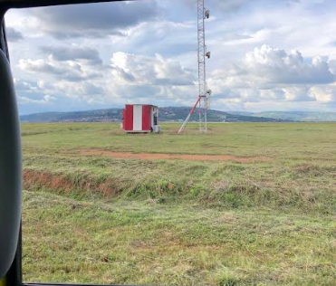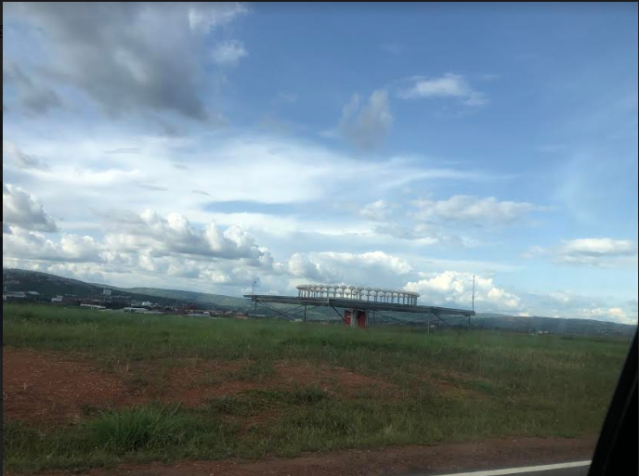
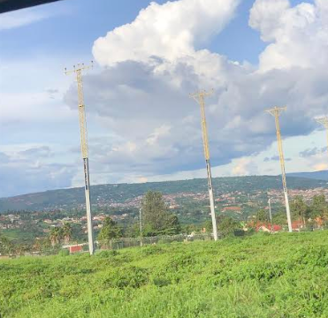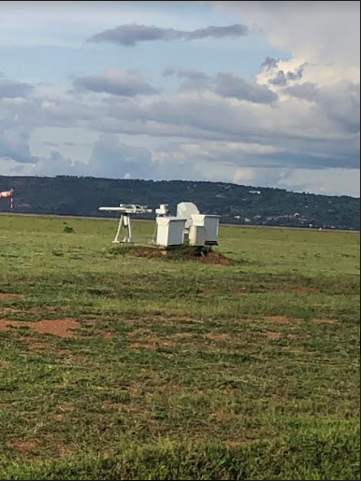
Figure 1: Some of the utilities existing at the KIA.
The connection between the proposed aircraft hangar and Kigali International Airport.
The proposed project components will be connected to various existing facilities at the Kigali international airport. These facilities include the existing runway, which is a designated strip of land used for takeoff and landing of aircraft. The existing apron is also an important facility that serves as the area where aircraft are parked, refueled, and boarded. In addition, the existing stormwater drainage system is responsible for collecting and draining excess rainwater from the airport, ensuring that it does not interfere with the airport's operations.
Other existing facilities to which the proposed project components will connect include the Akagera aviation offices, which serve as administrative and operational facilities. Furthermore, the project will rely on the existing power and water connections as well as water tanks to provide electricity and water needed for the airport's operations. Finally, the existing fuel tanks will be utilized to store fuel for the aircraft, ensuring a constant supply of fuel for the airport's operations.
The existing infrastructure of KIA that will be used by the proposed hangar include an airstrip (runway), runway details, fueling area, apron, control tower, high-speed taxiway, helicopter stand, fire station, stormwater drainage channels.

2.3 Project Objectives
The objective of the CEAS campus is to empower the labor force in the aviation industry by providing qualifications in the aviation field not only in Rwanda but also in the region and beyond. The proposed CEAS campus is composed of different departments: pilot training; maintenance training, cabin crew, dispatch, ancillary courses; air traffic management courses; aeronautical information services; aeronautical meteorological services; aeronautical communications operations; communication navigation and surveillance; airport emergency services (operations) and other support programs. The objective of the proposed aircraft hangar is to provide shelter for fixed wings and rotary wing aircraft, maintenance/engineering and other technical aircraft activities.

2.4 Project Financier
The proposed Centre of Excellence for Aviation Skills (CEAS) project will be financed by the African Development Bank (AfDB) and OPEC Fund contributions.

2.5 Project Cost and Staffing
The CEAS's total cost for establishing the infrastructure amounts to approximately 52,070,000 USD, inclusive of VAT. The project is double funded with AfDB contributions amounting to 24,120,000 USD and OPEC contributions amounting to 27,950,000 USD.
To ensure the success of the proposed project during its construction and operation, a workforce will be required. The estimated number of workers needed during the 24-month construction phase is up to 1000 individuals. The labor force will comprise of unskilled workers from local communities who will perform general work, as well as skilled laborers who are either locally sourced or imported from foreign countries.
There is a total of 318 construction workers who will be hired during the construction of the aircraft hangar, as well as a total of 682 construction workers who will be hired during the construction of the campus. It is recommended that the contractor ensures that at least 30% of the construction workers hired are women. During the operational phase of the aircraft hangar and campus, a total of 98 individuals will be hired.

2.6 Project Components
The proposed CEAS project will be comprised of an aircraft hangar capable of accommodating 8 Beechcraft King air size aircraft at Kigali International Airport, as well as a campus to serve up to 192 students.

2.6.1 Aircraft Hangar
The proposed aircraft hangar will have a capacity of accommodating 8 aircraft, located 270 m from the runway centerline. The layouts and 3D illustrations of the hangar are shown below.
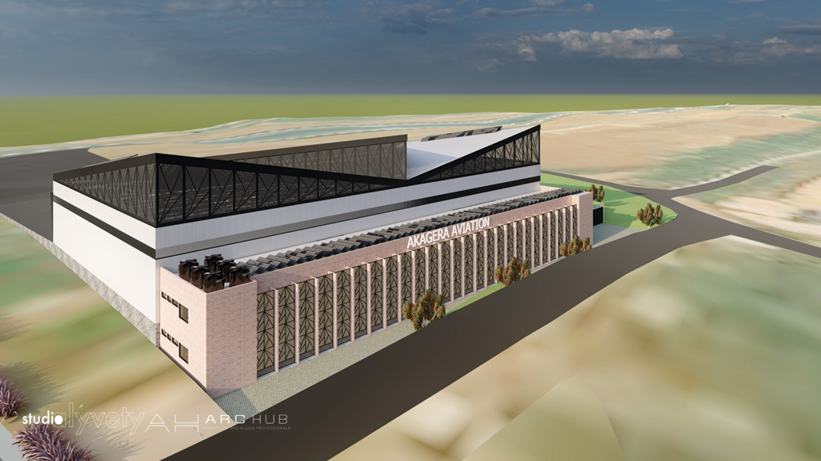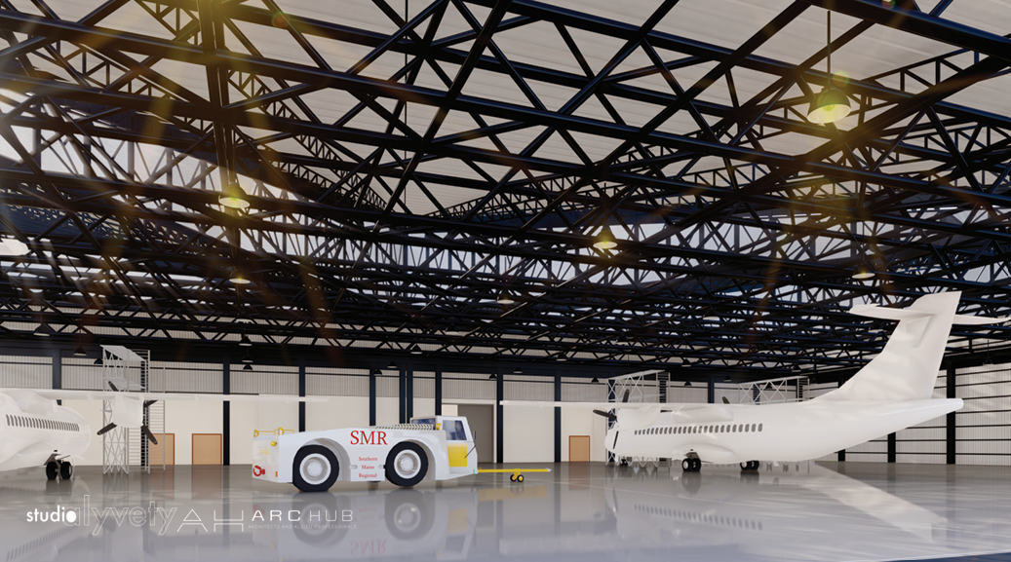
Figure 2: 3D illustrations of the aircraft hangar
The underground level mainly comprises:
- Rainwater tank 3M deep
- WASAC water tank 3M deep
- Oil separator
The ground level mainly comprises:
- Cafeteria
- Closet/WWTP machine room
- Men bathrooms and women bathrooms
- Changing room/women
- Changing room/men
- Server and electric room
- Battery room
- Mother’s room
- Customer/ hospitality service desk
- Security
- Archive room
- IT rooms
- Kitchen pantry room
- Conference room
- Electrical room
- Pump room
- Power room
- Main circulation corridor (111 sqm)
- Terrace
The first floor mainly comprises:
- Hangar floor
- Tech stores
- WC/women and WC/men
- Consumables room
- Closet
- IT rooms
- Security rooms
- Electrical rooms
- Chief engineer and engineer’s office
- Store manager office
- Composite
Aircraft hangar green design features include:
- Improved multi-pitch roof design to allow ventilation and lighting clerestories.
- Revised roof structure to minimize use of steel.
- Incorporated ridge caps vents and roof vents.
- Use of light weight fiber roof panels to reduce weight and maximize maintenance.
- Use of insulated cladding materials
- Use of polycarbonate translucent cladding panels for increased natural lighting.
- Offices have a shading screen to reduce direct solar penetration southeast and southwest.

2.6.2 Campus
The proposed campus site plan will be comprised mainly of:
- Main campus block wing A: academic and admin wing
- Main campus block wing B: academic and restaurant wing
- Main campus block wing C: student hostels and cabin crew training wing
- Tennis court, mini-football pitch, dual basket and volleyball court
- Leisure and indoor games block
- Utilities powerhouse
- Security isolation area
- VIP and PWD drop-off
- Green paved parking zones
- Service roads, entry and access points

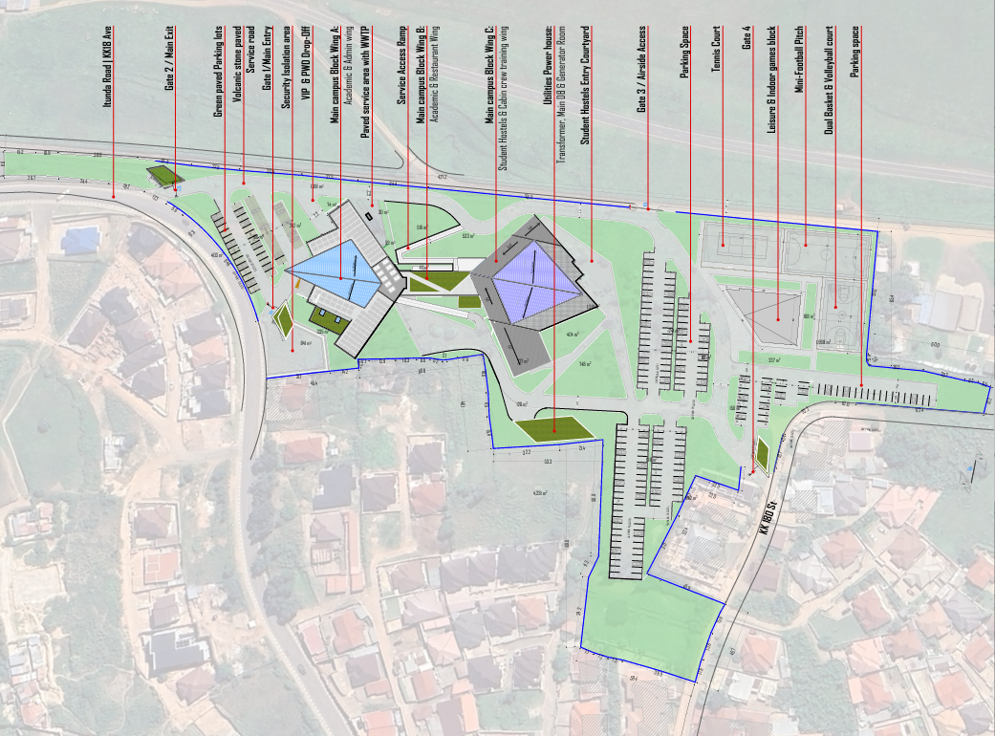
Figure 3: Campus building overall site plan
The lower ground level -1 mainly comprises:
- Lecture theatre lower level
- Storage
- Crew lounge
- Reception
- Technical room
- Store
- Washrooms
Level 0 mainly comprises:
- Health room
- Washrooms
- Prayer rooms
- Nursing and wellness room
- Control room
- Servers and IT equipment room
- IT department room
- Technical room
- Storage space
- Office
- Conference rooms
- Lecture theatre
- Store
- Tech room
Level 1 mainly comprises:
- Classrooms
- CBT training room
- Library
- Exam room
- Quality management department
- HR management department
- Logistics management department
- Business development department
- Finance department
- Management offices
- Admin assistant offices
- Additional offices
- Double volume AMT workshop
- Air compressor room
- Tools room
- Washrooms
- Stores
- Tech room

Level 2 mainly comprises:
- Classrooms
- Head of training
- Senior trainer
- Head of flight training
- Briefing room
- Simulation rooms
- Tech rooms
- Flight dispatch/operations rooms
- Head of cabin crew training
- Smoke simulation room
- Reserve rooms
- Cabin crew training pool
- Cabin crew training slides
- Washrooms
- Electric room
- Store
- Green roof
Level 3 mainly comprises:
- Electric room
- Stores
- General storage
- Cold storage room
- Dry storage room
- Main kitchen
- Indoor and outdoor dining area
- Laundry rooms
- Bedrooms
- Students lounge
- Tech rooms
- Concrete slabs with solar panels
- Translucent roof
- Washrooms
- Changing rooms

Level 4 mainly comprises:
- Students lounge
- Outdoor students lounge
- Bedrooms
- Storage areas
- Laundry area
- Tech rooms
- Water tanks platform
- Green roof
Level 5 mainly comprises:
- Students lounge
- Bedrooms
- Storage areas
- Laundry area
- Tech rooms
Level 6 mainly comprises:
- Students lounge
- Bedrooms
- Storage areas
- Laundry area
- Tech rooms
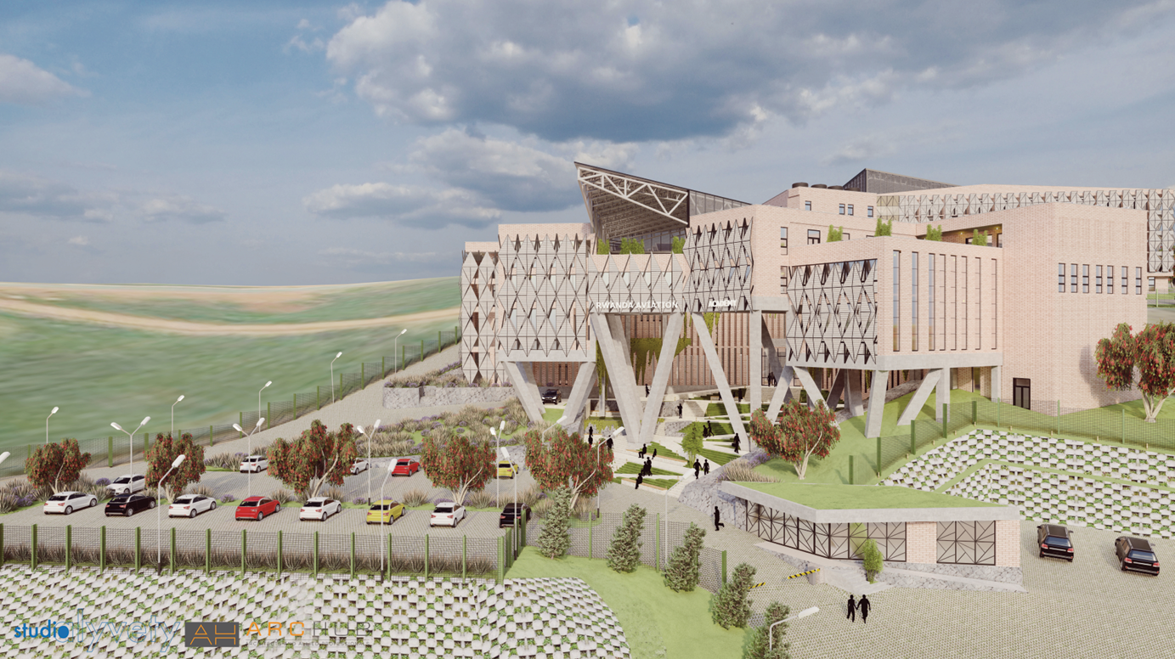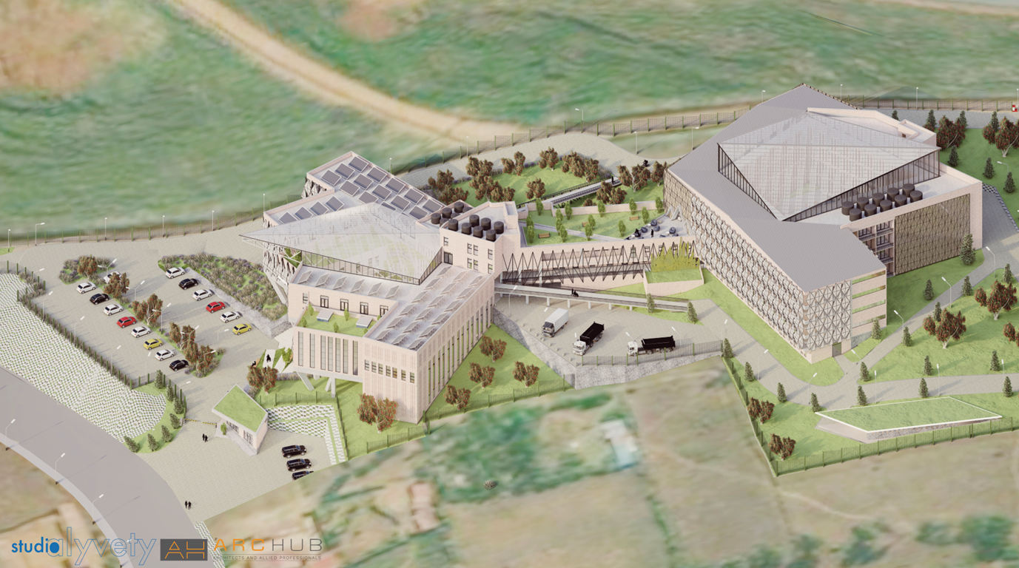
Figure 4: 3D visualizations of the campus building

2.6.3 Associated Facilities & Services

2.6.3.1 Liquid waste management
During construction, it is necessary to provide temporary sanitation facilities for workers, and in this case, the use of temporary ecosan toilets is advised. These toilets are designed to have minimal environmental impact, as they conserve water and offer opportunities for composting human waste.
Campus wastewater treatment plant
During operations, the wastewater treatment system for the campus is designed to process 75 cubic meters of wastewater per day (75 m³/day) for a population of 500 people, utilizing treatment stages that include stabilization, aeration, sedimentation, and filtration. The system has a Biological Oxygen Demand (BOD) capacity of 18 kg/day. The wastewater recycling system follows a grey and black water recycling approach using Membrane Bioreactor (MBR) technology and will adhere to the RSB effluent water quality standards. The treated wastewater is designated for various uses, including irrigation. This treatment and recycling system enhances water efficiency by enabling the reuse of treated water for essential functions.
Hangar wastewater treatment plant
The wastewater treatment plant is designed to treat 15 cubic meters of wastewater per day, for a population of 100 people. The plant has a Biochemical Oxygen Demand (BOD) capacity of 18 kilograms. The treatment system comprises multiple chambers, each designed to facilitate efficient wastewater treatment. The stabilization chamber, aerated bioreactor, sedimentation chamber.
Description of the treatment process
The wastewater treatment plant uses a five-stage treatment process to treat wastewater effectively. Breakdown of the technology to be used:
      - Stabilization chamber: Wastewater will be collected here, where specially bred bacteria are introduced to begin the bio digestion process.
      - Aerated bioreactor: Air is pumped into this chamber to accelerate bacterial action, which degrades solids into clear effluent and non-toxic sludge.
      - Sedimentation/recirculation chamber: The aerated water flows into this chamber, where sludge settles and is re-circulated back to the stabilization chamber for further processing.
      - Clarification chamber: Clarified water is collected here and then pumped through a mixed bed sand/activated carbon filter to remove remaining particles and odors.
      - Chlorination: The treated water is chlorinated to neutralize any remaining bacteria, making it suitable for open discharge.
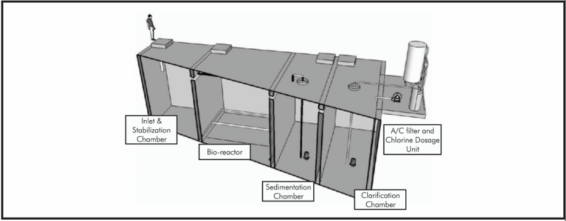
Figure 5: Typical plant flow layout

2.6.1.2 Refuse management
For solid waste management within the aircraft hangar and CEAS facilities, this is to be handled through the management. Appropriate areas will be provided with storage bins for collection and strategically placed within the aircraft hangar and campus facilities. The storage bins will be clearly marked for segregation of each type of waste. Transportation of solid waste will be done by a licensed private company, which goes directly to the Nduba dump site. The company/association will sort waste prior to disposal, with organic types composted while non-organic reduced or recycled where feasible. Recycling programs aim to divert at least 50% of waste from the dumpsite. Hazardous waste will be disposed of at a specific hazardous disposal site. RAC also has a MoU with REMCO for the recycling of steel scraps. The hangar facility will follow KIA's wildlife hazard management plan, and both the airport waste management team and RAC will responsibly handle waste using appropriate disposal and recycling methods.

2.6.1.3 Water supply and storage
The campus will include a dedicated water tank area to enhance water storage and distribution, ensuring a reliable supply. Additionally, the hangar will be equipped with two underground water tanks, further reinforcing the project's water resilience. Key efficiency measures include water-efficient showerheads and bathroom faucets with aerators that reduce water usage. The water closets utilize a single flush system. Bidets, urinals, and kitchen sinks are also equipped with optimized flow rates to further reduce water consumption.
A rainwater harvesting system has been integrated, utilizing a 5,335 m2 catchment area to collect and store rainwater. This harvested water is directed for use in toilet flushing, cleaning, and fire suppression significantly reducing reliance on the municipal water supply. Rooftops and designated green roofs serve as the primary catchment areas, effectively capturing precipitation during rainfall events. Conveyance is ensured through a system of gutters and downspouts that channel the collected water into underground storage facilities. To enhance water quality, first flush diverters are installed to redirect the initial runoff typically carrying dust, debris, and other contaminants away from the storage system. The harvested water is stored in below-ground reinforced concrete tanks.
Additionally, a wastewater treatment and recycling system has been implemented to treat wastewater generated on-site using membrane bioreactor (MBR) technology. The treated water will be reused for irrigation, further conserving potable water. To enhance monitoring and efficiency, smart water meters are installed to track real-time consumption and detect any leaks or inefficiencies, enabling proactive water management. Water will also be sourced from the municipal Water and Sanitation Corporation (WASAC) to meet water needs.
In terms of overall water consumption, the project is expected to require approximately 1,523 cubic meters of water per month, a demand that already reflects its water-saving initiatives, which are projected to achieve about 64.71% conservation compared to conventional designs.
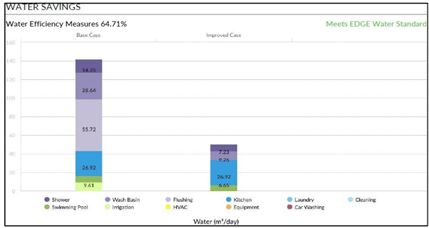
Figure 6: Water savings

2.6.1.4 Surface drainage
A storm water drainage system is designed to collect and convey run-off generated during and after rainfall events, for safe discharge into a receiving watercourse. Rainwater from paved areas shall be collected by open / closed drains and discharged to the public storm sewer system. The public stormwater sewer system beneath the aviation training center discharges stormwater to the Rubirizi wetland located in the larger area of indirect influence of the project site (refer to fig 47). To account for the steep terrain of the campus site, the design incorporates a transformation of the terrain into a design asset by employing a tiered or stepped approach. The campus buildings are placed on different levels to follow the natural slope, ensuring improved water drainage and runoff control. To further reduce the risk of surface runoff, nature-based solutions (NBS) such as planting grasses and trees, as well as using permeable paving that allows stormwater to seep into the ground, will be implemented. These measures will help to mitigate any potential issues caused by the runoff of rainwater on the site.

2.6.1.5 Power supply
During the construction phase, the aircraft hangar facility is projected to consume approximately 200–300 kilowatt-hours (kWh) of electricity, while the campus facility will require 400–600 kWh. Once operational, the combined facilities will require an estimated 2780 kWh per day.
To meet this energy demand, the CEAS facilities will be connected to the existing Kigali International Airport (KIA) substation. Additionally, backup diesel generators will be installed to provide emergency power during outages. The generator, housed in a soundproof enclosure near the hangar, will minimize noise pollution and reduce the need for lengthy distribution cables. To prevent overloading the public power grid and ensure stable voltage for the hangar, a dedicated transformer will be installed nearby.
As part of its commitment to sustainability, the CEAS will integrate solar power systems for both the hangar and campus facilities, which will offset 60% of annual energy use:
- The Hangar: A grid-tied (on-grid) solar power plant will be installed, with a total solar energy daily peak capacity of 336 kWh.
- The Campus: A hybrid solar power plant will be implemented, combining solar energy with other energy sources (e.g., diesel, battery storage, or grid connection). The total solar energy daily peak capacity is 843.43 kWh.
The project is expected to achieve energy savings of approximately 20.71% through the adoption of sustainable building measures.
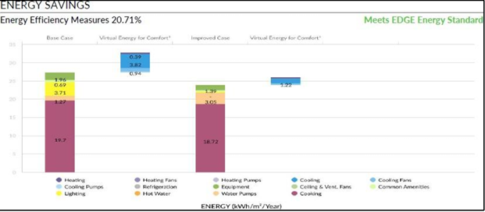
Figure 7: Energy savings

2.6.1.6 Emergency services
Kigali International Airport has a well-established emergency response plan in place to handle any unforeseen incidents that may occur during its operations. This plan is designed to provide assistance and support services in a uniform manner, ensuring that all specifications are met. As emergencies and disasters can happen at any time without warning, it is essential to prepare for them to minimize panic and confusion. Therefore, Emergency Response Plans (ERP) will be instituted throughout the proposed project cycle. To ensure effective emergency management during the project's operational phase, the proponent will adhere to the existing emergency response plan for KIA. The regular operational documents contain information on how the proponent will respond to different incidents that may occur during the project.

2.6.1.7 Fire protection and Rescue services
The planned project facilities at Kigali International Airport do not have a separate fire protection system of their own. Instead, the proposal includes the installation of automatic firefighting systems on the site. These systems will be supplemented by the existing KIA fire brigade in the event that the system encounters difficulties in effectively handling a fire incident. The fire protection system for the proposed project will consist of fire hydrants, fire suppression, fire sprinkler system, fire detection and Warning system. Given the presence of flammable fuels and aircraft, special attention should be given to designing the sprinkler system to account for potential fuel fires. This may involve incorporating foam or other specialized suppression systems where necessary.

2.6.1.8 Road and accessibility & parking space
The project site will be accessible through two roads, which will allow the center to have two entrances. The main access to the training center will be through the tarmac road located at the lower part of the site, while the main block or academic block will be adjacent to the main road or the main entrance. The project planning will consider the new road proposed by the Kigali Master Plan 2050, which will pass through the site and will serve as a service road within the center. The first access is the tarmac road located at the Airport boundary in Busanza. The second access is the airside access road, which will be exclusive to pedestrians and bicycles, promoting sustainable non-motorized transport and fitness. Additionally, parking spaces have been provided to accommodate cars that will be utilizing the facilities. The design provides 250 car parking spaces. The aircraft hangar will provide taxiways that will connect to the existing runway. The road connecting the hangar to the academic block (1Km length) is proposed to be non-motorized.

2.6.1.9 Landscaping
Landscaping emphasizes the use of native and adaptive species that are resilient, require minimal maintenance, and reduce water demand. Given the aviation-focused context, plant species have been carefully selected to balance aesthetic appeal with safety requirements, particularly to mitigate wildlife attraction, especially avifauna. The plan prioritizes species that do not produce fruits or seeds and avoids vegetation that may create shelter or nesting opportunities for birds and other wildlife, thereby minimizing risks to aviation operations. Compliance with RCAA obstacle limitation clearance height regulations has also been ensured by prioritizing low-growing species such as shrubs, herbs, and grasses in restricted zones, while in the leisure block where height limitations are more flexible, a broader range of plants has been incorporated.
The proposed palette of species includes Juniperus, Hinoki cypress, Hibiscus elatus, Weeping bottlebrush, dragon tree, Garden croton, African violet, Juniper, Garden thyme, velvet leaf kalanchoe, aloe, Bermuda grass, Sword fern, variegated snake plant. This selection aligns with the sustainability principles of ecological balance, operational functionality, and aesthetic value. In addition, the landscaping design integrates irrigation supported by recycled water from the on-site wastewater treatment plant further contributing to resource efficiency and sustainable site management.

2.6.1.10 Clean cooking system
The Clean Cooking System for CEAS emphasizes energy-efficient appliances, clean fuels, and sustainable resource management. Consistent with this, the system incorporates high-efficiency cooking equipment, such as induction stovetops, energy-efficient ovens, refrigerators, and LED lighting, ensuring minimal energy demand and reduced greenhouse gas emissions. An advanced ventilation system with energy-efficient range hoods and airflow control mechanisms further improves indoor air quality while enhancing energy savings. LPG is selected as the primary fuel due to its efficiency, clean combustion, and relatively low carbon footprint.
Water efficiency and waste management are integral components of the green kitchen strategy. The design integrates low-flow faucets, water-efficient dishwashers, greywater recycling, grease traps, and wastewater treatment systems to minimize water consumption and ensure safe effluent management. Additionally, composting and recycling programs will be implemented to reduce solid waste. The system also integrates renewable energy sources, including solar panels, to support essential kitchen operations and reduce dependence on grid electricity. Smart kitchen technologies will be employed to monitor and optimize both energy and water use, ensuring long-term efficiency and sustainability in operations.

2.6.1.11 Gender considerations
In the design of the CEAS, gender consideration was taken into account, with separate accommodation provided for girls and boys. The girls' accommodations are designed to maximize privacy and safety, with their rooms separated from the boys' accommodation. Additionally, a higher number of washrooms have been reserved for girls to avoid long lines, taking into account that they may require more time in the washroom.

2.7 Design Considerations
The design of the proposed CEAS project facilities has incorporated the following design considerations:
For the Campus:
- The design adheres to the Rwanda Green Building Minimum Compliance, the City of Kigali Master Plan and aviation authority guidelines (RCA & RCAA).
- Noise mitigation is addressed by building orientation and incorporating acoustic materials, vegetative buffers, and strategic placement of functional areas.
- Height restrictions and flight path clearances are respected through careful zoning and building height controls, ensuring full regulatory compliance.
- Shared spaces, such as combined recreation and dining areas, reduce the overall footprint while serving multiple purposes. For example, student lounges are adjacent to dining halls to encourage community interaction without additional spatial requirements.
- The absence of redundant spaces ensures that each room or area serves a distinct purpose or is multi-functional. This principle is applied throughout, from classrooms that double as seminar rooms to staff offices designed for hot-desking.
- The design adheres to universal design principles to ensure inclusivity, including provisions for people with disabilities (PWDs). Features such as elevators, ramps, wide corridors, and appropriately positioned fixtures cater to diverse user needs.
- The design incorporates modular layouts for classrooms, offices and accommodation rooms, allowing for easy reconfiguration as training needs evolve. This flexibility extends to future expansions, with pre-planned extensions integrated into the current layout.
- IoT-enabled systems ensure that lighting, HVAC, and other utilities are optimized based on real-time usage. This not only reduces operational costs but also enhances space functionality by adapting to user behaviors.
- Locally sourced materials with low carbon footprints are used throughout. Examples include FSC-certified timber, and non-toxic paints to minimize environmental impact.
- Durability and lifecycle efficiency guide material selection, reducing maintenance costs and enhancing the building’s long-term sustainability.
- The building orientation maximizes natural light while minimizing heat gain, reducing reliance on artificial lighting and air conditioning.
- Solar panels are installed across rooftops, contributing to energy neutrality. Energy-efficient LED lighting and motion sensor-based systems further reduce consumption.
- Natural cross-ventilation is achieved through strategic placement of windows, reducing the need for HVAC systems. Green roofs and shaded areas also help regulate indoor temperatures.
- Rainwater harvesting systems are integrated into the design to supply water for flushing and non-potable uses. Low-flow fixtures in washrooms and kitchens minimize water usage.
- A wastewater recycling plant treats greywater for reuse in landscape/irrigation, significantly reducing water waste.
- The landscape design includes green roofs, vegetative barriers, and native plant species to promote biodiversity. These features also help absorb noise, reduce urban heat, and enhance the aesthetic value of the site.
- Permeable surfaces in parking lots and pathways reduce storm water runoff and enhance groundwater recharge.

For the Aircraft hangar
- Improved multi-pitch roof design to enhance ventilation and allow natural lighting through clerestories.
- Revised roof structure to minimize the use of steel, reducing material costs and weight.
- Incorporation of ridge cap vents and roof vents to improve airflow and heat dissipation.
- Use of lightweight fiber roof panels to reduce structural load and facilitate easier maintenance.
- Use of insulated cladding materials to enhance thermal efficiency and energy conservation.
- Installation of polycarbonate translucent cladding panels to maximize natural daylight penetration and reduce artificial lighting needs.
- Shading screens for office areas to minimize direct solar penetration, especially on the southeast and southwest facades, reducing heat gain and improving indoor comfort.
- Solar panels are installed on the rooftop, contributing to energy neutrality. Energy-efficient LED lighting and motion sensor-based systems further reduce consumption.

2.8 Project Phasing and Activities
The project activities during all phases (design, implementation, operation, decommissioning) are characterized by the following phases:
Preconstruction phase:
- Reconnaissance of the project site.
- Identification of alternative sites.
- Pre-feasibility and feasibility studies of the chosen construction site.
Construction phase: It is estimated that the construction will take a period of 24 months. Construction of the CEAS:
- Site fencing and managing site access and contact points.
- Land clearing.
- Excavation.
- Foundation works.
- Leveling, and finishing.
- Installation of plumbing and electrical fixtures.
- Soil preservation.
Operation phase:
The use of the CEAS facilities.

Aircraft hangar operation activities:

- Aircraft storage
- Maintenance and repair
- Overhaul and refurbishment
- Modification and customization
- Cleaning and detailing
- Testing and inspection
- Training such as simulation exercises or safety drills, for pilots and maintenance personnel.
Campus operation activities:
- Classroom instruction
- Flight training
- Simulator training
- Ground school training
- Certification courses
- Safety training
- Use of the hostel and recreation facilities

Decommissioning phase:
- Demolition of the CEAS facilities and management of debris formed during breakdown of the units.
- Reuse other construction materials without carelessly disposing of them.

2.9 Description of Construction Materials and Equipment
The project seeks to meet environmental goals of limiting carbon release into the atmosphere. Building materials must be carefully chosen to enhance and sustain the environment, also giving preference to those readily available locally. The following are the proposed environmentally friendly construction materials for the CEAS facilities, which will achieve 43% savings for materials embodied carbon.
Foundation and superstructure materials: reinforced concrete, stone masonry, precast concrete elements.
Elevation and cladding materials: industrial clay bricks, naturally contoured lava stones, metallic framed screen walls.
Roof structure materials: mild steel roof systems, polycarbonate sheets, standing seam sheets, green roof.
Internal finishing materials: zero carbon straw panels, recycled wood panels, polished concrete floors, 100% solids epoxy coating.
Paving and external works: interlocking lava stone grass pavers, natural limestone drainage channels.
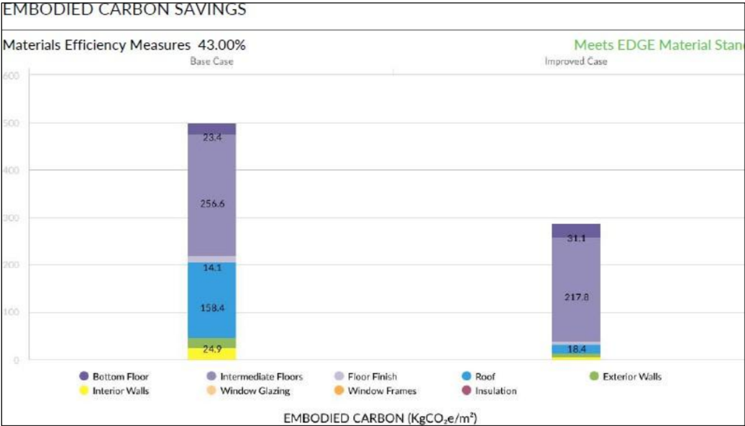
Figure 8: Embodied carbon savings
During the construction phase the following are the proposed equipment and machinery to be used for the establishment of the CEAS facilities: 1 excavator, 1 bulldozer, 2 wheel loaders, 1 tower crane, 1 mobile crane, 4 dump trucks (20CM), 1 trailer-35T, 4 pick-ups, 2 forklifts, 2 sets hoist, 2 generators (15KV), 1 concrete batching plant, 2 concrete mixer trucks with pumps, 1 total station, 1 theodolite, 1 laser level, 100 cubic meters water tanks, 2000 sqm metal scaffolding, 1 concrete pump/boom pump, 1 line pump.

2.10 Facility emission computation and reduction strategies

2.10.1 Emissions from the CEAS Project
The CEAS project is committed to achieving EDGE (Excellence in Design for Greater Efficiencies) certification, with a strong focus on sustainability through energy efficiency, water conservation, and the use of sustainable materials. Key initiatives include the installation of solar panels, LED lighting, motion sensors, and rainwater harvesting systems, complemented by robust waste management and recycling programs aimed at diverting at least 50% of waste from landfills. Calculations made in the EDGE assessment show that the project’s final embodied carbon is calculated at 289 kg CO₂e/m², accounting for emissions from material extraction, processing, transportation, and construction. Operational CO₂ emissions are projected at 11.60 tCO₂ per month, reflecting energy consumption during the building's operation. With an anticipated annual operational CO₂ savings of 54 tCO₂ and embodied carbon savings of 3,780.09 tCO₂e, the CEAS project is set to achieve net negative carbon emissions of -163.9 tCO₂e per year, offsetting more emissions than it produces.

2.10.2 Strategies for emission reduction
The CEAS project integrates several strategies to reduce greenhouse gas (GHG) emissions and promote sustainability. These strategies focus on energy efficiency, renewable energy, sustainable construction materials, water conservation, and waste management. Renewable energy integration: Solar energy installation, energy-efficient lighting, mart energy management. Energy efficiency measures integrated in the design account to 20.71% energy savings. Sustainable building design & materials: Low-embodied carbon materials, insulation and efficient double-glazed windows. Water conservation strategies: Rainwater harvesting system, wastewater treatment & reuse. Waste management and circular economy: 50% Waste diversion target, sustainable cooking systems.

3.0 POLICY, LEGAL, AND INSTITUTIONAL FRAMEWORK

3.1 Introduction
This section of the ESIA Report details the Policy, Legal and Institutional Framework for the proposed Centre of Excellence in aviation skills (CEAS) project, covering the national policies, and legislations that are relevant to this project as well as applicable international treaties and conventions. International legislation such as AfDB Operational Safeguards was considered in this report. The section is intended as a guide to the relevant permitting requirements that deal with the environmental impacts of this proposed development and the agencies to which they relate.

3.2 National Legislation
Several national laws, plans, and policies offer a framework for Rwanda's goals and aspirations as well as guiding principles for this project. These are as discussed below.

3.2.1 Policy Framework

3.2.1.1 The Rwanda Development Vision, 2050
Rwanda’s Vision 2050 articulates the long-term strategic direction for “the Rwanda we want” and the enabling pathways to achieve this ambition. To achieve economic and social development as part of its Vision 2050, Rwanda has invested heavily in its national carrier, airport infrastructure and capacity building to connect the country to markets overseas, ensure access for business professionals and investors, and create employment.
Alignment aspects
- The proposed project will attract and sustain high private investment, promote higher public investment as well as improve human capital through education.
- The implementation of the proposed project will aid in upskilling previously unskilled labor.

3.2.1.2 National Strategy for Transformation, (NST-2, 2024-2029)
The National Strategy for Transformation 2 (NST2) focuses on enhancing the quality of life for all Rwandans while fostering sustainable economic growth and development. The aviation sector will be expanded by scaling up RwandAir’s capacity. The establishment of an Aviation Skills Academy and hangar will support the creation of the necessary skills and local capacity to sustain the growth of the sector.
Alignment aspects
- The proposed project will contribute to social transformation since it will create employment in the operational and construction phase.
- The proposed project will support the creation of necessary skills needed for the aviation sector to grow.
- As part of its development, the proposed initiative aims to increase women's participation and empowerment as a contribution to national transformation.
- The proposed project will help boost investments in the sector, achieving significant increases in land efficiency and innovative capacity.

3.2.1.3 National Environment and Climate Change Policy, 2019
The policy ensures Rwanda has a clean and healthy environment that is resilient to climate variability and supports a high quality of life for its society. The main policy objectives are greening economic transformation; enhancing functional natural ecosystems and managing biosafety; strengthening meteorological and early warning services; promote climate change adaptation, mitigation, and response; improve environmental well-being for Rwandans; strengthen environment and climate change governance; promoting green foreign and domestic direct investment and other capital inflows.
Alignment aspects
- The implementation of the proposed project will ensure the use of low-carbon materials in construction, as well as promote waste management practices to reduce GHG emissions.
- The project will contribute to reducing gas emissions and adapting to climate change impacts.
- Energy efficiency through the incorporation of solar energy, LED lighting, and motion sensors aligns with the policy by prioritizing the adoption of renewable energy and energy-efficient technologies.

3.2.1.4 Health sector policy, 2015
The overall aim of this policy is to ensure universal accessibility of equitable and affordable quality health services for all Rwandans.
Alignment aspects
- The proposed project will have well equipped first aid rooms to deal with health problems that may result from accidents and hazards.
- Alignment through maintaining health and safety on the project site and implementing awareness programs on HIV, AIDS, child abuse, SH, Malaria, etc.

3.2.1.5 Green Growth and Climate Resilience National Strategy for Climate Change and Low Carbon Development, GGCRS 2022
Rwanda's Green Growth and Climate Resilience vision aim for a developed, climate-resilient, and low-carbon economy by 2050. The GGCRS promotes carbon neutrality, green industry, knowledge-based services, eco-friendly urban settlements, and sustainable use of rural ecological resources, aiming to decouple economic growth from primary natural resource dependency.
Alignment aspects
- The proposed project will incorporate energy and water efficiency measures and prioritize waste recycling in its design to uphold a low carbon system.
- Renewable energy sources will be used for electricity consumption in the proposed project facilities.
- The construction of new facilities will involve the use of sustainable building materials and green building design to minimize their environmental impact.
- Incorporation of climate adaptation and resilience measures in the design of the project facilities.

3.2.1.6 National Energy policy, 2015
The overall goal of the policy is to ensure that all residents and industries can access energy products and services that are sufficient, reliable, affordable, and sustainable.
Alignment
- The use of solar energy in the project aligns with the policy's goal of increasing the share of renewable energy sources in the country's energy mix.
- The incorporation of motion sensors, LED lighting, and cross ventilation and use of natural lighting in the project's design promotes energy efficiency.

3.2.1.7 Nationally Determined Contributions, 2025
As a Party to the UNFCCC, Rwanda seeks to contribute to the ambitious goal of limiting temperature rise to 2ºC with efforts to reach 1.5ºC agreed under the Paris Agreement. The updated NDC sets out Rwanda's bold commitment to reduce GHG emissions by 53% compared to BAU in 2035.
Alignment aspects
- The proposed project must be in alignment with the national policy strategies and the international agreements on climate change (e.g., GGCRS, NDC, etc.)
- The proposed project will play a significant role in helping to offset carbon emissions by utilizing low-carbon solutions. The building framework achieves net carbon emissions of -163.9 tCO2e/year.

3.2.1.8 Rwanda Biodiversity policy, 2011
The policy provides an overarching framework for the conservation, sustainable utilization, access to biodiversity resources and fair equitable sharing of benefits derived from the resources.
Alignment aspects
- The design and execution of the proposed project in an environmentally sound and sustainable manner, aligns with the policy’s objective of preserving Rwanda's biological diversity.
- This policy shall apply not only to construction at the project site but also its surroundings and affiliated areas by clearing as little land as possible, preserving soil health, revegetating cleared areas, restoration of borrow pits for stabilized soils and mined quarries for construction material.

3.2.1.9 Land Policy, 2019
The overall objective of the national land policy is to strengthen land administration and management to ensure optimal allocation and use of land.
Alignment aspects
- Sustainability will be promoted by implementing environmentally friendly practices such as using renewable energy, reducing waste, and conserving water resources, which will reduce the environmental impact of the facility and promote sustainable development.
- The proposed project is in complete cognizance of the provision of physical planning. As the proposed project will be utilizing the land for the development of infrastructure, the objectives of the National Land Policy must be considered and implemented.

3.2.1.10 National Sanitation Policy, 2016
The Policy seeks to create favorable conditions for fair and sustainable access for the population, clean drinking water and appropriate sanitation infrastructure, and the development of natural resources.
Alignment aspects
- The proposed infrastructures will adopt technologies that do not deplete water resources and optimize the use of water resources throughout its phasing. Water and sanitation facilities will be of acceptable standards and properly managed.
- To ensure responsible waste management, the proposed project must comply with the waste management plan.

3.2.1.11 Natural Cultural Heritage Policy, 2015
The mission of the cultural policy is to provide an appropriate framework for the preservation and protection of Rwandan culture to provide a foundation upon which the country’s sustainable development is anchored.
Alignment aspects
- The proposed project can incorporate cultural elements into the design of the buildings, that reflect the country's cultural heritage.

3.2.1.12 National Urbanization Policy, 2025
The Policy provides a strategic framework to guide Rwanda’s urbanization towards achieving Vision 2050. Urban physical development under this policy prioritizes compact and connected urban settlements, sustainable land management, resilient construction practices, and climate adaptation measures to create livable cities that foster economic growth while conserving resources.
Alignment aspects
- The project will promote sustainable development by implementing eco-friendly practices such as reducing carbon emissions materials, using renewable energy sources, minimizing waste, integrating green spaces and incorporating climate-resilient construction methods.
- The project will promote compact and efficient land use through sustainable site design and resource-efficient planning.

3.2.1.13 Kigali City Master Plan, 2020
The Kigali City Master Plan 2020 introduces a more equitable, flexible, and incremental approach to city development. These regulations explain the proposed zoning plan and development control regulations.
Alignment aspects
- The proposed project will be designed and built in the context of the objectives of Kigali City Masterplan 2020. The project site is compatible with the land use and zoning regulations.
The developer will ensure that the project is designed with sustainability in mind, taking into account environmental impact and energy efficiency.

3.2.1.14 National Policy on Occupation Safety and Health
This Policy provides guidelines to cover areas that support the development and implementation of an effective OSH system.
Alignment aspects
- The proposed project should develop and implement an OSH policy that outlines the organization's commitment to ensuring a safe and healthy work and learning environment.
- A risk assessment should be conducted to identify potential hazards and risks within the facilities. An OSH management system will be established to manage and control the identified risks.
- The project should adhere to this strategy's pertinent laws and recommendations. This will involve giving employees personal protective equipment (PPE), putting in place training programs on safety procedures, setting up procedures for handling accidents and emergencies, and ensuring that all equipment and facilities are maintained to ensure their safety and good working condition.

3.2.1.15 National Gender Policy, 2021
The overall goal of this policy is to improve gender equality and equity in various sectors while increasing women’s access to productive economic resources and opportunities and ensuring that women and men are free from any form of gender-based violence and discrimination.
Alignment aspects
- The proposed project will have policies and practices in place to prevent and address gender-based discrimination, harassment, and violence.
- The proposed project should encourage women's leadership and participation during its phasing.
- The proposed project will ensure equal opportunities for women and men to access the training and job opportunities that will emanate from the project.

3.2.1.16 National transport policy and strategy, 2021
The policy aims to address the current transport sector challenges through three main policy pillars: promotion of sustainable development of an integrated transport infrastructure network; enhancement of the quality of transport services; reinforcement of capacity building in transport sector and address crosscutting issues.
Alignment aspects
- The CEAS will contribute to reinforcing capacity building in the transport sector, by providing training and education in aviation-related fields. The well-trained professionals will be equipped to meet the industry’s demands.

3.2.1.17 National Cooling Strategy, 2019
The strategy provides Rwanda with a roadmap to address the country’s growing demand for refrigeration and air conditioning while promoting a green economy vision. It focuses on reducing energy waste, cutting greenhouse gas emissions, and phasing out ozone-depleting refrigerants.
Alignment aspects
- The design incorporates natural cooling techniques and ensures that air conditioning and refrigeration units meet the standards for efficiency and low-GWP refrigerants.
- The development demonstrates the shift to clean energy solutions, reducing emissions and contributing to Rwanda’s NDC.

3.2.1.18 Rwandan Standard RS 110: 2017 Water quality
Physical requirements of discharged domestic wastewater according to RS 110:2017
S/N | Parameter | Requirements (Max.) | Test methods
S/N | Parameter | Treated wastewater | Test methods
1. | Temperature variation of treated wastewater compared to ambient temperature of water °C | 3 | Thermometer
2. | Color Pt-Co | 200 | RS ISO 7887

Chemical requirements of discharged domestic wastewater according to RS 110:2017
S/N | Parameter | Requirements (Max.) | Test methods
S/N | Parameter | Treated wastewater | Test methods
1. | TDS [mg/l] | 1,500 | ISO 7107-2
2. | TSS [mg/l] | 50 | RS ISO 11923
3. | pH | 5-9 | RS ISO 10523
4. | Nitrates [mg/l] | 20 | RS ISO 5663
4. | Nitrites [mg/l] | 2 | ISO 6777
4. | Total Nitrogen [mg/l] | 30 | ISO 11905
5. | Total Phosphorus [mg/l] | 5 | RS ISO 6878
6. | BOD5 [mg/l] | 50 | RS ISO 5815-2
7. | COD [mg/l] | 250 | RS ISO 6060
8. | Oil and grease [mg/l] | 10 | ISO 9377-2
9. | Chlorine [mg/l] | 2 | ISO 7393
10. | Sulphate [mg/l] | 500 | ISO 22743
11. | Pesticides [mg/l] | Not detectable | ASTM D 8025-16

Biological requirements of discharged domestic wastewater according to RS 110:2017
S/N | Parameter | Requirements (Max.) | Test methods
S/N | Parameter | Treated wastewater | Test methods
1. | Fecal Coliforms [fcu/100 ml] | 400 | ISO 4831

3.2.2 Legal Framework

3.2.2.1 Constitution of the Republic of Rwanda, 04/08/2023
It should be noted at the outset that, all laws and regulations in Rwanda must be aligned with principles in the Constitution. It is relevant to the CEAS project as it establishes the legal foundation for environmental protection, the right to a clean and healthy environment, and safe living conditions, requiring the project to be implemented in compliance with national laws, environmental standards, and principles of non-discrimination and public safety.
Compliance aspects
- The proposed project will be implemented in accordance with the provisions of the constitution.
- The proposed project will comply with all environmental regulations and take steps to minimize its impact on the environment.
- The proposed project implementation should not discriminate against any individual or group of individuals. The CEAS should ensure equal opportunities for all individuals.
- The proposed project will ensure that all facilities, equipment, and training programs are safe and comply with health and safety regulations.

3.2.2.2 Law N°48/2018 of 13/08/2018 on Environment
This Law determines modalities for protecting, conserving, and promoting the environment against climate change. It provides the legal framework for environmental protection and management, requiring the project to undergo an ESIA, prevent pollution of soil and water resources, manage waste appropriately, and ensure sustainable use of natural resources throughout its lifecycle.
Compliance aspects
- The proposed project will obtain the EIA certificate before commencing its operations.
- The proposed project will take steps to reduce its energy consumption, promote energy efficiency, implement proper waste management procedures, and prevent air, water and soil pollution.
- REMA will monitor environmental performance and compliance with environmental laws and regulations as well as regular environmental audits to identify areas for improvement.

3.2.2.3 Ministerial Order No 003/MoE/25 of 19/08/2025 relating to Environmental and Social Impact Assessment
The Order is directly relevant to the CEAS project as it establishes the list of activities subject to ESIA, the procedures and requirements for conducting ESIA, including project screening, preparation of terms of reference, stakeholder consultation, and obtaining ESIA approval from the authorized organ prior to project implementation.
Compliance aspects
- Given that the project is listed as one that must undergo a full ESIA, the assessment is being conducted to identify the project’s potential environmental and social impacts and propose measures to mitigate them, and the project screening and categorization will be made by the RDB ESIA team based on the project brief and ESIA report.
- The ESIA is being done with due consideration of the opinions of all the relevant stakeholders.

3.2.2.4 Law N°49/2018 of 13/08/2018 Determining the Use and Management of Water Resources in Rwanda.
The law determining the use and management of water resources regulates the use, conservation, protection, and management of water resources and defines the rules for the use, conservation, protection, and management of water resources. It is relevant to the CEAS project as it requires the protection of water resources from pollution, proper wastewater management, and sustainable use of water in line with integrated water resources management principles during project construction and operation.
Compliance aspects
- The proposed project will require water during the construction and operation phases. The provisions of this act are relevant in ensuring water resources are sustainably utilized.
- The project will be implemented in a manner that avoids contamination of water resources and overuse of water during the project’s different phases.

3.2.2.5 Law N0 064/2021 of 14/10/2021 governing biological diversity.
The purpose of this Law is to conserve, manage, protect, and promote biological diversity. The Law is relevant to the CEAS project as it requires the protection of biodiversity, including classified species and threatened ecosystems, and obliges the project to avoid prohibited activities and ensure that construction and operation do not degrade habitats or adversely affect wildlife.
Compliance aspects
- The developer shall take measures to avoid negatively affecting protected species and take action to protect and conserve the biological diversity in the project’s area of influence.
- A biodiversity assessment will be conducted to determine the impact of project operations on local ecosystems and wildlife. This assessment should identify any endangered or threatened species that may be affected by the facility's activities.

3.2.2.6 Land Law N° 27/2021 of 10/06/2021
This Law determines modalities of acquisition, registration, allocation, possession, transfer, management, and use of land. The Law requires the project to be implemented in line with sustainable land use principles, efficient utilization of land and resources, and compliance with planned zoning and integrated land use requirements.
Compliance aspects
- Project activities must be executed in a way that preserves, protects, and uses land productively.
- The developer must ensure that all aspects of construction comply with relevant laws and regulations governing land use.

3.2.2.7 Law N° 27/2023 of 18/05/2023 amending the Law N⁰ 26/2018 of 30/08/2018 regulating labor in Rwanda
Law N° 27/2023 is relevant to the CEAS project as it governs labor conditions, requiring the project to prohibit child labor, prevent discrimination and sexual harassment, ensure fair employment practices, and provide a safe and healthy working environment during construction and operation.
Compliance aspects
- The developer will ensure that project implementation abides to conducive working conditions.
- The labor law will be observed to ensure good working conditions and wellness.
- The developer has considered equal opportunities for both women and men in training and hiring for project activities as provided by the law.
- The developer will not hire children for any form of project work.
- The developer will issue contracts to the workers, to ensure their working terms and conditions.
- The contractor shall uphold health, safety, and welfare standards in the workplace for all employees and visitors, as stipulated in article 77.

3.2.2.8 Ministerial Order No 02/MIFOTRA/22 of 30/08/2022 on Occupational Safety, Employees’ and Employers’ Organisations, Child Employment, Employment of a Foreigner and Circumstantial Leave
This Order establishes general occupational health and safety conditions applicable to both public and private sectors. It defines employer and employee obligations regarding workplace safety, risk assessment, emergency preparedness, use of PPE, fire prevention, and protection against occupational hazards. It also regulates child labor, employment of foreign workers, skills transfer requirements, and circumstantial leave provisions.

Compliance aspects
  - The project will comply by ensuring safe working conditions during construction and operation, including provision of PPE, first aid facilities, fire prevention systems, and annual OHS training.
  - Occupational health and safety risk assessments will be conducted prior to commencement of activities and periodically throughout project implementation.
  - The project will adhere to provisions on employment of foreign workers, including labor market testing and skills transfer requirements where applicable.
  - Child labor will be strictly prohibited

3.2.2.9 Law N° 18/2016 of 18/05/2016 governing the preservation of air quality and prevention pollution in Rwanda, 2016
This law determines modalities for preservation of air quality and prevention of air pollution in Rwanda. It’s relevance to CEAS project lies in the requirements control of air emissions from project activities, including construction works and transport, compliance with permissible emission limits, and implementation of measures to prevent air pollution and safeguard air quality.
Compliance aspects
- The highest permissible emission limits of air pollutants shall be abided with in accordance with ambient air quality standards.

3.2.2.10 Law N° 059/2024 of 20/06/2024 amending law N° 20/2018 of 29/04/2018 establishing regulations governing civil aviation
The law establishes regulations governing civil aviation in Rwanda. The Law applies to the CEAS project as it governs civil aviation operations, requiring that all aviation-related training, facilities, and activities comply with licensing, certification, safety, and operational standards, including adherence to airworthiness, authorized personnel requirements, and reporting of aviation incidents.
Compliance aspects
- All aviation personnel, including pilots, air traffic controllers, and maintenance personnel, must obtain the necessary licenses and certifications from RCAA.
- All aviation operators and related service providers must implement a Safety Management System (SMS) that conforms to the international standards set by ICAO.
- All aircraft operating on the project site must comply with the airworthiness standards set by the RCAA. Aircraft maintenance and repair operations must also conform to international standards, and the RCAA may conduct periodic inspections to ensure compliance.
- The proposed project must comply with environmental regulations, including noise and emissions standards, to minimize the impact of aviation on the environment.
- All aviation stakeholders must comply with the security measures and requirements set by the RCAA to ensure the safety and security of passengers, crew, and aircraft.

3.2.2.11 Rwanda green building minimum compliance system
Rwanda green building minimum compliance system is conceived as simple, effective, and environmental performance-oriented indicators. These indicators are mandatory in nature and would be applicable for category 4 & 5 buildings as per the ministerial order determining urban planning and building regulations. It applies to the CEAS project as it sets mandatory environmental performance requirements for buildings, requiring the project to incorporate energy and water efficiency, environmental protection measures, and improved indoor environmental quality in the design, construction, and operation of its facilities.
Compliance aspects
The developer has considered:
- Incorporating energy-efficient design features into the building, such as insulation, cross ventilation, natural lighting, shading devices, and energy-efficient lighting and HVAC systems.
- Integration of solar energy systems.
- Choosing building materials that are environmentally friendly, such as recycled or sustainably sourced materials.
- Use of water-efficient fixtures and equipment, such as low-flow toilets and faucets, to reduce water usage.
- Incorporating rainwater harvesting and greywater recycling systems to conserve water.
- Encouraging the use of non-motorized pedestrian walkways.
- Implementing a waste reduction and recycling program.
- Educating staff and visitors on the importance of sustainability and encouraging them to adopt sustainable practices.

3.2.2.12 Rwanda Building Code, 2019.
This Code's objective is to provide the minimal standards necessary to protect the general welfare, public health, and safety. All buildings and related non-building structures in Rwanda are subject to regulations, controls, and monitoring regarding their design, construction, material quality, use and occupancy, location, maintenance, sanitation, lighting, and ventilation, energy conservation, safety, including measures to protect life and property from fire and other hazards attributed to the built environment.
Compliance aspects
The proposed project’s activities comply with the Rwanda Building Code in these ways:
- Suitable site that meets requirements for building on safe, stable ground, and accessible to all.
- Facilities designed in compliance with the RBC guidelines, including requirements for structural safety, fire safety, accessibility, plumbing and sanitation, electrical systems, and energy efficiency.
- Approved building materials that meet standards for safety, durability, and sustainability.
- Relevant authorities should conduct regular inspections during construction to ensure compliance.
- Compliance with requirements for energy efficiency, waste reduction, and water conservation will be ensured.

3.2.2.13 Rwanda Urban Planning Code (UPC), 2015
The Urban Planning Code (UPC) provides the principles for the sustainable development and management of land used for human settlement. It is binding for all categories of land within urban areas for any development and investment project, public institutional, tourist, public spaces, urban renewal, and infrastructure servicing.
Compliance aspects
- The proposed project facilities shall be built in accordance with the requirements of this code such as requirements for site development, fire protection, plot level service and sanitation infrastructure, rainwater harvesting, stormwater erosion control planning and management.

3.3 Institutional Framework

3.3.1 Ministry of Infrastructure, MININFRA
Ministry of Infrastructure (MININFRA) is the government authority mandated to ensure sustainable infrastructure development covering transport, energy, water supply and sanitation, housing and human settlement sectors aiming to drive Rwanda’s economic growth and enhance quality of life of the citizen. The ministry ensures formulation of national policies and strategies; sector oversight, budgeting, and resource mobilization, for transport infrastructure development projects in the country such as the proposed CEAS project.

3.3.2 Ministry of Environment, MoE
The Ministry of Environment (MoE) is responsible for formulating policies relating to environment. Given that the ministry is responsible for developing policies and programs related to environmental conservation, sustainable development, and climate change mitigation and adaptation, it can play a role in ensuring that the CEAS project is carried out in an environmentally sustainable and socially responsible manner that has no negative impacts on local ecosystems and communities.

3.3.3 Rwanda Environment Management Authority, REMA
REMA coordinates and oversees all aspects of environmental management for sustainable development. It has the role of monitoring the compliance of environmental requirements and development of additional standards. Parts of its functions include monitor and supervise impact assessment, environmental audit, strategic environmental assessment, and any other environmental study. REMA as the environmental authority has the mandate to conduct environmental monitoring to make sure the recommendations of the ESIA study and proposed mitigation measures are implemented.

3.3.4 Rwanda Development Board, RDB
RDB brings together all the government agencies responsible for the entire investor experience under one roof. To facilitate the investment in Rwanda and to ensure that the proposed development strives towards sustainable development, the department of one stop centre of the RDB determines the classification of projects and determines the level of ESIA required. RDB coordinates the ESIA process and has also power or responsibility to issue ESIA Certificate of Authorization and other environmental clearance certificates to projects.RDB will provide project management services i.e., finance, procurement, M&E and audit of project activities.

3.3.5 Rwanda Civil Aviation Authority, RCAA
Rwanda Civil Aviation Authority is mandated to regulate and ensure oversight of Aviation Safety, Security, Economic regulation of Air Services and development of Civil Aviation. The authority aims at developing, implementing, and maintaining a safe, secure, and efficient civil aviation industry in Rwanda. It is in this context that the establishment and operations of the proposed CEAS will follow Rwanda civil aviation regulations and technical standards.

3.3.6 Ministry of Education, MINEDUC
MINEDUC, as the sector lead ministry for education and training, will provide overall policy orientation and strategic guidance for the academic components of the CEAS project. The Ministry will ensure that all training programs, curricula, and certifications offered by the centre comply with national standards for academic qualification, accreditation, and quality assurance. In addition, MINEDUC will facilitate alignment with education frameworks and support the recognition of qualifications at both national and international levels where applicable.

3.3.7 Ministry of Finance and Economic Planning, MINECOFIN
MINECOFIN, as the government’s lead institution for treasury and external financing, will be responsible for signing the financing agreement on behalf of the Government of Rwanda. The Ministry will ensure alignment of the project with national development priorities and oversee the financial commitments and obligations associated with the project.

3.3.8 Ministry of Public Service and Labor, MIFOTRA
MIFOTRA, through its office, will play a key role in leading the capacity building component of the CEAS project. The Ministry will provide strategic guidance to ensure that training programs align with national skills development priorities, labour market needs, and workforce development frameworks.

3.3.9 Rwanda Housing Authority, RHA
The Rwanda Housing Authority (RHA), as the regulatory body responsible for building occupation in Rwanda, will ensure that the CEAS facilities comply with national requirements related to occupancy permits and certification. RHA will oversee the approval process for occupation and confirm that the buildings are fit for use in accordance with applicable standards.

3.3.10 City of Kigali, CoK
The City of Kigali (CoK) will be responsible for issuing the construction permit for the CEAS project and ensuring that the proposed development complies with urban planning regulations, zoning requirements, and the Kigali City Master Plan. The city will also oversee compliance with approved designs and support monitoring during the construction phase.

3.3.11 Rwanda Standards Board, RSB
RSB is the public institution that undertakes all activities pertaining to the development of standards, conformity assessment and meteorology services in the country. RSB publishes standards documents that establish specifications and procedures designed to maximize the reliability of the materials, products, methods, and/or services people use every day. Standards address a range of issues, including but not limited to various processes/systems to help maximize product functionality and compatibility, facilitate interoperability and support consumer safety, trade promotion and public health. The development and implementation of the proposed project must be in conformity with standards and specifications set by RSB.

3.3.12 Aviation Travel Logistics, ATL
Aviation Travel and Logistics Holding Limited is a holding company established by the Government of Rwanda with the mission of managing aviation related activities including travel, logistics, ground, freight, and cargo handling, as well as charter services. ATL has five subsidiaries that help position Rwanda as a regional aviation hub for tourism, cargo, and logistics-related activities. ATL will coordinate and provide the necessary aviation sector specific technical support while the RDB will provide project management services i.e., finance, procurement, M&E and audit of project activities.

3.3.13 Akagera Aviation Ltd
Akagera Aviation Ltd is a subsidiary of ATL and operates from Kigali International Airport in Rwanda. It provides a range of aviation services including charter flights, cargo transportation, aerial surveys, and medical evacuations. Additionally, the company provides pilot training services. The project will be co implemented by ATL through its subsidiary Akagera Aviation with RDB assuming overall coordination responsibility. ATL will coordinate and provide the necessary aviation sector specific technical support while the RDB will provide project management services i.e., finance, procurement, M&E and audit of project activities.

3.3.14 Rwanda Airports Company, RAC
Rwanda Airports Company Ltd is committed to promoting Rwanda’s Airports as a prime destination for airlines and diversifying aeronautical and non-aeronautical revenue streams. RAC oversees the airport’s commercial activities, including airport concessions and retail businesses, as well as managing air-hub businesses, engineering, and infrastructure development. Its main responsibilities include the management and monitoring of air space; flight, terminal, safety, airport operations; airport's commercial activities, airport concessions and retail businesses; and the management of facilities. The management of KIA is in the hands of RAC, which means that the CEAS facilities will operate in this setting.

3.3.15 RwandAir
RwandAir is the national airline of Rwanda based at the Kigali International Airport. RwandAir receives aviation training from Akagera Aviation Ltd and is poised to gain further benefits from the upcoming CEAS project, which aims to enhance the skills of local aviation personnel, cater to the demands of Rwanda and the surrounding region, and thereby facilitate further growth and development for the airline.

3.3.16 Kicukiro district
As the host local authority, the district, through its environmental officer and technical departments, will monitor compliance with environmental protection measures during construction and operation phases, including proper waste management, noise and dust control, stormwater drainage, and occupational health and safety standards. The district will also facilitate stakeholder consultations at sector, cell, and village levels to ensure that local communities are adequately informed and that grievances are effectively addressed through established local mechanisms. Furthermore, the district will ensure that the project aligns with urban planning regulations, promotes local employment opportunities and support sustainable development within its jurisdiction.

3.4 International Standards

3.4.1 African Development Bank’s Environmental and Social Operational Safeguards requirements

3.4.1.1 Operational Safeguard 1: Assessment and Management of Environmental and Social Risks and Impacts

The developer shall assess, manage, and monitor the E&S risks and impacts of the project throughout the project life cycle to meet the requirements of the OSs in a manner and within a time frame acceptable to the Bank.
Categorization of projects as per AfDB:
- Category 1: High-risk operations likely to cause significant and/or irreversible adverse environmental and/or social impacts on a large scale, or to significantly affect environmental or social components that the Bank or the borrowing country considers sensitive.
- Category 2: Moderate-risk operations likely to cause adverse E&S impacts that are lower than in Category 1 operations, medium-scale, easily reversible, and readily minimized by applying appropriate management and mitigation measures or incorporating internationally recognized design criteria and standards.
- Category 3: Low-risk operations that do not directly or indirectly adversely affect the environment and that are unlikely to induce adverse social impacts. This category does not require a formal ESA although E&S mitigation or maximization measures may be included/recommended in the project design.
The proposed project falls under category 2 projects likely to have detrimental site-specific environmental and/or social impacts that are less adverse than those of Category 1 projects. Category 2 projects require an appropriate level of environmental and social assessment (ESIA) tailored to the expected environmental and social risk so that the developer can prepare and implement an adequate ESMP to manage the environmental and social risks of subprojects in compliance with the Bank’s safeguards.

3.4.1.2 Operational Safeguard 2: Labor and Working Conditions

The developer shall develop and implement written Labor Management Procedures (LMPs) applicable to the project in accordance with the requirements of national law and this OS.

3.4.1.3 Operational Safeguard 3: Resources Efficiency and Pollution Prevention and Management

The developer shall include resource-efficiency and pollution-prevention principles in the project activities or initiatives in accordance with the principles of cleaner production. They shall implement technically and financially feasible measures for improving the efficient consumption of energy, water, and raw materials, as well as other resources. The developer shall apply pollution prevention and control measures consistent with national legislation and standards, applicable international conventions, and internationally recognized standards and good practice, particularly the EHSGs.

3.4.1.4 Operational Safeguard 4: Community Health, Safety and Security

To this end, the developer shall develop and implement a Health and Safety Management Plan. They shall design, construct, operate, and decommission the structural elements of the project in accordance with national legal requirements, and the ISS Guidance Notes, taking into consideration safety risks to third parties and affected communities. The developer shall avoid the potential for community exposure to water-borne, water-based, water-related, and vector-borne diseases, as well as communicable and non-communicable diseases that could result from project activities. They shall ensure that women, girls, boys, and men are protected from SEAH and GBV. The developer shall identify and implement measures to address project-related emergency events that could compromise community health and safety.

3.4.1.5 Operational Safeguard 6: Habitat and Biodiversity Conservation, and Sustainable Management of living Natural Resources

The ESA as set out in OS1 will consider direct, indirect, and cumulative project-related impacts on habitats and the biodiversity they support. This assessment will consider threats to biodiversity, for example, habitat loss, degradation and fragmentation, invasive alien species, overexploitation, hydrological changes, nutrient loading, pollution, and incidental take, as well as projected climate change impacts.

3.4.1.7 Operational Safeguard 8: Cultural Heritage

The ESA, as set out in OS1, will consider direct, indirect, and cumulative project-specific risks to and impacts on cultural heritage. The developer shall aim to avoid impacts on cultural heritage. A chance-finds procedure will be followed if previously unknown cultural heritage is encountered during project activities (refer to Annex 13)

3.4.1.8 Operational Safeguard 10: Stakeholder Engagement and Information Disclosure

The developer shall facilitate meaningful consultations with all stakeholders by providing them with timely, relevant, understandable, and accessible information, and consulting with them in a culturally appropriate manner, free of manipulation, interference, coercion, discrimination, intimidation, and reprisal. In consultation with the Bank, the developer shall develop and implement a Stakeholder Engagement Plan (SEP) proportionate to the nature and scale of the project and its potential risks and impacts. The developer shall propose and implement a grievance mechanism to receive and facilitate resolution of such concerns and grievances

Table 1:Gap analysis
AfDB Operational standards (OS) | Rwandan National Environmental and Social framework | Additional Requirements stemming from AfDB OS
OS1: Assessment and Management of Environmental and Social Risks and Impacts | - Law conserving and promoting environment, Nº 48/2018 of 13/08/2018 requires an EIA is prepared for all projects before implementation.  - Ministerial Order No 003/MoE/25 of 19/08/2025 relating to environmental and social impact assessment indicates a list of activities that must undergo an EIA as well as it reflects ESIA procedure to follow.  - Differentiation between full and partial EIA | - ESMPs for every project and activity although not directly required by national legislation.  - Associated facilities need to be considered as per the AfDB OS definition.  - Cumulative impacts to be considered (specifically during construction).  - Management of contractors and development partners as per AfDB.
OS2: Labour and Working Conditions | - Rwanda has ratified the Fundamental ILO Conventions.  - Law N° 66/2018 of 30/08/2018 regulating Labour in Rwanda  Labour law addresses the following:  - Prohibits child labour, forced labour and discrimination.  - Protection of workers against violation or harassment, freedom of opinion and mentions general guidance on how employment contractual terms are followed and disputes can be resolved  - Ministerial order Nº 01 of 17/05/2012 on OHS conditions indicates duties of employers and self-employed persons.  - Gives powers of an occupational safety and health expert and labour inspector.  - Gives general provisions of health and hygiene, machinery safety, safety measures like safety signs, fire risk, air, and noise pollution.  - Elaborates on workplace welfare, health, and safety.  - Precaution measures for vulnerable groups. | - Development and implementation of an overall labour code of conduct.  - Development and implementation of written labour management procedures applicable to the Project.  - Enforcement and monitoring specifically observed regarding H&S. Common practice at construction sites shows H&S is neglected, e.g., no protective wear (helmets, boots, overalls, gloves), safety equipment is lacking (safety belts on scaffoldings), health of workers (drinking water, site first aid kits or mini clinics)  - Development and implementation of H&S plans according to international best practice and industry-specific guidelines.
OS3: Resource Efficiency and Pollution Prevention | - Law Nº 18/2016 of 18/05/2016 governing the preservation of air quality and prevention of air pollution in Rwanda  - Law N° 62/2008 of 10/09/2008 Putting in place the use, conservation, protection, and management of water resources regulations.  - Green Growth and Climate Resilience Strategy 2022 (GGCRS) set out a vision for low carbon growth (low carbon economy by 2050) | - Development and monitoring of specific pollution control management plans (especially for the management of pollution prevention during construction):  - Specific waste management plan during construction  - Specific wastewater management plan during construction.
OS4: Community health, safety and security | - The constitution states that everyone has the right to live in a clean and healthy environment.  - Ministerial order nº 02/MIFOTRA/22 of 30/08/2022 on occupational safety, employees’ and employers’ organizations, child employment, employment of a foreigner, the child and circumstantial leave.  - Law No. 27/2023 of 18/05/2023 Regulating Labor in Rwanda. | - Requires comprehensive Health and Safety Management Plans for affected communities.  - AfDB mandates emergency preparedness and response plans for community safety.  - Requires incorporation of health and safety plans into all project procurement documents and regular updates.
OS 6: Habitat and Biodiversity Conservation, and Sustainable Management of living Natural Resources | - Law conserving and promoting environment No 48/2018 of 13/08/2018 requires ESIA to address the environmental conditions of the Project Area.  - Law N° 064/2021 of 14/10/2021 governing biological diversity in Rwanda  - Ministerial order No 007/2008 of 15/08/2008 establishing a list of protected animal and plant species.  - Law on management of land, No 43/2013 of 16/06/2013 classifying protected areas on state land. e.g. National parks.  - Ministerial Order No 007/16.01 of 15/07/2010 on management of land on shores of lakes and rivers.  - Ministerial Order No 006/MINIRENA/2015 of 18/06/2015 on management of state protected forests  - Law on forest management and utilization No 47 bis/2013 of 28/06/2013 encourages planting and conservation of forests. | - Assessment of modified, natural and critical habitat.  - Developing and implementing a Biodiversity Management Plan, where significant risks and adverse impacts on biodiversity have been identified.  - Assessment of any climate change impacts and risks affecting core ecological functions of habitats.  - Limiting procurement of natural resource commodities to suppliers demonstrating that they are not contributing to significant conversion or degradation of natural or critical habitats.
OS 7: Vulnerable Groups | - Rwanda is a country with a single/common culture, tribe, and language, with a national constitution that recognizes all Rwandans are born and remain equal in rights and freedom (article 16 of Rwandan Constitution, 2023).  - The National Social Protection Policy, 2020 includes objectives of ensuring minimum income security for all vulnerable groups. Key vulnerable groups in Rwanda include low income and/or labor-constrained individuals or households such as older people, people with disabilities, members of female-headed households.  - National Strategy for Transformation-2 | - OS7 considers highly vulnerable rural minorities (HVRM), including groups referred to as indigenous peoples in some contexts, as vulnerable. However, Rwanda does not recognize indigenous people.  - Where the screening process determines that potential adverse impacts on vulnerable groups are present, a more in-depth social assessment should be undertaken and identify opportunities for culturally appropriate and sustainable development benefits.
OS 8: Cultural Heritage | - Law No 28/2016 of 22/7/2016 on preservation of cultural heritage and traditional knowledge. | - A chance-finds procedure to be followed if previously unknown cultural heritage is encountered during project activities and included in all contracts relating to the construction of the project.
OS 10: Stakeholder Engagement and Information Disclosure | - Ministerial Order No 001/2019 of 15/04/2019 provides that the EIA is done with due consideration of the opinion of all the relevant stakeholders.  - General guidelines and procedures for EIA, 2006:  - Public consultation done during ESIA preparation.  - Public hearing and post consultations are conducted in the presence of REMA after the ESIA report has been submitted. Licensing will only be issued after this session. Communication of public hearing is done through radio, newspapers, or posters. | - Public hearing or disclosure is called by REMA and not done for all projects but for only complex ones. Also, it is not common practice to disclose the ESIA report via media. Only donor-funded projects require more extensive disclosure at community level.  - Emphasis on SEP; continuous engagement; seeking feedback from stakeholders on the E&S performance of the project and the implementation of the ESMP; establishing a grievance mechanism.

3.4.2 Regional and international Agreements
Rwanda has signed and/or ratified several international agreements and conventions relating to the environment both at regional and global level such as ones below.
- EAC Protocol on Environment and Natural Resources Management, 2006. Article 3 of this Protocol states that “it is a protocol of general application and shall apply to all activities, matters and areas of management of the environment and natural resources of the Partner States, including environmental impact assessment and environmental audits”.
- The EAC Regional Environment Impact Assessment Guidelines for shared ecosystems, 2005.
- The international Convention on Biological diversity and its habitat signed in Rio De Janeiro in Brazil on 5 June 1992, as approved by Presidential Order No 017/01 of 18 March 1995.
- The United Nations Framework Convention on Climate Change (UNFCCC), signed in Rio De Janeiro in Brazil on 5 June 1992, as approved by Presidential Order No 021/01 of 30 May 1995.
- The Kyoto Protocol to the framework on climate change adopted at Kyoto on March 6, 1998, as authorized to be ratified by Law No 36/2003 of December 2003.
- The Stockholm Convention on Persistent Organic Pollutants, signed in Stockholm on 22 May 2001, as approved by Presidential Order No 78/01 of 8 July 2002.
- United Nations Convention to Combat against Desertification (UNCCD).
- Vienna Convention for the Protection of the Ozone Layer, the Montreal Protocol on Substances that Deplete the Ozone Layer and the Amendments to the Montreal Protocol.
- Convention on the Conservation of Migratory animals’ wildlife and the Convention on International Trade in Endangered Species of wild flora and fauna threatened with extinction.
- IATA standards
- ICAO – safety and environmental requirements.
- The Chicago Convention on International Civil Aviation, signed on 7th December 1944. This landmark agreement established the core principles permitting international transport by air and led to the creation of the specialized agency which has overseen it ever since – the International Civil Aviation Organization (ICAO).
- The Montreal Convention signed on 28th May 1999. It establishes airline liability in the case of death or injury to passengers, as well as in cases of delay, damage or loss of baggage and cargo.
- Tokyo Convention on Offences and Certain Other Acts Committed on Board Aircraft, 1993.
The foregoing notwithstanding, the developer and contractor will have a contractual obligation to avoid impacts that may violate above conventions, wherever encountered.

4.0 DESCRIPTION OF THE PROJECT AFFECTED ENVIRONMENT
This chapter describes the baseline environmental conditions of the study area using data collected from primary surveys (including scoping and site walkovers) and supplemented by secondary sources such as previous studies and online datasets. It provides an overview of the project location within Kicukiro District, detailing both physical and socio-economic characteristics, including climate, hydrogeology, air quality, water and soil conditions, vegetation, ecology, population profiles, and land use practices. The main purpose of this section is to establish the Project Area of Influence (PAI) and existing environmental conditions, which are essential for assessing potential project impacts and informing appropriate mitigation measures, while ensuring compliance with environmental regulations during project planning.

4.1 Project Area of Influence

4.1.1 Area of Direct Influence (ADI)
The Project’s ADI is made up of two components the footprint area, i.e., the area occupied by the project’s infrastructure; and the area where direct impacts from the construction and operational activities will be felt.
The footprint includes the area occupied by the aircraft hangar and campus facilities. In the construction phase, the footprint also includes ancillary infrastructure such as temporary access roads and construction camp sites. It is expected that these ancillary infrastructures will be connecting the project site areas and surroundings. Within the footprint area, several activities will be implemented such as soil stripping, vegetation clearing, earth movements, etc., but they will be largely contained to their footprint. When considering the Project’s direct impacts outside of the footprint area, it is useful to separate the biophysical and socioeconomic impacts.
Therefore, the Project’s ADI is delineated as follows:
Biophysical environment: It is expected that all direct biophysical impacts resulting from project construction of different components and operation will be limited within the perimeter of the airport including the aircraft hangar site as well as campus site and areas immediately adjacent to this site. This width accounts for the trucks/ vehicles impacting the surroundings of the site and for a wider construction corridor and construction traffic, which will likely be required to establish temporary accesses, machinery movement, etc. Therefore, from a biophysical environment point of view, the boundary of the airport, including the site of the campus, is to be considered the ADI.
Socioeconomic environment: The communities surrounding the project site. Even if employment and economic stimulation may extend to other communities, direct socioeconomic impacts are expected to be felt mostly by the communities living in proximity to the project sites. Therefore, a 1km distance depicted from the perimeter of the project sites was assumed to encompass all impacted communities including to be positively impacted through employment and those to be negatively impacted by possible accidents and hazards, noise, etc. during transport of construction materials and operations of the project during training and maintenance.
Direct impacts are also to be expected in the areas where the auxiliary construction facilities will be located (construction camps, temporary accesses, borrow pits). However, the locations of these areas are not known at the present time, and thus they were not considered for the definition of Project ADI.

4.1.2 Area of Indirect Influence (AII)
Project’s AII is the geographic area where indirect impacts are likely to be felt, or in other words, where secondary impacts resulting from direct ones are felt. As such, the Project’s AII is defined as follows:
Biophysical environment: In terms of the biophysical environment, few or no indirect impacts are expected outside of the ADI. Therefore, a 1km wide corridor is depicted from the perimeter of the airport where the aircraft hangar is situated, as well as the campus site.
Socioeconomic environment: Socioeconomic indirect impacts will likely be felt, namely associated with creation of job opportunities, mobilization of workforce, development of informal commercial activities, etc. These indirect impacts are likely to be experienced mostly in areas closer to the project site. Therefore, this area is depicted to be 5km from the perimeter of the airport where the aircraft hangar is situated, as well as the campus site. Benefits and impacts from project-induced changes in the ADI are likely to extend to other communities within these territories such as the neighbouring cells in Kicukiro district, due to labour sourcing, waste management and construction material sourcing.
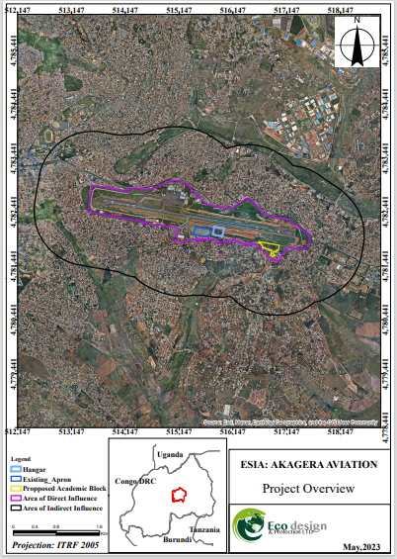
Figure 9: Map showing the site overview.

4.2 Physical Environment

4.2.1 Project site location
The proposed campus site is located in Kicukiro district's Nyarugunga sector, in Nonko and Rubirizi cells, while the hangar site is situated in Kicukiro district’s Kanombe sector, Rwimbogo cell. The project will comprise two key components: a hangar and a campus. The hangar will be located in the landside area of the Kigali International Airport, in close proximity to the south apron of the airport. Specifically, it will be situated 270 meters away from the runway centerline. Access to the hangar will mainly be through a taxiway connecting it to the existing south apron of the airport.
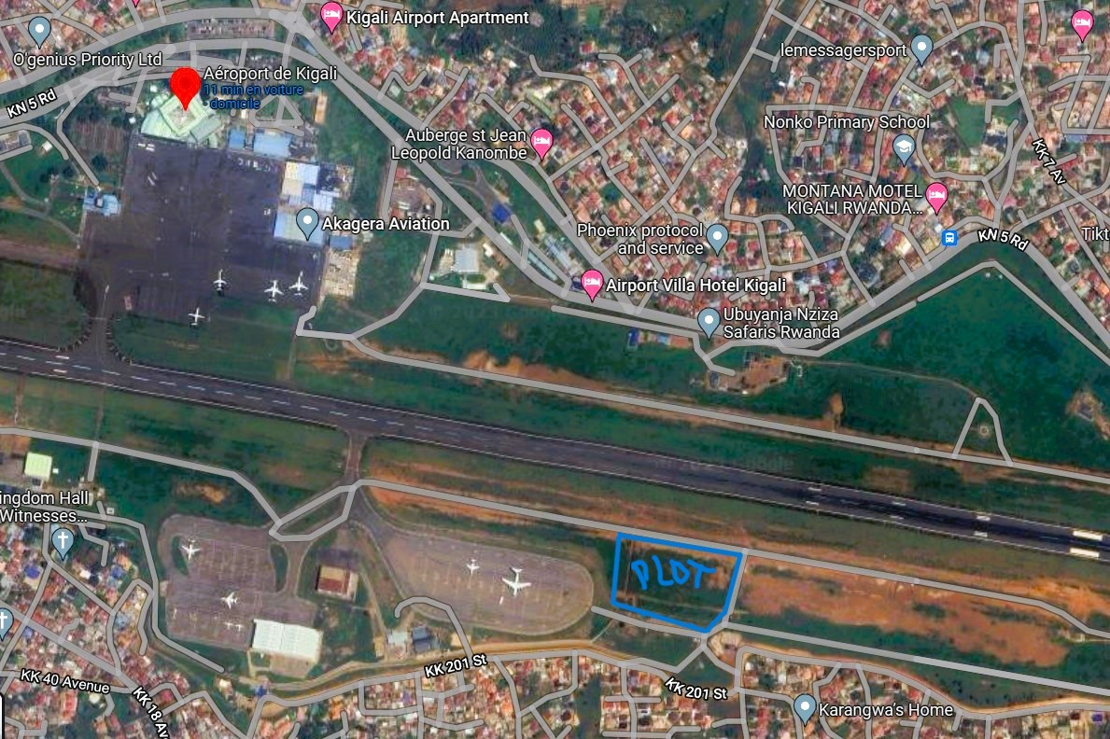
Figure 10: Hangar site location
The campus site will be positioned in the southeastern region of the Kigali International Airport's exterior plot within airport buffer land use.
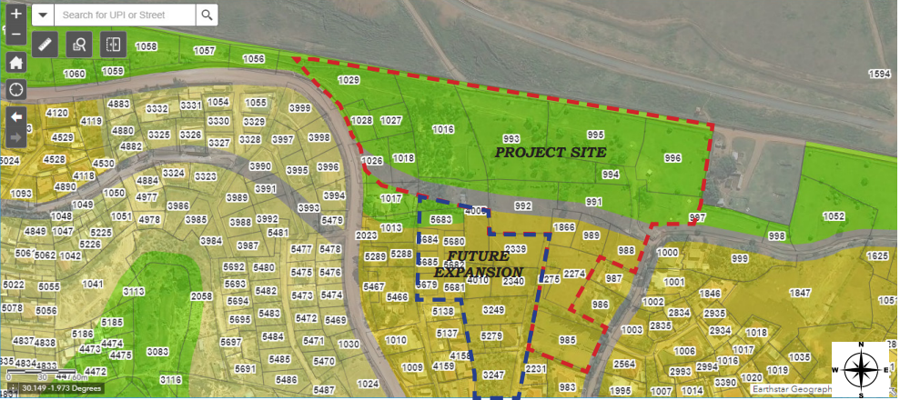
Figure 11: Campus site location

The figure below displays the project sites and various components that are situated in close proximity to the project area. These components are numbered as follows:
1: Proposed Aircraft hangar - this is the area where the aviation hangar is intended to be constructed, and it will be located on the landside area of the Kigali International Airport, adjacent to the south apron of the airport.
2: Proposed Campus - this refers to the location where the aviation training academy will be established, and it will be situated in the southeastern region of the Kigali International Airport's exterior plot.
3: Existing Kigali International Airport Runway - this is the area where the runway of the Kigali International Airport is situated.
4: Akagera Aviation HQ - this component represents the headquarters of Akagera Aviation, which is an aviation company that is located in close proximity to the project area.
5: Existing Apron - this is the section of the airport where aircraft are parked, unloaded, or loaded with cargo, and it is situated adjacent to the area where the aviation hangar will be constructed.
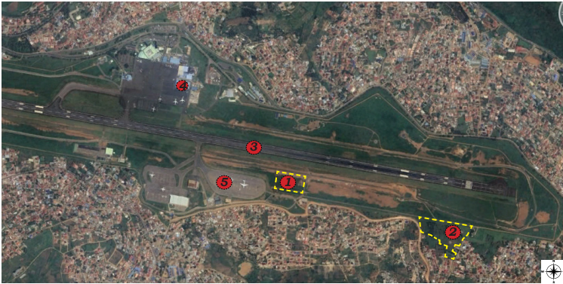
Figure 12: Location of project sites and different surrounding components

4.2.2 Climate and rainfall
Rwanda has a tropical climate characterized by its hilly landscape stretching from east to west. The country has four primary climatic regions: eastern plains, central plateau, highlands, and regions around Lake Kivu. Overall, the country has four climatic seasons represented through the long rainy season: March to May, and short rainy season: September to November. These seasons alternate with the long dry season: June to August, and short dry season: December to February. The warmest annual average temperatures are found in the eastern low lying (20 - 21°C) and Bugarama Valley (23 - 24°C), and cooler temperatures in higher elevations of the central plateau (17.5 - 19°C) and highlands (less than 17°C). The rainy season averages heavy rainfall of about 1200mm per year.

According to the weather data gathered over the past 30 years, the most favorable time to conduct any project activities in Kicukiro district is between January and March, May through September, and December. During these periods, the weather is pleasant with a comfortable temperature and minimal precipitation. The average temperature in Kicukiro is the highest in January, at 79°F, and the lowest in May, at 72°F.
Kigali International Airport experiences a subtropical highland climate, which is characterized by moderate temperatures, distinct rainy and dry seasons, and moderate temperature variations between day and night. The climate is generally comfortable and mild, with heavy rainfall during the rainy seasons and little to no rainfall during the dry seasons. The data presented in the figures below provide information on the average rainfall and temperature at Kigali International Airport.
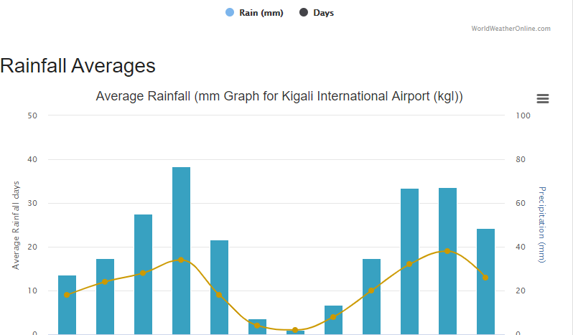
Figure 13: Average Rainfall mm Graph for Kigali International Airport.
Source: World weather online
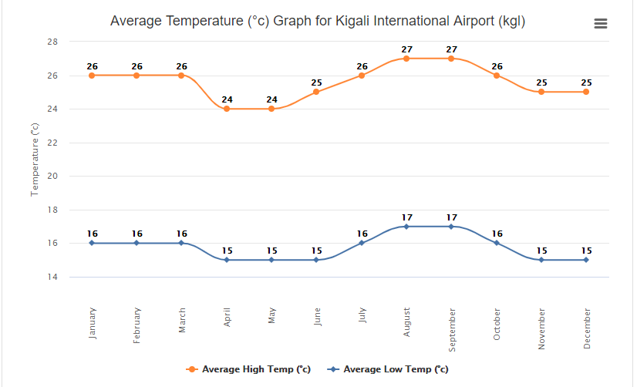
Figure 14: Average Temperature oC Graph for Kigali International Airport.
Source: World weather online

4.2.3 Topography
The proposed project side is on the hillside at elevation between 1415-1429 m above sea level, with slopes of about 8 %. The surroundings of the project site are characterized by a mixture of high mountains with average altitude of 1,800 m mainly located in the rural zone of Kicukiro District (GoR, 2013). The geographic coordinates of the plot are shown in the table below.
Table 2: Geographic coordinates of the plot
Point | X (º) | Y (º) | Z(m)
Northeast | 1º 57' 21.79"S | 30º 09' 31.87"E | 1429
Northwest | 1º 57' 23.93"S | 30º 09' 27.55"E | 1422
Southeast | 1º 57' 24.52"S | 30º 09' 33.14"E | 1421
Southwest | 1º 57' 26.49"S | 30º 09' 28.92"E | 1415

The site is a free land with no development within boundaries and connected to 2 existing roads from the lower and upper side based on topography. The campus site has a steep slope and has two main parts according to the Topography; one part which is flat (on the Top hill) and another part with steep topography which is managed in the design and becomes an opportunity for the center buildings as they are below the level of the KIA runway, therefore the center is not affected by the aircraft sound.
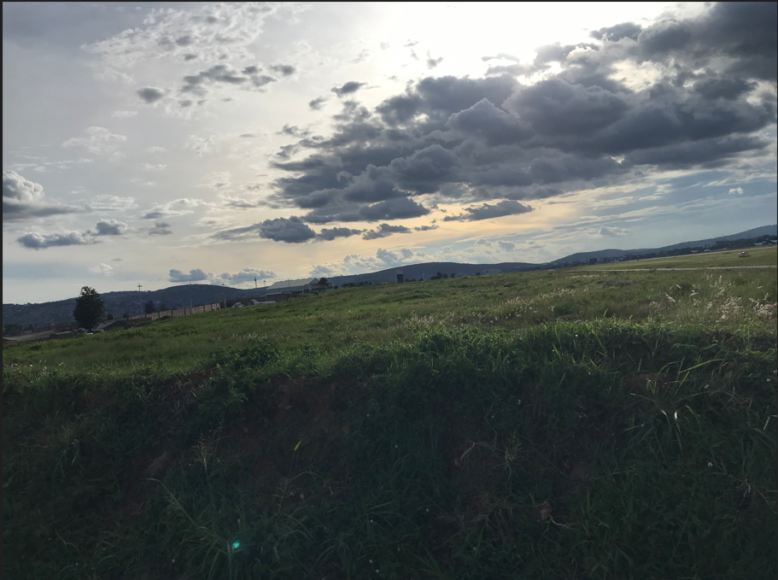
Figure 15: View of the topography within the aircraft hangar project site
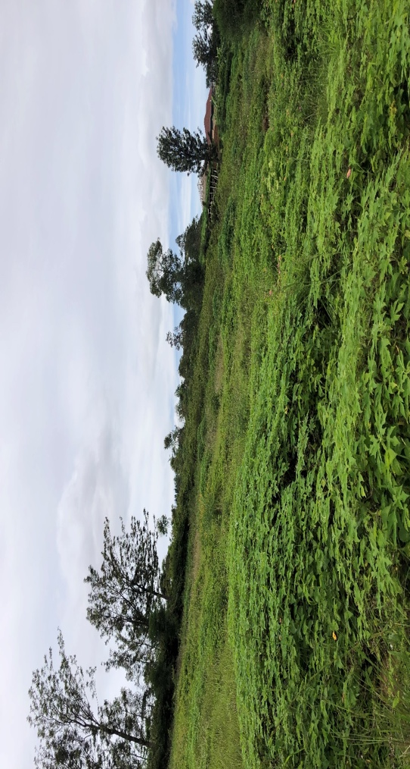
Figure 16: View of the topography at the campus site
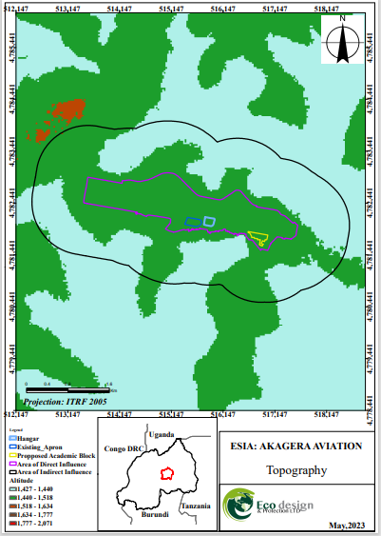
Figure 17: Map showing the topography of the proposed project sites.

4.2.4 Hydrology
Within the larger project area of indirect influence, the wetland present include the Rubilizi, and the Mwanana-mulindi-kanombe wetlands located approximately 0.64 km from the site, which serve as natural water purification systems, play a vital role in preventing flooding in the surrounding areas, and are home to a variety of plant and animal species.
In this context, rainwater from paved areas shall be collected by open / closed drains and discharged to the public storm sewer system which discharges to the Rubirizi wetland.
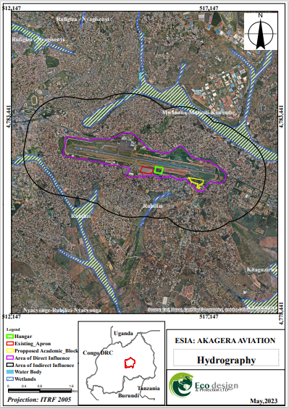
Figure 18: Map showing the hydrology of the project area.

4.2.5 Geology and soils
The City of Kigali is underlain by granitic and meta-sedimentary rocks. The degree of metamorphism undergone by the sediments is generally low. Primary rocks observed in the city are schists, sandstones, and siltstones. The surface of the city is dominated by lateritic soil along the hillsides and alluvial soil along the marshlands. There are four general types of soil found in Kigali: lateritic soils, arkosic sands, colluvium (slope wash) and alluvium (river deposits). The valley of Nyabugogo and Nyaborongo River provide a fertile belt of alluvial soil suitable for agriculture whereas the hilly slopes have undergone soil erosion for a long time, leaving them bare and less productive.

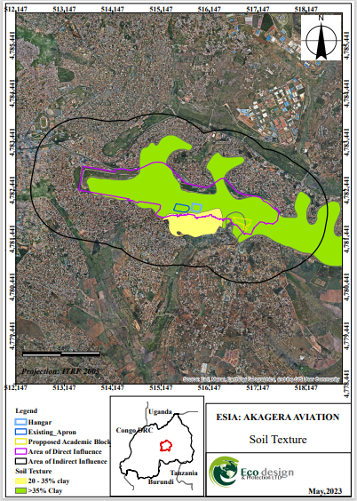
Figure 19: Map showing the types of soil in the proposed project sites.

4.2.6 Ambient air quality
According to an inventory of sources of air pollution in Rwanda (REMA, 2018), the major sources of ambient air pollution is road traffic emissions, emissions from power generation and industrial sources. The results from passive monitoring for NO2 and SO2 show that along KN-5 the main road to Kigali international airport reported a concentration of 84µg/m3 for NO2 and <4.8µg/m3 for SO2. This demonstrates that the high concentration is only located within proximity to the road, clearly demonstrating that vehicles are one of the main sources of pollution in Kigali and that the airport itself is not having a significant impact on NO2 concentrations. As for residential areas in the same area but set away from the road only recorded a concentration of 24µg/m3 for NO2 and <4.8µg/m3 for SO2. These findings reflect the ambient air quality in the surroundings of the proposed CEAS project site.

4.2.7 Ambient noise level
Due to the increasing urbanization and population growth, noise pollution continues to worsen and poses a severe risk to public health. This is especially concerning in developing countries like Rwanda. Airports such as the Kigali International Airport can be noisy places due to the high levels of activity, including the takeoff and landing of planes, ground handling, and airport operations. The noise generated by aircraft engines can be particularly loud, and this can be a concern for people living near airports. The noise level of Airbus A320 and Boeing 737-800 type aircraft, which are widely used in the medium category all over the world, is around 93-94 decibels.

4.2.8 Seismic activity
According to the National Risk Atlas of Rwanda, for earthquake hazard, the study revealed that Rwanda could have potential intensity varying from MMI V to MMI VII based on two scenarios of 2475-year and 475-year return periods. According to the below hazard zonation map, Kicukiro district falls in the moderate zone of V MMI range.
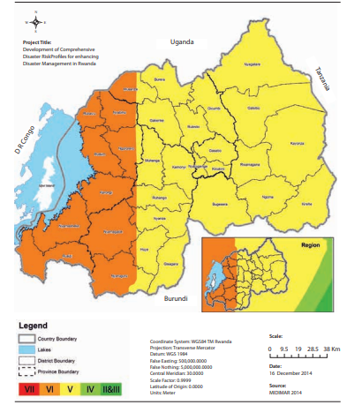
Figure 20: Earthquake hazard zonation map at 10% probability of exceedance in 50 years

4.2.9 Land cover
Aircraft hangar site
The proposed location for the aircraft hangar is mostly covered by natural vegetation, mainly grass on a flat landscape. It is located close to various existing features, including an apron for aircraft parking, a WASAC water tank that serves as a reservoir for airport facilities, and taxi lanes that connect the hangar site to critical areas like the runway and terminal buildings. Additionally, the site's boundaries are approximately 189 meters away from the centerline of the current runway. Many weather and other utility instruments for the airport are also in the vicinity of the hangar site.
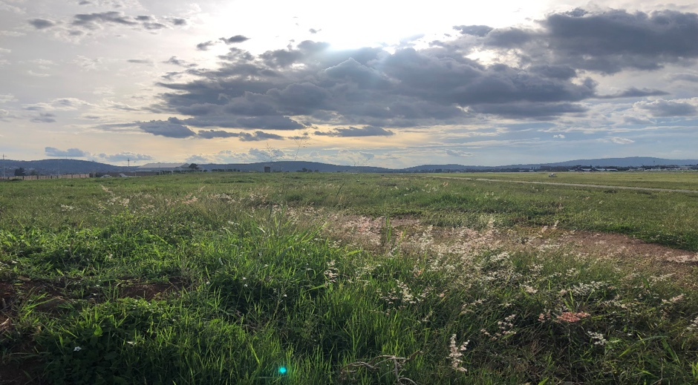
Figure 21: Land cover of the aircraft hangar site
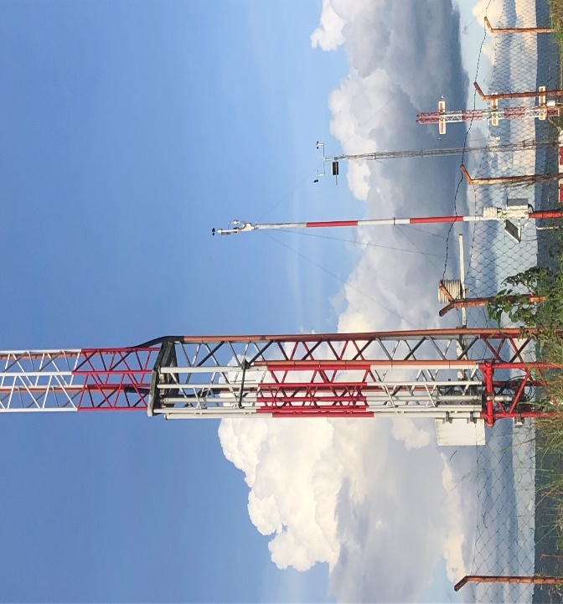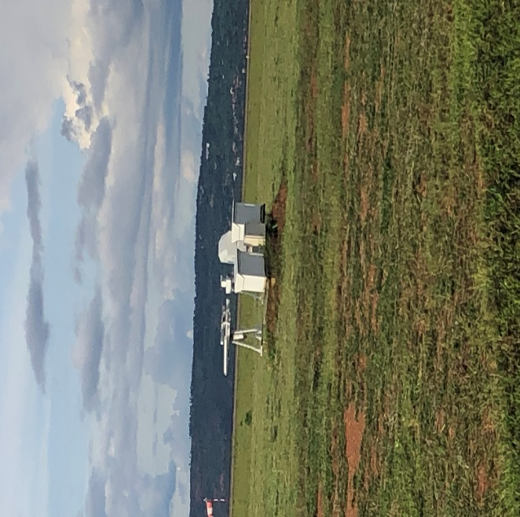
Figure 22: Instruments in the vicinity of the aircraft hangar site
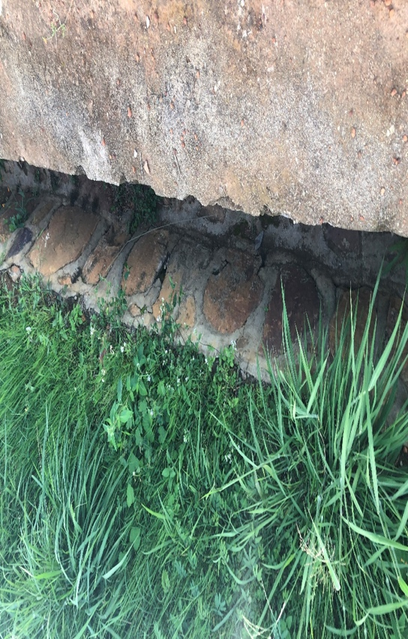
Figure 23: Drainage structures next to the aircraft hangar site
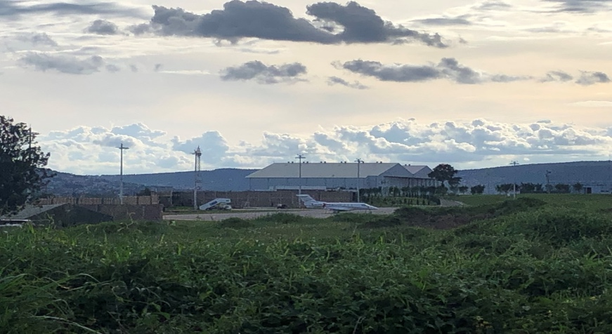
Figure 24: Existing apron next to the aircraft hangar site
Campus
The suggested site for the campus is located just outside the airport's boundaries. The land on this site has a steep slope and is mostly covered with vegetation, including grass, as well as tall standing trees.
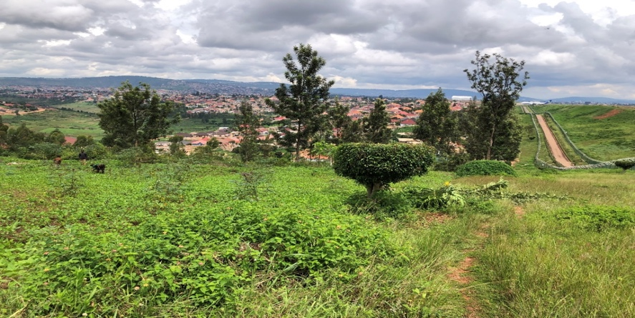
Figure 25: Land cover of the proposed campus site
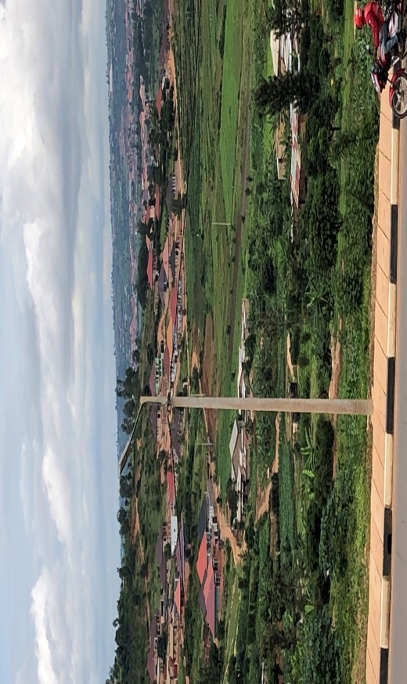
Figure 26: Utilities that are present in the vicinity of the campus site
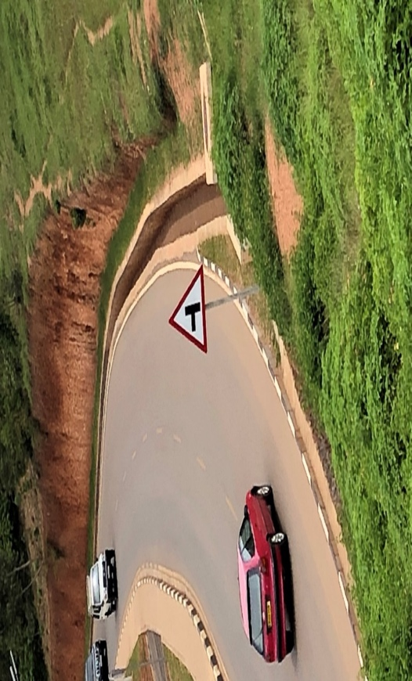
Figure 27: Drainage structures beneath the proposed campus site
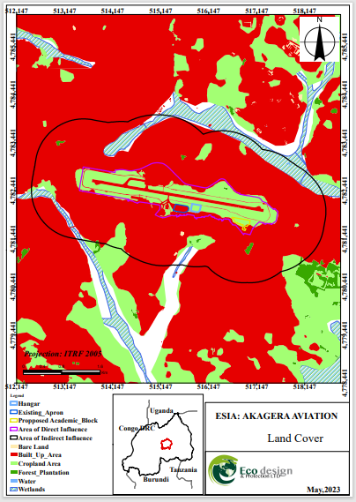
Figure 28: Map showing the land cover of the proposed project sites

4.3 Biological Environment

4.3.1 Flora
The natural vegetation in Kicukiro district has been largely replaced by smaller plants, with eucalyptus trees being the most common. However, some wild plants can still be found in marshes and uncultivated areas. The district has a diverse flora that includes both native and introduced species such as jacaranda, mango, banana, hibiscus flowers, bougainvillea flowers, acacia, cassava, coffee, sweet potatoes, and eucalyptus trees. In the larger project area, shrubs and rainfed herbaceous crops are the main types of crops that can be grown.
The proposed location for the aircraft hangar is mostly covered by natural vegetation, which is mainly grass growing in a flat landscape. On the other hand, the vegetation found at the campus site consists of grass mostly Digitaria Abyssinia (East African couchgrass) and Melinis repens (Natal grass), as well as tall standing trees such as Mangifera indica (mango), Grevillea robusta (silk oak), Lantana camara (common lantana), Clerodendrum johnstonn (bag flower), Jacarands mimosifolia (jacaranda).
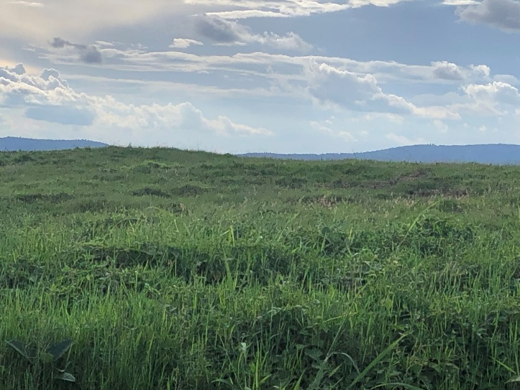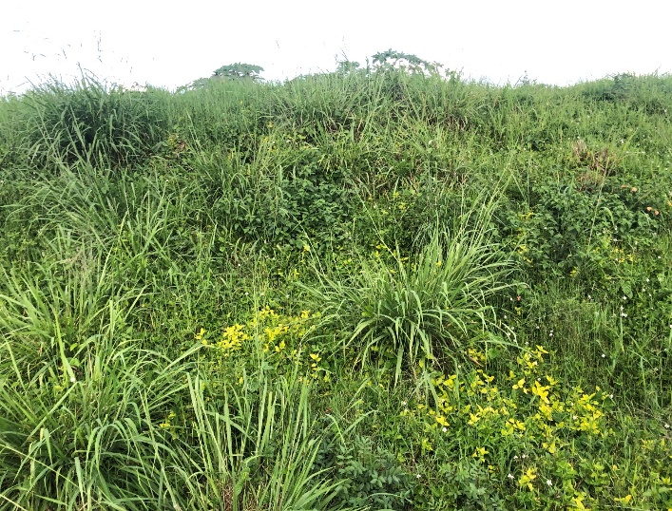
Figure 29: Flora present on the proposed aircraft hangar site
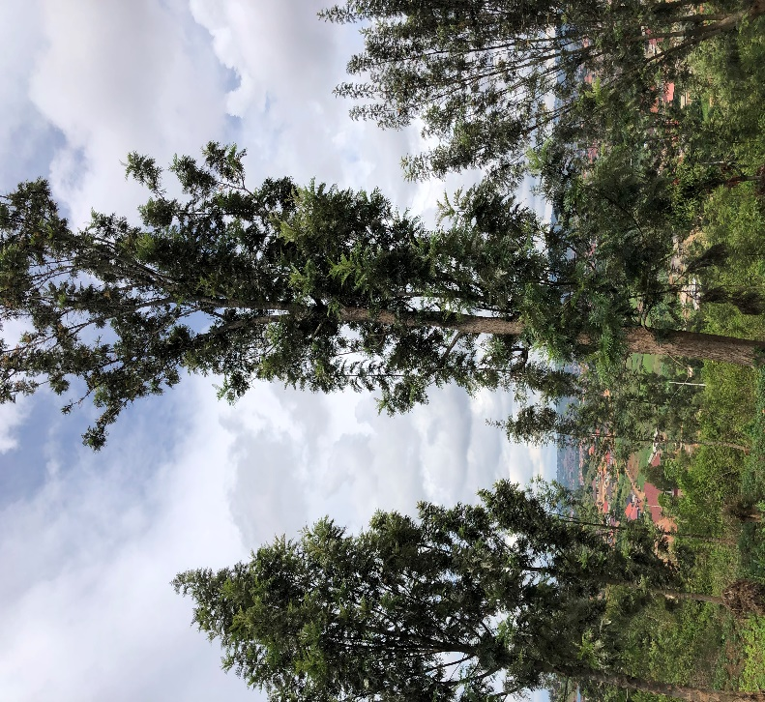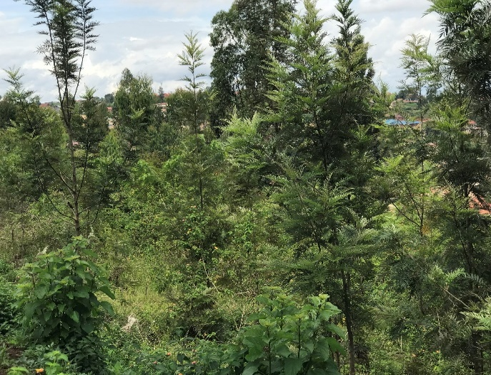
Figure 30: Flora present on the campus site
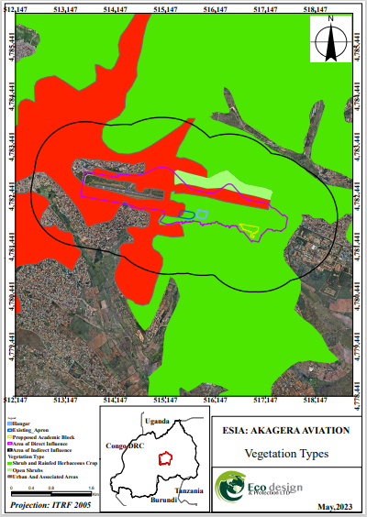
Figure 31: Map showing the vegetation type of the proposed project sites

4.3.2 Fauna
According to the KIA Wildlife Hazard Management, within the Kigali international airport, the following bird species are present within a 13km radius. These include black kite (Milvus migrans), black-headed heron (Ardea melanocephala), house martins (Delichon urbica), owl (Strigidae), ibis, yellow billed stork (Mycteria ibis), plover (masked lapwing), common kestrel (Falco tinnunculus), african mash harrier (Circus ranivorus), pigeon (Columba livia), long crested eagle (Lophaetus occipitalis), grey crowned crane (Balearica regulorum), marabou stork (Leptoptilos crumeniferus), hooded vulture (Necrosyrtes monachus), african Hawk-eagle (Aquila spilogaster), pied crow (Corvus albus), hamerkop (Scopus umbrette), swallow (Hirundo rustica), and bishop (Ploceidae).
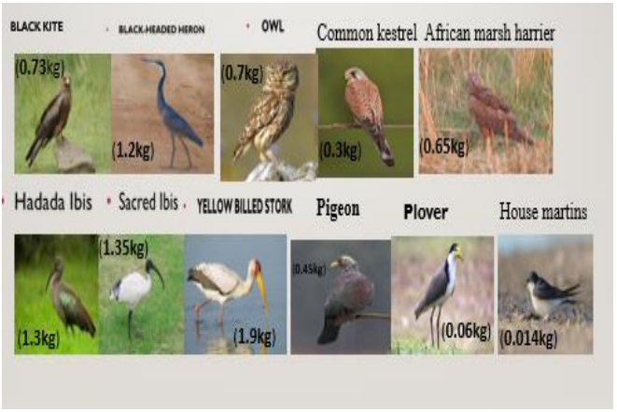
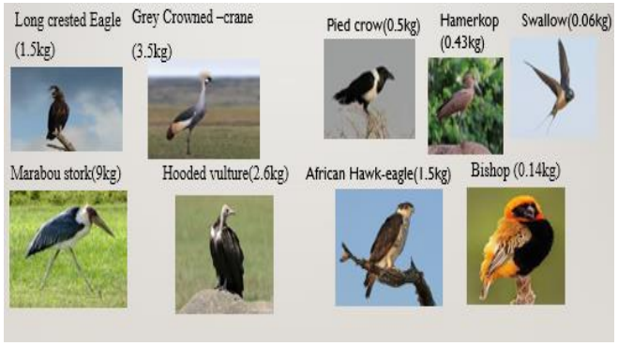
Figure 32: Bird species present at KIA.
Source: KIA Wildlife Hazard Management, 2023
According to KIA Wildlife Hazard Management, mammal species found at KIA include stray dogs, cats, side-striped Jackal, monkey.

4.3.3 Sensitive ecosystems
Sensitive ecosystem is defined in this study as fragile and rare ecosystem within the area. Kicukiro district is located in the Eastern Province of Rwanda and is known for its diverse ecosystems that are home to a variety of plant and animal species. Some of the sensitive ecosystems in Kicukiro district include Masaka wetlands, Nyandungu wetlands, Rwandex wetlands, Rufigiza-Nyagisenyi wetlands. Narrowing down to the proposed project sites, within the larger project area of indirect influence, the wetland present includes the Rubilizi, and the Mwanana-mulindi-kanombe wetlands, which are located at approximately 0.64 km from the site.
These wetlands serve as a natural water purification system and play a vital role in preventing flooding in the surrounding areas. They also play an important breeding ground for fish and provide a natural habitat for several bird species.
Construction activities and increased surface runoff may alter drainage patterns and introduce sediments or pollutants into these wetlands, potentially affecting their water purification, flood control functions, and ecological integrity, if not properly managed. Protecting these sensitive ecosystems is thus critical to maintaining the biodiversity of the area and ensuring the well-being of the local communities that depend on them.

4.4 Socio-Economic Environment

4.4.1 Population and Demography
According to the fifth Rwanda Population and Housing Census (RPHC5), which took place in August 2022, the population of Rwanda was 13,246,394. This figure shows that there was an annual growth rate of 2.3% between 2012 and 2022. The province with the highest level of urbanization is the City of Kigali, with 86.9%. When looking at specific Districts, Gasabo in the City of Kigali has the largest population, while Kicukiro is the most densely populated District in the country. the total population of Kicukiro District was 491,731; with male population being 249,115 and female population 242,616. The population density of the district is 2,944. Given the high population density of Kicukiro District, the proposed development is expected to create employment opportunities for local residents during construction. However, the temporary influx of workers may place additional pressure on local services if not properly managed.

4.4.2 Economic activity and livelihood
The fifth Rwanda Population and Housing Census (RPHC5) provides data on the distribution of employed individuals based on the branch of economic activity they are engaged in, excluding those involved in subsistence agriculture. The census indicates that the majority of employed individuals are involved in market-oriented agriculture, accounting for 53.4% of the total employment. The next significant branches of economic activity are trade, construction, manufacturing, transportation and storage, each employing less than 10% of the total employed population. The remaining branches of economic activity individually make up less than 4% of total employment. According to EICV5, the overall working to population ratio of Kicukiro district is 71.9%. The main usual job status of workers in Kicukiro district shows that 66% are employed in non-farm wage jobs, while 8.5% work as independent farmers, and 18.9% work as independent non-farmers. Additionally, 3.7% work in wage farm jobs and 2.9% are unpaid non-farmers.
The majority of workers in the district are engaged in the service sector (166), followed by industry (46), and agriculture (53). The working age population in Kicukiro district of male and female is 137 and 136 respectively. Men work on average 51 hours per week, while women work on average 47 hours per week. Kicukiro district has a well-developed financial sector, with most banks, microfinance institutions, and insurance companies having branches in the area. Almost all adults in the district (97%) are included in the financial sector.
In this context, the proposed project is expected to generate short-term and long-term employment opportunities, particularly in construction, services, and support activities. The availability of a relatively skilled and financially included workforce in Kicukiro District increases the potential for local recruitment, thereby contributing to household incomes and supporting local livelihoods.

4.4.3 Poverty
The fifth Integrated Household Living Conditions Survey (EICV5) shows that poverty and extreme poverty rates in Kicukiro district are lower than the national averages. The poverty rate in Kicukiro district is reported at 11.4%, with an extreme poverty rate of 3.5%. This indicates that poverty reduction efforts in the district have been relatively successful, though more work needs to be done to address the root causes of poverty and ensure sustainable development. The proposed project is expected to support poverty reduction by creating employment opportunities during both construction and operation, thereby increasing household incomes. In addition, the associated student population will stimulate local businesses and services, contributing to the local economy.

4.4.4 Education
Kicukiro district hosts numerous schools that cater to the educational needs of the local community. The educational sector in Kicukiro district has played a vital role in promoting literacy and education access to the local community. In this context, the establishment of the proposed CEAS will complement the existing education system in Kicukiro District by introducing a tertiary institution focused on professional aviation skills development. The project will enhance access to specialized training for Rwanda and the region, support human capital development in the aviation sector, and strengthen the district’s role as an educational and skills hub.

4.4.5 Land use
Based on the Kigali Master Plan 2020, the proposed site for the hangar project is located inside the Kigali international airport and the Aviation training center project site is within the airport buffer zone.

4.4.6 Infrastructure
The data presented is taken from the 2022 Fifth Population and Housing Census in Rwanda and a socio-economic survey done specifically for households in the project location.

4.4.6.1 Energy
At present, airport facilities rely on REG, the national grid, to supply power for lighting purposes. However, there is already a transformer situated within the airport premises which helps to reduce the reliance of the facilities on the public power distribution system. Any cooking facilities will be consistent with local urban energy patterns, minimizing additional pressure on the national grid and supporting efficient energy use.

4.4.6.2 Water availability
Currently, within the airport premises, there is a water reservoir that functions as the airport's water supply and distribution system. It guarantees a continuous water supply to the airport independently, without relying on the public water distribution line.
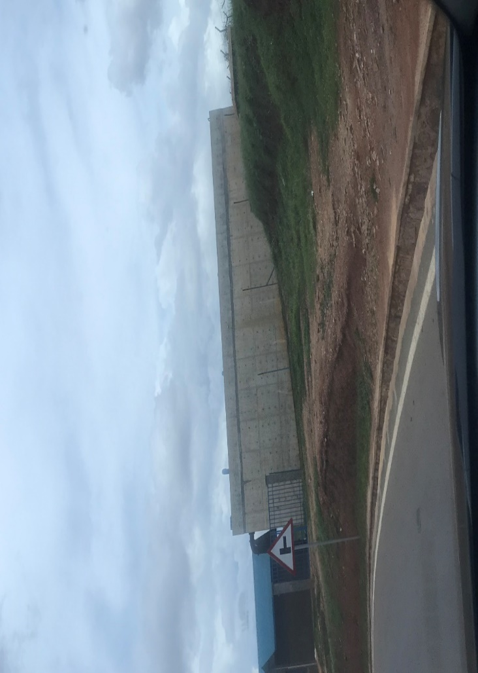
Figure 33: WASAC water tank next to the proposed aircraft hangar site.

4.4.6.3 Waste management facilities
Solid waste management
In Rwanda, the main modes of solid waste disposal used by the private households are the compost dumping (more than half), thrown in the household's fields or bushes (around a third) and Waste collection companies (one out of ten). As for Kicukiro district, private households dispose of waste by the following modes: 4.1% through public compost dumping, 15.1% through household compost dumping, 58% through waste collection companies, 21.7% throw in the household’s fields or bushes, 0.2% burn their wastes, 0.1% dispose in a river/ stream/ drain/ gutter/ lake, 0.7% by other modes, 0.3% not shared.
Liquid waste management
According to the 5th RPHC, in Rwanda, the private households use several modes of sewage disposal. The main ones are disposal in the courtyard (45%), bush (19%), Cesspool (18%), Sump (8%), and Main sewer (6%), while other modes of sewage disposal (Rivulet/Trench/Channels, street,) are used by less than 5% of the households. As for Kicukiro district, the distribution (%) of the private households by main mode of sewage disposal is as follows: 6% in the sump, 12.8% in the courtyard, 1.1% in the rivulet/ trench/ channels, 0.9% in the street, 8.4% in the main sewer, 59.4% in the Cesspool, 4.8% in the bush, 0.6% by other means.
Narrowing down to the proposed hangar site, the site is within the existing Kigali International Airport, which has a comprehensive waste management system and procedures. The proposed CEAS will integrate with the airport’s existing solid and liquid waste management systems, ensuring proper collection, treatment, and disposal. This aligns with Kicukiro’s high reliance on organized waste services and minimizes environmental impacts.

4.4.7 Traffic trends
The KMPU Interim Master plan traffic report utilized traffic counts to identify the highest volume of traffic during peak hours in the morning and afternoon. This information was then used to evaluate the capacity of intersections. Specifically, in the Kigali International Airport (KIA) area, where the proposed project will be located, five intersections along the KN5 major arterial road leading to the airport were studied. The report recorded peak traffic periods during the morning and afternoon. The following peak periods were observed:
- The peak period for intersection 1 (KK103 St/ KK 5 Ave) occurred between 06:45 AM and 07:45 AM as well as between 17:00 PM and 18:00 PM. The highest volume occurs at 07:30 AM and 17:15 PM.
- The peak period for intersection 2 (KN5/KK3) occurred between 06:45 AM and 07:45 AM as well as between 17:00 PM and 18:00 PM. The highest volume occurs at 07:30 AM and 17:30 PM.
- The peak period for intersection 3 (KN5/ KG109) occurred between 06:45 AM and 07:45 AM as well as between 17:00 PM and 18:00 PM. The highest volume occurs at 08:15 AM and 18:00 PM.
- The peak period for intersection 4 (KN3/KN5) occurred between 07:15 AM and 08:15 AM as well as between 17:00 PM and 18:00 PM. The highest volume occurs at 08:00 AM and 18:00 PM.
- The peak period for intersection 5 (KN 5/ KG1) occurred between 07:30 AM and 08:30 AM as well as between 17:00 PM and 18:00 PM. The highest volume occurs at 08:15 AM and 18:00 PM.
It is important to analyze traffic patterns on roads that lead to the airport, as this information is crucial in determining how any future development in the area may contribute to the existing traffic flow.
The proposed CEAS will generate additional traffic during both construction and operational phases, primarily from staff, trainees, and service vehicles. By considering existing peak traffic periods along KN5 and surrounding intersections, the project can plan access and scheduling to minimize congestion, improving overall traffic management and maintaining efficient connectivity to the airport.

5.0 PROJECT ALTERNATIVES

5.1 Introduction
This chapter examines project alternatives, defined as different approaches to achieving the project’s objectives, ranging from minor modifications to complete redesigns. It presents the environmental and social justification for the alternatives considered for the CEAS project, along with the criteria used to assess their significance and the reasons for selecting the preferred option. Recognizing that project activities from site clearance to construction and operation may generate impacts, the section evaluates each alternative based on environmental and social effects, costs, compatibility with local conditions, and alignment with institutional and training needs, with the aim of identifying options that minimize adverse impacts.

5.2 Alternatives for Site Location
The CEAS project will be located in Kicukiro District, Nyarugunga Sector, with the hangar positioned within the landside area of Kigali International Airport and the campus situated in the airport’s buffer zone. This location was the only viable alternative considered due to the need for direct connection to airport operations and facilities such as the runway. The selected site is suitable as it aligns with existing land use, is close to related infrastructure, and supports efficient aircraft services. Alternative locations were not feasible due to potential disconnection from airport functions, lengthy land acquisition processes, limited availability of suitable land, and Rwanda’s predominantly hilly terrain, which makes it difficult to find flat, elevated areas appropriate for aviation infrastructure.

5.3 Alternatives for Facilities’ Design

Two design concepts have been explored thus far for the aircraft hangar and campus facilities. The initial design of the aircraft hangar as shown in the figure below consisted of a mono pitch roof that would be associated with issues such as expensive roof structure, lack of ridge cap ventilation and high maintenance; the metallic cladding would be associated with high maintenance, overheating and greenhouse effect, high embodied energy and not durable; the front road fencing would be associated with obstruction of views and natural light at the ground floor and unnecessary additional project cost; and the office façade would as well be associated with exposed glazing attracting direct solar penetration and heat gain, and wide plastered and painted wall surfaces attract high maintenance costs.
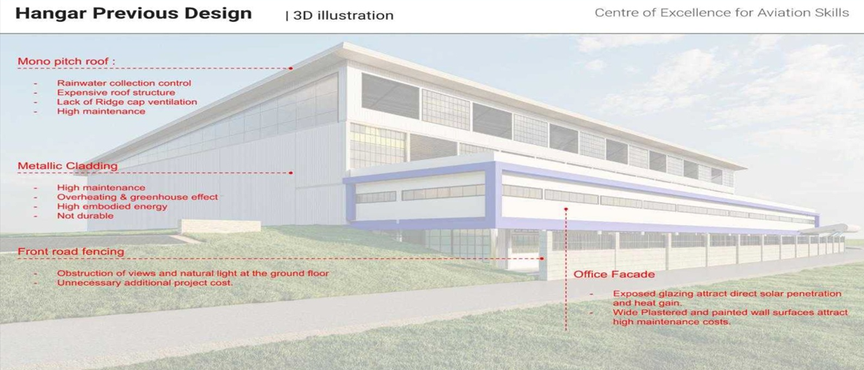
Figure 34: Aircraft hangar previous design concept
The new hangar design illustrated below incorporates eco-friendly and cost-efficient materials and structures. The new roof design include improved multi-pitch roof design to allow ventilation and lighting clerestories, roof structure to minimize use of steel, ridge caps vents and roof vents, and use of light weight fiber roof panels to reduce weight and maximize maintenance; the new materials design includes use of insulated cladding materials and polycarbonate translucent cladding panels for increased natural lighting; the facades and shading includes offices having a shading screen to reduce direct solar penetration southeast and south west.
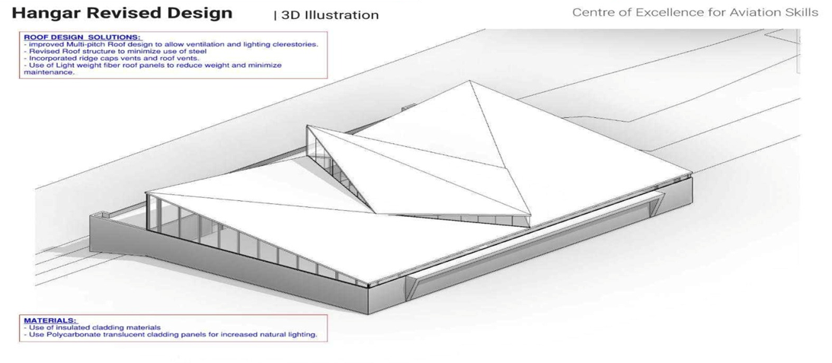
Figure 35: Aircraft hangar new design concept
The new design of the campus successfully balances cost efficiency, functional integration, regulatory compliance, and sustainability. By leveraging natural topography and integrating green building technologies, the facility sets a benchmark in environmentally responsible and innovative aviation education infrastructure. The following figures show a comparison of the previous and new CEAS design respectively.
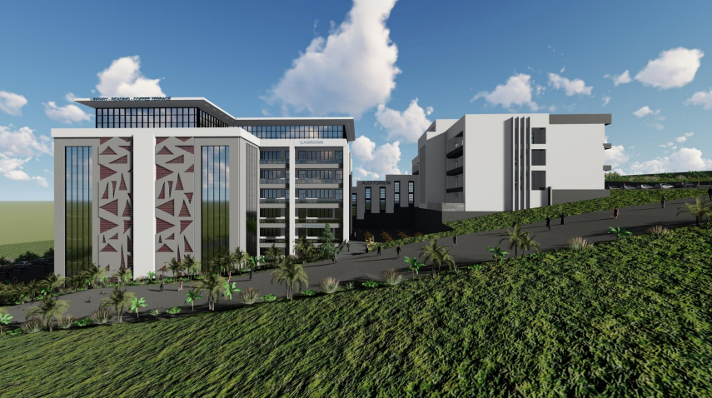
Figure 36: Campus previous design concept
Figure 37: Campus new design concept
These new design concepts align with the developer’s vision and ensure long-term operational efficiency and environmental stewardship. It focuses on energy efficiency, water conservation, material efficiency, indoor environmental quality, and climate resilience, to minimize environmental impact and create a healthy, cost-effective, future-proof facility. The green building highlights key achievements of 20.71% energy savings, 64.71% water conservation, 43.00% material efficiency, and net carbon emissions of -163.9 tCO2e/year.

5.4 Alternatives for Waste Management
The CEAS project adopts a sustainable waste management strategy addressing both wastewater and solid waste across its two separate sites (hangar and academy). Due to distance and capacity constraints, the option of connecting the hangar to the existing Kigali International Airport wastewater treatment plant was deemed impractical and costly; therefore, dedicated wastewater treatment plants will be established at each site as the most feasible solution. During construction, temporary ecosan toilets will be used to minimize environmental impact through water conservation and composting potential. For solid waste, a source-segregation approach will be implemented, with labeled bins for different waste streams, including e-waste. Waste management will be overseen by the project team, with licensed entities responsible for transporting waste to the Nduba dumpsite, while organic waste will be composted and non-organic waste directed toward recycling and reduction. This approach ensures efficient, compliant, and environmentally responsible waste management.

5.5 Alternative for Power Supply
To meet the electricity demand of the proposed aircraft hangar and campus facilities, two alternatives were considered. The first option involves connecting both the hangar and campus to the existing KIA substation. The second option involves connecting only the hangar to KIA's substation, while the campus connects directly to the public electricity supply system from REG. Based on cost, reliability, technical feasibility, and environmental considerations, alternative 1 of connecting both facilities to the KIA substation was selected as the most viable option. It provides a stable and cost-efficient power supply while allowing for the integration of renewable energy solutions to enhance sustainability.
Alternative 1: Connection of both facilities to the existing KIA substation (preferred option)
This option involves connecting both the aircraft hangar and the campus to the existing Kigali International Airport (KIA) substation. To enhance reliability, a dedicated transformer will be installed near the hangar to prevent voltage drops and overloading of the public electricity grid. Additionally, backup diesel generators will be deployed, housed in soundproof enclosures near the hangar to minimize noise pollution and avoid lengthy distribution cables. Although relying on municipal electricity contributes to resource consumption and potential emissions, this option will incorporate solar energy solutions to improve sustainability. A grid-tied photovoltaic (PV) system will be installed on the hangar, allowing for grid supplementation and potential energy export, while the campus will implement a hybrid solar system with battery storage to ensure continuous power availability. The on-site PV system will offset 60% of annual energy use.
Alternative 2: Separate power connections for the hangar and campus (not preferred)
The second alternative proposed connecting the hangar to the KIA substation while the campus would receive power from the public electricity grid supplied by REG. While technically feasible, this option was deemed less cost-effective due to increased infrastructure costs, including additional distribution lines and metering systems. Moreover, reliance on two separate power sources could introduce voltage fluctuations and inefficiencies, particularly during peak demand periods. This alternative would also require separate backup generators for both facilities, increasing operational costs and maintenance requirements. Environmental considerations also factored into the decision, as a dual-supply approach would lead to higher dependency on non-renewable energy sources without an integrated sustainability strategy. The campus, if connected directly to the public grid, would have limited flexibility in adopting renewable energy solutions without further technical modifications.

5.6 Alternative for Water Supply
The CEAS project facilities will rely on a highly efficient and sustainable water supply system as the sole alternative considered. This system integrates multiple water-saving measures, including low-flow fixtures, rainwater harvesting, wastewater treatment, and condensate water recovery, to optimize water consumption and minimize waste. A rainwater harvesting system will supply water for non-potable uses such as toilet flushing, cleaning, and fire suppression, significantly reducing reliance on external sources. Additionally, a wastewater treatment and recycling system will treat wastewater generated on-site, ensuring its reuse for irrigation. To enhance monitoring and efficiency, smart water meters will track real-time consumption and detect leaks or inefficiencies. While this sustainable water management approach will form the core of the project's supply strategy, water will also be sourced from the municipal WASAC to meet water needs. This integrated system ensures responsible water use while minimizing dependency on municipal water supplies.

5.7 The “No project” Alternative
The zero alternative for the purposes of the assessment is the situation where the project does not proceed. Under the zero alternative for the project there are no adverse environmental or social impacts as there is no construction or operation of the Project. However, this would need to be balanced against the fact that there would also be no beneficial impacts associated with the project not being implemented such as to empower labor in aviation industry by providing qualifications in the field to serve local (Rwanda) and regional needs as well as provide shelter for fixed wing, rotary wing, maintenance/engineering and other technical aircraft activities.
This option was not considered viable because:
- This would mean no job creation: At the stage of construction, the prospects of employment of skilled and unskilled labor for masons, draftsmen, drivers, mechanics, engineers would be lost.
- Income to government: Income in the form of taxes to the government from the increased profits will not be realized.
- The area will not open quickly to other investments, which will also be a source of employment for the locals.
- Income source for over 1000 workers during construction and 98 workers during operations, cost efficient local construction material for all types of construction projects, payments made for the energy and water consumed are all sources of income and revenue to the Government that could be lost if this option of doing nothing was taken.

Already a considerable financial commitment has been made to the feasibility and environmental studies, as well as the development of architectural plans and related designs. In case the project is not implemented, all the participants such as the designers, the local and national authorities, the contractors, materials suppliers, and the workers in the development chain will lose economic gains that would have otherwise been realized during the project life.

6.0 EVALUATION OF IMPACTS/RISKS AND MITIGATION/ENHANCEMENT MEASURES

6.1 Introduction
"An impact" can refer to any alteration to the current state of the environment that results from human actions or an external factor. High-level categories of project receptors that may be affected adversely or beneficially can be identified as environmental (such as air quality, waterbodies, landscapes, terrestrial soils, and geology); biodiversity (such as habitats, species etc.); social (such as residents of local communities, businesses, land and other resource users, and cultural heritage resources).
Impacts therefore may be positive/beneficial or negative/adverse. They may also be direct or indirect, long-term, or short-term, and extensive or local in effect. The identification of the impacts is categorized as primary impact (where the construction and operation works will be concentrated i.e., within the boundaries of the aircraft hangar site and the campus site); secondary impact (the off-site activities such as borrowing sites, quarries, and other sources of material such as water, sand, murram, excavation, waste disposal, camp site, location for accommodation of personnel, equipment, and storage of materials).
When impacts build upon one another, they are said to be cumulative. The construction and operation of the CEAS, as well as other auxiliary facilities, could result in positive or negative environmental effects. To assess the potential impacts of the proposed project, the consultant used various techniques and tools to identify both the positive and negative impacts and evaluate their significance. The analysis included examining severity, intensity, nature, extent, magnitude, and duration of the potential impacts, as well as the sensitivity and vulnerability of the affected environment. By using this approach, the consultant was able to assess the impacts and recommend mitigation measures to address them.

6.2 Project categorization
Each component of the proposed project was screened for E&S risks at the project conceptualization stage. There are risks specific to the operation of the project which include noise pollution, and the handling of hazardous materials, occupational health and safety issues, and community health and safety issues, to mention a few. Construction works of the proposed project and auxiliary facilities posing environmental risks involve major civil works which will result in temporary and highly localized adverse impacts and occupational safety concerns. Such works have the potential for adverse temporary and site-specific environmental impacts. As a result, the proposed CEAS project was classified as a project likely to cause less adverse environmental and social impacts, category 2 per AfDB OS1, as well as IL2 per national EIA guidelines.

6.3 Methodology of evaluating impacts

6.3.1 Criteria for evaluating the significance of impacts.
The impact may be positive or negative. A positive impact generates an improvement of the component of the environment affected by the project, while a negative impact contributes to its deterioration. Impact is evaluated based on the criteria defined below.

6.3.1.1 Duration of an impact
Impact can be described as temporary or permanent. A temporary impact may be spread over several days, weeks or months, but must be associated with the notion of reversibility. While a permanent impact has a character of irreversibility is observed permanently or long term. The evaluation of the frequency or recurrence of the anticipated impact also contributes to better defining the notion of duration.

6.3.1.2 Extent of the impact
The extent of the impact of action refers to the environmental or spatial extent of its impact. It may be specific, local, or regional. To some extent, it is independent of the limitations of the study areas that have been identified for this project.
A regional scope relates generally to a vast territory with a geographical structure and / or administrative which is defined and perceived by a population, or who may be from natural components of the environment found there (e.g., ecological district which includes large similar physiographic features).
Local scope refers, in turn, to a portion of smaller territory, a particular ecosystem at a given administrative entity or an environmental dimension that is perceptible as part of a regional population.

6.3.1.3 Intensity of impact
The intensity of the impact depends on the extent of the changes observed on the component affected by a project activity or disturbances that result. Thus, a low intensity is associated with an impact causing only slight modifications to the target component; do not question its use or features.
Finally, an impact is qualified high intensity when bound to very significant changes in a component. For the biological environment, high intensity is the destruction or alteration of an entire population or a high proportion of the size of a population or habitat of a species. About the human environment, negative intensity is considered strong if the disturbance affects or limits irreversibly the use of a component by a community or population, or whether its functional and safe use is severely compromised.

6.3.2 Assessment of the significance of the impact
The outcome of an overall assessment, which concentrates on the impact of a project activity compared to a component of the receiving environment and is based on the criteria outlined above, is the significance of an impact. Four major classes are used for this purpose: negligible, minor, moderate, or major. Significance is determined by a construction which combines the criteria described in 6.3.1, this is to say the value of the affected part, the duration of the impact, the extent and intensity of the disturbance that it generates on the environment, all put into perspective by one or specialist (s) in the field. The table below shows the grid for determining the overall significance of an impact.
Table 3: Project impacts assessment
Intensity | Extent | Duration | Significance of impact
 |  |  | Major | Medium | Minor
Strong | Regional | Permanent | ×
Strong |  | Temporary |  | ×
Strong | Local | Permanent | ×
Strong |  | Temporary |  | ×
Strong | Punctual | Permanent |  | ×
Strong |  | Temporary
Medium | Regional | Permanent | ×
Medium |  | Temporary |  | ×
Medium | Local | Permanent |  | ×
Medium |  | Temporary |  |  | ×
Medium | Punctual | Permanent |  | ×
Medium |  | Temporary |  |  | ×
Weak | Regional | Permanent |  | ×
Weak |  | Temporary |  |  | ×
Weak | Local | Permanent |  | ×
Weak |  | Temporary |  |  | ×
Weak | Punctual | Permanent |  |  | ×
Weak |  | Temporary |  |  | ×

Risk assessment is used to relate the impact assessment using a stipulated assessment criterion whereby impacts area identified and given a rating or weighting and obtaining an overall rating or significance of an impact) and risk management (relating directly to applicable mitigation measures to be implemented to manage a risk of an impact in the best interest of a society; Schogren, 1990). The guideline criteria followed in this study are presented in the table below.
Table 4: Impact Significance with criteria assessment and ratings
Nature or Status of the Impact: The type of effect the activity would have on the environment
Status | Description
Positive: | a benefit to the holistic environment
Negative: | a cost to the holistic environment
Neutral: | no cost or benefit
Duration of the Impact: The lifetime of the impact
Score | Duration | Description
1 | Short term | Less than 2 years
2 | Short to medium term | 2 – 5 years
3 | Medium term | 6 – 25 years
4 | Long term | 26 – 45 years
5 | Permanent | 46 years or more
Extent or Scale of the Impact: The distance from source that impacts may be experienced
Score | Extent | Description
1 | Site specific | Within the site boundary
2 | Local | Affects immediate surrounding areas
3 | Regional | Extends substantially beyond the site boundary
4 | National | Affects country
Reversibility of the Impact: To what degree its influence on the relevant environment can be negated
Score | Reversibility | Description
1 | Completely reversible | Reverses with minimal rehabilitation & negligible residual affects
2 | Reversible | Requires mitigation and rehabilitation to ensure reversibility
3 | Irreversible | Cannot be rehabilitated completely/rehabilitation not viable
Intensity or Magnitude of the Impact: Severity of the negative and magnitude of positive impacts
Score | Severe/beneficial effect | Description
1 | Low | Little effect - negligible disturbance/benefit
2 | Low to moderate | Effects observable - environmental impacts reversible with time
3 | Moderate | Effects observable - impacts reversible with rehabilitation
4 | Moderate to high | Extensive effects - irreversible alteration to the environment
5 | High | Extensive permanent effects with irreversible alteration
Probability of the Impact: Describes the likelihood of the impact actually occurring
Score | Rating | Description
1 | Unlikely | Less than 15% sure of an impact occurring
2 | Possible | Between 15% and 40% sure of an impact occurring
3 | Probable | Between 40% and 60% sure that the impact will occur
4 | Highly Probable | Between 60% and 85% sure that the impact will occur
5 | Definite | Over 85% sure that the impact will occur
The Consequence (C) |  | = Magnitude/Intensity (M/I) + Extent (E) + Duration (D) + Reversibility (R).
Determination of Significance
After assessment of an impact in accordance to the criteria described above, the significance of an impact can be determined. The various ratings as indicated above are according to these criteria. These ratings are then used to calculate a significance (S) rating and are formulated by adding the sum of ratings given to the extent (E), duration (D), Reversibility (R) and intensity (I) and then multiplying the sum with the probability (P) of an impact as follows:
Significance (S) = (E+D+R+I) X P
Significance rating
Score out of 100 |  | Significance
1-14 |  | Very low
15-29 |  | Low
30-44 |  | Medium-low
45-59 |  | Medium-high
60-80 |  | High
81-100 |  | Very high

Table 5: Significance of impact criteria
Magnitude of potential impact | Sensitivity of receptors
Magnitude of potential impact | Very severe | Severe | Mild | Low/ negligible
Major | Critical | High | Moderate | Negligible
Medium | High | High | Moderate | Negligible
Minor | Moderate | Moderate | Low | Negligible
Negligible | Negligible | Negligible | Negligible | Negligible

6.4 Potential Impacts

6.4.1 Positive Impacts
The positive impacts of this project refer to the benefits the Center of Excellence for Aviation Skills project will bring to the area and the nation as a whole. Enhancement measures are elaborated on as well in the following section.

Both Construction and Operation Phases

6.4.1.1 Creation of job opportunities
The proposed CEAS project is expected to significantly contribute to employment in Kicukiro District, where the employment-to-population ratio is 55.7%. During the 24-month construction phase, up to 1,000 jobs will be created, including unskilled workers such as foremen, truck drivers, and general laborers from local communities, as well as skilled professionals including engineers, architects, contractors, and consultants. During the operation phase, approximately 98 personnel will be employed, including pilots, aircraft maintenance staff, cabin crew, and support staff. Therefore, the project contributes to reduced unemployment and improved livelihoods in the area.
Enhancement measures
- The developer will ensure compliance with labor laws and provisions in Rwanda, throughout the phasing of the project.
- During hiring, priority should be given to the residents and the immediate community.
- The contractor should inform workers (mostly during construction) that the employment opportunity is short-term to prepare them in case employment comes to an end due to the reduction of work.
- All workers (including subcontractors) will be trained on health and safety, and emergency preparedness and response plan to respond timely to the incidents.
- The developer should offer training and capacity development programs for residents for services that they may require in the implementation and operation phase, so as to increase their competitiveness in contributing to the project.

6.4.1.2 Flow of income-or wealth-enhancing activities
The CEAS project will stimulate economic activity by increasing the flow of goods, services, and income at both local and national levels. During construction, procurement of locally available materials and labor will support businesses and generate income within the community. In the operation phase, employed personnel will create demand for goods and services, while the facility itself will require ongoing services, further enhancing economic circulation. With an investment of USD 52,070,000, the project will also contribute to national economic development, strengthen Rwanda’s position as a regional aviation and service hub, and increase government revenue through taxes and licensing.
Enhancement measures
- The goods and materials required during construction and operation phases shall be sourced locally as much as possible to enhance the income of the residents in the project area.
- Construction contracts should stipulate that the contractor sources materials from approved sites and sources in the locality where possible.
- Priority in hiring should be the residents in the locality, as much as possible.

6.4.1.3 Promotion of gender equality
The implementation of such a project will contribute to the promotion of gender equality in the region in the sectors of construction and aviation. The contractor is responsible for ensuring the involvement of women in various construction roles, such as engineers, foremen, and other positions traditionally held by men, thus contributing to gender equality. According to the RPHC5, there is a significant gender disparity in education levels among young people in Rwanda, with a higher proportion of males holding a university-level education compared to females (3.8% vs 2.8%). The establishment of the CEAS presents an opportunity to contribute to bridging this gap by offering higher education and training opportunities for women, in male-dominated careers such as piloting and aircraft maintenance. Consequently, the project will be creating equal employment opportunities and career advancement opportunities for all genders throughout its phasing.
Enhancement measures
- During the construction phase, the contractor should prioritize the employment of women and ensure that they have equal opportunities to work alongside their male counterparts in construction activities.
- The developer should consider conducting outreach programs to schools and communities to promote aviation as a viable career path for women. This can include information sessions, career fairs, and other events aimed at encouraging more women to pursue careers in aviation.
- The project can incorporate gender-sensitive policies in the workplace to help create a conducive environment for all genders to thrive and excel in their careers.
- The developer should undertake research to better understand the barriers that prevent women from entering and advancing in the aviation industry. Therefore, addressing these barriers can lead to a more gender-inclusive aviation industry.
- The design provides for gender appropriate facilities such as separate accommodation for girls and boys to maximize privacy and safety.

6.4.1.4 Technological change and innovation
The CEAS project will support technological advancement and innovation in Rwanda’s aviation sector by integrating modern technologies and green construction practices during the development phase. During operation, the facility will utilize advanced equipment and innovative training methods to ensure high standards in aircraft maintenance and aviation training. Equipped with high-tech teaching facilities, the CEAS will enhance skills development and position Rwanda as a growing hub for aviation technology and innovation.
Enhancement measures
- The contractor will use eco-friendly materials and processes.
- The project will collaborate with regional and international universities such as Coventry University, as well as research institutions to develop new technologies and innovations. This can lead to the creation of new products, processes, and services that can help to improve the efficiency and safety of the aviation sector in Rwanda.
- The project can invest in continuous training and development of its employees to ensure they stay up to date with the latest technologies and innovations in the aviation industry.
- The project will embrace renewable energy sources such as solar to supplement power needs, thus reducing its carbon footprint and promoting the use of sustainable technologies in the aviation sector.

6.4.1.5 Capacity building
The CEAS project will enhance capacity building by developing technical skills and facilitating knowledge transfer during both construction and operation phases. During construction, local workers will gain skills in areas such as engineering, construction management, and use of modern technologies and equipment, improving their employability. In the operation phase, the center will provide advanced training and knowledge transfer through interaction with experienced aviation professionals and the use of state-of-the-art facilities. Training will cover key aviation fields including piloting, air traffic management, cabin crew, maintenance, and aeronautical meteorology, while also supporting research, innovation, and the development of best practices in the aviation industry.
Enhancement measures
- There will be customized training programs that are tailored to the needs of specific industries or clients and can help attract more clients and increase revenue.
- There will be modern training equipment, such as simulators and virtual reality systems, that can enhance the training experience and provide trainees with a more realistic and immersive learning environment.
- The project developer will hire experienced and qualified trainers who have industry experience and relevant certifications that can enhance the quality of training and provide trainees with valuable insights and practical knowledge.
- The proponent should regularly hold trainings that will help the recruited workers acquire these crucial skills and information.
- Locals will be given preference when hiring, and as a result, they will engage with specialists from other sectors and disciplines, thus increasing their expertise.
- Construction will expose local artisans to expatriates in both construction and supervision and thus provide them opportunities to acquire new skills, technologies, and approach to doing things all of which amount to enhancing the local technical capacity.
- The developer can make it a contractual obligation for the contractors to hire and train a specific percentage of women.
- Capacity building should be held to improve on the developer’s awareness on environment protection and sustainability.

6.4.1.6 Promotion of green building practices
The Centre of Excellence for Aviation Skills project contributes to the establishment of eco-friendly, green and sustainable green infrastructure that contributes to the reduction of negative impacts on the natural environment by using less water, energy, and other natural resources; employing renewable energy sources and eco-friendly materials; and reducing emissions and other waste. The development aligns with Kigali’s Master Plan 2050, the Rwanda Green Building Minimum Compliance System, SDGs, AfDB ISS, by promoting sustainable urban development, smart land use, eco-friendly infrastructure and integration of climate-resilient designs to ensure long-term sustainability, minimizing environmental risks and resource depletion.
The design enhances green building through:

- Energy efficiency and renewable energy (20.71% energy savings):
- Incorporation of solar energy systems that offsets 60% of annual energy use.
- LED lighting, energy-efficient HVAC systems, and smart building technologies.
- Efficient lighting systems with auto on/off controls and motion sensors.
- The use of insulated cladding and shading devices will enhance thermal efficiency.

- Water efficiency (64.71% water savings):
- Integration of rainwater harvesting systems to collect and store rainwater for flushing, cleaning, and other non-potable uses.
- Water-efficient plumbing fixtures such as low-flow toilets, sensor-based taps, and aerated faucets.
- On-site wastewater treatment plants will allow for the recycling and reuse of greywater.

- Use of natural materials and natural light:
- Prioritize sourcing materials such as bamboo, recycled wood, and low-carbon concrete.
- Large windows, skylights, and open-space designs.
- The integration of lightweight fiber panels and passive ventilation techniques.

- Environmentally preferable building materials and specifications (43% materials embodied carbon savings):
- Adoption of low-emission, non-toxic, and locally sourced building materials.
- Use of recycled and repurposed materials.
- The use of hollow concrete blocks and double-glazing windows will reduce embodied carbon emissions by 3,780.09 tCO₂e.
- Use of reflective roofing materials, green roofs and permeable paving.
- Integration of indoor green spaces and plants.

- Waste reduction:
- Developing and implementing a comprehensive waste management plan.
- Use of durable materials that can be disassembled and reused at the end of their lifecycle.
- Partnering with recycling facilities and integrating on-site composting for organic waste to minimize waste taken to the landfill. Recycling programs aim to divert at least 50% of wastes from landfills.

- Toxics reduction:
- Eliminate the use of hazardous chemicals in paints, adhesives, insulation, and coatings.
- Proper storage and disposal systems for hazardous materials.
- A fresh air pre-conditioning system to optimize indoor air circulation and minimize reliance on air conditioning.
- Use of low-VOC materials, and non-toxic finishes.
- Use of non-toxic cleaning and maintenance products.
- Eliminate high-GWP refrigerants to achieve zero refrigerant global warming potential
- The use of natural materials and moisture-resistant construction techniques will help prevent mold growth and improve occupant health.

Operation Phase

6.4.1.7 Support to tourism and local business
The CEAS project will support tourism and local businesses by strengthening Rwanda’s aviation sector and improving service quality. By enhancing the capacity of Akagera Aviation Ltd, the project will enable better-maintained aircraft and highly trained crews, improving tourist experiences and attracting more visitors to key destinations. In addition, the academy will supply skilled aviation professionals to RwandAir, further strengthening the aviation and tourism sectors. Increased tourist arrivals will stimulate local businesses and contribute to economic growth.
Enhancement measures
- The developer promotes eco-tourism by offering tours to natural parks and wildlife sanctuaries, which will help in raising awareness about the importance of conservation efforts in the country.
- The developer can continuously train and develop their employees to improve their skills and knowledge in the aviation and tourism industry. This will offer high standard customer care training at all levels in the academy to provide high standard services to all tourists and build a good reputation.
- Continuously improving customer experience by gathering feedback from customers and implementing changes to their services and operations based on the feedback received.

6.4.1.8 Improved infrastructure and status of the area
The construction of the CEAS will create opportunities for the development of infrastructures, such as fiber optic networks; roads, wastewater treatment, water, and electricity, which will improve the connectivity and accessibility of the region, as well as the quality of life for the local community and attract more businesses to the area, which will enhance the status of the area. Furthermore, the design of the CEAS facilities has been optimized to ensure the efficient use of land space in Kigali city. This will lead to increased returns on land investment in the area, making it more economically viable for businesses to invest in the region.
Enhancement Measures
- Maintaining a continued role of all stakeholders to the project in the implementation phase, for combined efforts in sustaining this development.
- Adequate regular maintenance of the infrastructure will be required to sustain the buildings and positively increase the conditions that will exist then.
- Creating opportunities for enhancing trade with the locals and catalyzing economic generation in the area.
- The design has considered enhancing the attractiveness of the building such as the visual amenities of the project components.
- The enhancement in accessibility of the facilities by improving road networks, transportation, and parking facilities can make them more attractive.

6.4.1.9 Enhanced maintenance and protection of aircraft
The CEAS project will enhance aircraft maintenance and protection through the establishment of a modern hangar facility that provides shelter from weather elements, reducing damage and maintenance costs. The temperature-controlled environment will help prevent corrosion and deterioration of aircraft components. In addition, the hangar will be equipped with dedicated maintenance facilities, tools, and workshops to ensure safe and high-quality servicing.
Enhancement measures
- There should be regular inspections of aircraft and equipment necessary to identify any potential safety issues and prevent accidents.
- Implementing safety protocols and guidelines, such as maintenance schedules, standard operating procedures, and emergency response plans, can help ensure that all aircraft and facilities are operating safely and efficiently.
- The facilities shall provide training to employees and students at the CEAS campus on safety procedures, maintenance practices, and emergency response.
- The proponent should invest in advanced technology that can help identify potential safety hazards and streamline maintenance processes.

6.4.1.10 Improved reputation of the aviation sector
The CEAS project will enhance the reputation of Rwanda’s aviation sector by improving the skills and professionalism of the workforce through specialized training in areas such as piloting, aircraft maintenance, and air traffic management. The provision of high-quality training and development programs will strengthen industry standards and promote the sector as innovative and knowledge based. In addition, the establishment of a well-equipped aircraft hangar will improve maintenance quality and safety, ensuring aircraft are in optimal condition. Overall, improved skills, safety practices, and service quality will contribute to a more efficient and reputable aviation industry. .

Enhancement measures
- Adhere to international standards and regulations for aviation safety and quality.
- The developer should invest in modern technologies and infrastructure, such as state-of-the-art simulators and aircraft maintenance equipment, that can enhance the reputation of the aviation sector and provide trainees with high-quality and innovative training.
- There should be the provision of excellent customer service to trainees and clients so that it can enhance the reputation of the aviation sector and attract more trainees and clients who value the center's professionalism and commitment to their success.

6.4.2 Negative Impacts
Pre-Construction phase

6.4.2.1 Biodiversity loss
The CEAS project presents risks associated with vegetation clearance, excavation, and site preparation activities, which are expected to result in biodiversity loss primarily during the construction phase. The project areas are currently covered by grass species such as Digitaria abyssinica and Melinis repens, as well as trees including Mangifera indica, Grevillea robusta, Lantana camara, Clerodendrum johnstonii, and Jacaranda mimosifolia. Site preparation activities, including clearing and excavation, will lead to the removal of vegetation and some trees, resulting in loss of plant species and habitat for birds. This may also contribute to soil erosion, increased surface runoff, and changes in local microclimatic conditions such as temperature, humidity, and rainfall patterns over time. In addition, although nearby wetlands such as Rubilizi and Mwanana–Mulindi–Kanombe are located within the area of indirect influence and are not directly affected, there is a risk of indirect impacts through potential contamination of stormwater or underground water systems. These wetlands play an important role in water purification, flood regulation, and providing habitats for bird species, and therefore require careful protection during project implementation.
Both pre-construction and construction phase

6.4.2.2 Increased runoff and stormwater

The proposed CEAS project may contribute to increased runoff and stormwater generation during both the pre-construction and construction phases as a result of vegetation clearance, site preparation activities, soil disturbance, excavation works, and the gradual increase in impervious surfaces. Preliminary activities such as geotechnical investigations, access preparation, and early mobilization may already reduce soil infiltration capacity and expose soils to erosion, while construction activities involving heavy machinery operation, earthworks, material storage, and foundation works are expected to further intensify surface runoff and sediment transport. The sloping terrain at the campus site and the presence of an existing road running downslope may accelerate stormwater flow and increase the risk of localized erosion and drainage disturbances. In addition, runoff contaminated with sediments, oils, fuels, construction materials, and other pollutants may enter existing drainage systems and potentially affect downstream water quality and drainage performance if not properly managed.

Construction phase
Bio-Physical environment

6.4.2.3 Soil erosion and compaction
The CEAS project presents risks related to soil disturbance, excavation works, and the use of heavy machinery, which are likely to result in soil erosion and compaction. Soil compaction and erosion are likely to occur during the construction phase due to the use of heavy machinery such as bulldozers and excavators, which compress the soil, reduce pore space, and limit water infiltration. Land clearing, grading, and excavation will disturb soil structure and natural drainage patterns, increasing surface runoff and the risk of soil erosion. The removal of nutrient-rich topsoil will further worsen these impacts by reducing vegetation cover and making the soil more vulnerable to erosion. In addition, the site’s topography increases susceptibility to erosion, particularly if control measures are not properly implemented and maintained, potentially leading to sediment accumulation and obstruction of water flow.

6.4.2.4 Damage to the utilities in the area
The CEAS project may cause damage to existing utility infrastructure in the project area, including water mains, plumbing networks, meteorological stations, optical fibers, and electrical cables, due to excavation works, heavy machinery, and truck movements during construction. Such damage could lead to disruptions in essential services such as water and electricity supply, affecting surrounding airport operations and residential communities. In addition, dust and debris from construction activities may enter and block utility systems. These impacts may pose safety risks to workers and the public, resulting in costly repairs, reduced productivity, reputational damage, and potential compensation if not properly managed.

Occupational Health and Safety

6.4.2.5 Occupational health and safety impacts
Construction environments have inherent risks of potential workplace hazards that may pose injuries to workers. During construction, workers may be exposed to physical hazards such as falling from heights, being struck by falling objects, or being caught in machinery. Workers could also be exposed to chemical and biological hazards, due to exposure to chemicals such as paints, solvents, and adhesives that can cause respiratory issues, skin irritation, contaminants, or even long-term health effects. Additionally, loud noise levels generated during construction could cause hearing damage or other health issues for workers. The job's physical demands, such as lifting heavy materials or staying in uncomfortable positions for extended periods, can expose workers to ergonomic hazards. There is also a possibility of electrical hazards due to the usage of electrical equipment and wiring. Prioritizing occupational health and safety during construction activities is crucial to prevent injuries and ensure a secure work environment for all workers.

6.4.2.6 Noise pollution
Activities associated with the CEAS construction will cause an increase in noise levels and vibrations in the surroundings of the construction sites, owing to the nature of machinery in use and the activities such as drilling, excavation, and night-time construction. Construction works, delivery of building materials by heavy trucks and the use of heavy machinery/equipment including bulldozers, generators, metal grinders, and concrete mixers will contribute to high levels of noise and vibration within the construction site and the surrounding area. The normal levels of 55 decibels (dB) recommended by the World Health Organization (WHO) will be surpassed in the duration of the construction process. Such incessant noise is harmful to the environment.

Socio-economic environment

6.4.2.7 Child labor impacts
On construction sites, the risk of employing underage workers may be present, which goes against child labor laws. These laws are in place to protect children under 18 from engaging in any work that could harm their well-being, education, or overall development. Specifically, in Rwanda, it's illegal to involve children in any project-related activities that could exploit them economically or expose them to hazardous conditions. Such conditions could hinder their education or jeopardize their physical, mental, spiritual, moral, or social welfare.

6.4.2.8 Employment-labor issues
Residents in the community, especially young people, stand to typically benefit from increased prospects for temporary employment, mainly while the proposed project is under construction and later during operations. Even though locals will be given preference when hiring, there may be situations when local labor is not accessible owing to the need for experience and required skills. The contractor therefore usually brings labor force from outside, who are skilled and sometimes fulltime employees, which could result in potential social conflict between the contractor and the residents if local skilled and unskilled labor is not hired for the construction period. In addition, the loss of jobs at the end of the construction phase will have an effect on many individuals and households in terms of livelihoods and incomes. Their standard of living is likely to fall as they return to previous livelihood patterns.

6.4.2.9 Labor influx
There may be an inflow of migrant workers to the neighborhood if outsourcing labor from outside the community is required for the proposed project's construction. This influx may lead to social issues such as increased crime, drug use, and other forms of criminal activity. This can make the residents feel unsafe and uneasy. Additionally, the arrival of workers from different backgrounds may cause cultural clashes and conflicts that could harm the community's cultural identity. The influx of workers can also disrupt the social fabric of the community. Overall, an increase in the number of construction workers might have pervasive consequences for the community.

6.4.2.10 Impact on heritage
Throughout the screening process, all potential sites with cultural significance including human remains or burial grounds, were avoided. However, if any cultural sites are uncovered during construction, there's a risk of damage to remains, cultural artifacts, etc., if precautions aren't taken. Losing such resources would be profoundly detrimental. If any historical or cultural relics are found during construction, it is essential to collaborate with local authorities and the relevant organizations to ensure proper preservation and conservation measures are taken.

6.4.2.11 Impacts associated with construction campsites
During construction, the establishment of worker campsites for offices, storage, and sanitary facilities may lead to environmental impacts if not well managed. These include soil pollution from spills, water contamination from improper handling of fuel, oil, and wastewater, and air and noise pollution from generators and vehicles. Poor waste management and sanitation can result in pest infestations, unpleasant odors, and health risks, while clearing land for campsites may cause minor vegetation loss and ecological disturbance. At the decommissioning stage, inadequate removal of campsite facilities may leave residual fuels, wastewater, and solid waste, as well as abandoned structures, leading to soil and water contamination, visual impacts, safety hazards, pest infestation, and land degradation. In addition, soil disturbance during dismantling may increase erosion and alter local drainage if the site is not properly restored.

Both Construction and Operation phases
Bio physical environment

6.4.2.12 Influx of birds leading to bird strike hazards
CEAS project may increase the risk of bird strike hazards due to activities during both construction and operation. During construction, improper waste disposal and site disturbances may attract birds, increasing the likelihood of bird–aircraft collisions. Bird strikes can occur during all flight phases, especially during takeoff and landing, and may cause damage to aircraft components such as engines and windshields, posing safety risks. During operation, the risk is heightened by the presence of trainee pilots and the existing bird population around Kigali International Airport within a 13km radius, where species such as black kites, black-headed herons, house martins, owls, and others are known contributors to bird strikes. Existing conditions such as bird crossing or entering the runway, grassland habitats, food sources (e.g., insects and waste), nearby wetlands, dumpsites, and bird nesting areas further increase bird activity in the area. Therefore, bird strikes remain a significant aviation safety concern requiring effective management to reduce risks to aircraft operations.

6.4.2.13 Air pollution
Air quality in the CEAS project area, located within and around Kigali International Airport, is expected to be affected during both construction and operation phases. During construction, excavation, site clearing, and earthworks will generate fugitive dust, especially during dry and windy conditions, affecting workers, nearby communities, roadside businesses, and vegetation by reducing photosynthesis. Emissions from construction machinery will release pollutants such as particulate matter, sulfur dioxide, carbon monoxide, and carbon dioxide, which may cause health impacts and contribute to environmental issues such as global warming. During operation, activities including aircraft take-offs and landings, engine testing, fueling, maintenance, and kitchen operations will generate exhaust gases, dust, and other pollutants. These emissions, including carbon monoxide and nitrogen oxides, may contribute to smog formation and respiratory problems. Fuel spills may release hazardous pollutants into the air, while dust accumulation on aircraft and runways may reduce visibility and braking performance, posing operational and safety risks.

6.4.2.14 Micro-climate modification
The CEAS project may lead to micro-climate modification due to vegetation clearance and increased built-up surfaces during construction and operation. Removal of vegetation will disrupt the natural ecosystem that regulates local climate and supports biodiversity, while construction activities and use of heavy machinery will generate greenhouse gas emissions, contributing to climate change. During operation, the increase in concrete and paved surfaces will modify the micro-climate by reflecting shortwave solar radiation, which is converted into longwave radiation that is retained in the atmosphere, leading to localized warming. These surfaces will also absorb heat during the day and release it at night, further increasing temperatures. In addition, emissions from aircraft fuel use will contribute to atmospheric changes, reinforcing micro-climatic alterations. The combined effect of all these activities will not only alter the immediate environment of the project site but also have a wider reaching impact on the regional and global climate.

Occupational Health and Safety

6.4.2.15 Fire related impact
There is potential for the occurrence of fire and electrical hazards during construction, from activities that may cause such incidents, for example welding, use and storage of flammable substances like petrol that may be ignited to cause fire and others. Electrical installation works may as well pose electrical hazards like electrocution. Electrical and fire hazards may also arise during the operational phase given the buildings' reliance on electrical circuits for power consumption, and operations and maintenance being carried out in the hangar that may require more energy and higher voltages, that could result in a fire and electrical hazard if caution is not exercised.

6.4.2.16 Accidental spills, leakage & discharge risks
The CEAS project presents risks of accidental spills, leaks, and discharges during both construction and operation phases, which may lead to soil, water, and air pollution. During construction, pollutants such as dust, oils, hydrocarbons, cement, concrete residues, and heavy metals may originate from excavation, stockpiling, fuel storage, machinery use, and equipment maintenance, as well as accidental spills. During operation, there is a risk of spills and leaks of fuels (diesel, gasoline, jet fuel), lubricants, hydraulic fluids, and cleaning chemicals used in aircraft maintenance and operations. These incidents may occur during refueling, storage, equipment failure, or cleaning activities, posing risks of soil and groundwater contamination, harm to vegetation, and exposure risks to personnel. Fuel spills also increase fire hazards, while heavy rainfall may exacerbate impacts by spreading contaminants through runoff into drainage systems and water bodies if not properly controlled.

6.4.2.17 Security risks
Security is an integral aspect of any development project, especially during the construction and operation phases. The CEAS campus is no exception, as it attracts new people, including trainees and external users, who may have malicious intentions. Despite the implementation of tight security measures around the airport, there is still a possibility of security breaches resulting from anti-social behaviors. Some of the security problems that may arise during the project include theft of machinery, equipment, and building materials, which can disrupt the project's progress and lead to financial losses. Additionally, the influx of people may increase the risk of GBV, sexual harassment, and other sexual offenses like rape. Business hubs may also take advantage of the project's workforce and community members by selling illegal drugs, further worsening the security situation. Additionally, during the operation phase, there is potential for vandalism and theft of equipment, materials and other items with a ready-made market.
Socio-economic environment

6.4.2.18 Waste generation
The CEAS project is expected to generate significant quantities of solid, liquid, and e-waste during both construction and operation phases due to the presence of students, staff, and construction activities. Construction will produce large amounts of inert waste such as excavated soil, construction debris, biomass, untreated wood, concrete, asphalt, pipes, conduits, light steel material, stone, bricks, metal, ceramic tiles, glass and plastics, paper, food items, packaging materials, and some hazardous waste including sewage, batteries, waste oil including machinery fuel and lubricants, waste oil filters and oily rags, and cables containing substances. Improper disposal, such as dumping into drainage systems, may lead to soil, groundwater, and air pollution, especially from chemical substances like paints and cement. During operation, substantial wastewater and sewage will be generated from daily activities, with an estimated consumption of 1,523 m³ per month, posing risks of water contamination if not properly treated. Additional waste streams will include hazardous and e-waste such as fluorescent bulbs, electronic equipment, and aircraft maintenance waste (e.g., oils, hydraulic fluids, batteries, and parts). Poor management of e-waste may lead to informal disposal practices, exposing handlers and surrounding communities to health and environmental risks.

6.4.2.19 Disturbance to the existing scenery
The CEAS project will cause both temporary and permanent visual changes by transforming currently open and vegetated areas into fenced, built-up facilities. During construction, visual disturbances will arise from campsites, earthworks, material storage, scaffolding, increased traffic, heavy machinery, dust, and lighting, which may obstruct views and alter the appearance of the area. During operation, permanent structures such as the aircraft hangar and training facilities will modify the landscape due to their size and contrast with surrounding features. Additional visual impacts will result from aircraft movements, flight training activities (including drones), bright operational lighting at night, and the presence of fences and equipment such as cranes and fueling stations. These changes may affect nearby residential areas and alter the overall visual character of the environment.

6.4.2.20 Traffic congestion
Traffic congestion is a concern in the CEAS project area, particularly along the KN5 corridor leading to Kigali International Airport, where peak traffic already occurs in the morning and evening across key intersections. This existing traffic pattern indicates limited capacity during peak hours. During construction, increased movement of trucks and vehicles transporting materials is likely to exacerbate congestion, especially during peak commuting periods, potentially causing delays for workers and road users. During operation, additional traffic generated by staff, students, and service vehicles accessing the campus is expected to further increase congestion levels, leading to travel delays and inconvenience, particularly during peak hours.

6.4.2.21 Increased spread of diseases
During construction, the presence of workers, including migrants, may contribute to the spread of communicable diseases such as HIV/AIDS and other STDs, while poor hygiene in food preparation, inadequate sanitation, and unclean working conditions may lead to illnesses such as cholera, malaria, and other infections. During operation, the use of shared facilities by students and staff from diverse backgrounds increases the risk of disease transmission if proper hygiene is not maintained. Additional risks may arise from poor sanitation, accumulation of dust and debris, pest infestations, and stagnant water, which can promote the spread of bacteria, viruses, and other disease vectors, posing health risks.

6.4.2.22 Gender-related impact
The CEAS project may pose gender-related risks, particularly due to the male-dominated nature of the construction and aviation sectors. During construction, women may face limited employment opportunities, unequal work allocation, discriminatory practices, and inequitable pay. There is also a risk of sexual harassment, including demands for sexual favors, as well as verbal and physical harassment affecting both female workers and women in surrounding communities. During operation, gender bias in recruitment, performance evaluation, and promotion may limit women’s career advancement. The male-oriented culture of the aviation industry may create an unwelcoming environment, increasing the risk of discrimination and workplace harassment, which could discourage women’s participation in the sector.

6.4.2.23 Increased energy consumption
Currently, the airport relies on the national grid to provide electricity for lighting purposes. The construction and operation of the hangar and the campus within the airport and airport boundary will lead to an increase in electricity demand. This increase in demand may put a strain on the existing electrical infrastructure in the district.

6.4.2.24 Increased water consumption
The implementation of the proposed project will require a substantial amount of water, which may cause a water shortage in the surrounding area. Water is a crucial resource for construction activities, and the project's significant demand for water may lead to an increase in water demand, resulting in a shortage of water supplied by WASAC in the surrounding area. The shortage of water can have several negative impacts on the surrounding area, including hindering the construction activities, affecting the health and wellbeing of the surrounding community, and potentially disrupting the operations of the project. The shortage of water can cause delays in construction activities as well. Moreover, the lack of water can lead to health issues and hygiene-related diseases.
Operation phase
Occupational Health and Safety

6.4.2.25 Impacts associated with the storage and handling of hazardous materials
The CEAS project involves facilities such as fuel storage areas, battery charging stations, laboratories, welding and engine testing areas, which may contain hazardous materials including aviation fuels, lubricants, hydraulic fluids, solvents, acids, compressed gases, aircraft batteries, welding materials, radioactive testing equipment, and electronic waste containing heavy metals such as lead, mercury, and cadmium. Improper storage and handling of these materials may result in soil and groundwater contamination from spills and leaks, as well as air pollution from emissions such as carbon monoxide, nitrogen oxides, and particulate matter. These materials also pose risks of fire and explosion and may cause health and safety hazards to workers and surrounding communities through direct exposure.

6.4.2.26 Safety risks associated with the swimming pool
Given that the proposed campus consists of a swimming pool, there may be situations where contamination has been introduced into the pool area from a faecal incident, vomit, blood, or the accidental discharge of storm or sanitary sewage into the pool or on the pool deck. Therefore, a contingency procedure for dealing with both limited contamination and gross contamination needs to be provided. Limited contamination is defined as a contamination event where the amount of contamination is not sufficient to consume the disinfectant residual present in the swimming pool. In addition, a response plan should be developed for rescues and submersions, equipment failure, injury requiring medical attention, and other conditions or events that create a hazard to the health and safety of persons using the pool. Accidents in the swimming pool can happen very suddenly without warning. It is very important that the basic safety precautions are followed.

6.4.2.27 Community health and safety risks
The CEAS project may pose community health and safety risks during operation due to increased traffic and congestion, which may lead to accidents and reduced air quality. Emissions from aircraft and ground support equipment may contribute to air pollution, affecting nearby communities, particularly vulnerable groups with respiratory conditions. In addition, the use of chemicals and hazardous materials during aircraft maintenance may expose workers and surrounding populations to health risks. Flight training activities also present safety concerns, as inexperienced trainees may increase the risk of aircraft accidents or collisions. Such incidents could result in damage to infrastructure, injury, or loss of life, both within airport facilities and in surrounding communities, posing a significant risk to public safety.
Bio-Physical environment

6.4.2.28 Altered water quality of the swimming pool
The swimming pool water quality is critical for the health and safety of users. Proper water quality ensures a safe environment by preventing the spread of waterborne illnesses and infections. Sources of contamination include people swimming in the pool and debris from the surrounding area. If not properly maintained, pool water can harbor bacteria and algae, leading to health issues. Maintaining the right chemical balance helps manage contaminants and protects pool equipment. Responsible water management practices and regular checks are necessary to ensure quality water and minimize environmental impact.
Decommissioning Phase

6.4.2.29 Impacts Associated with Decommissioning Activities
The decommissioning phase of the proposed CEAS project may result in various environmental, occupational health and safety, and socio-economic impacts associated with the dismantling and demolition of the aircraft hangar, campus facilities, auxiliary infrastructure, and associated utilities. Activities such as demolition works, removal of equipment and materials, transportation of debris, handling of hazardous materials, and site restoration may generate significant amounts of solid waste, dust emissions, noise and vibration, and increased traffic movement. In addition, demolition activities may expose workers and nearby communities to occupational and safety risks including injuries from falling debris, machinery accidents, electrical hazards, fire risks, and exposure to hazardous substances such as oils, fuels, chemicals, batteries, and electronic waste. Improper disposal of demolition waste and hazardous materials may also result in soil and groundwater contamination. Furthermore, the end of project activities may lead to temporary loss of employment opportunities and reduced economic activities associated with the operation of the CEAS facilities. Proper implementation of decommissioning management measures, waste segregation, material reuse and recycling, and adherence to occupational health and safety requirements will be essential to minimize potential impacts during this phase.

6.4.3 Cumulative Impacts

6.4.3.1 Cumulative air quality deterioration
Construction dust, vehicle emissions, and aircraft training operations associated with CEAS, when combined with ongoing airport activities and increasing urban traffic in Kicukiro District, may incrementally elevate ambient air pollutant concentrations in the wider airport zone. Although individual contributions may remain within permissible standards, their additive effect over time could increase exposure levels for workers and nearby communities, particularly during dry seasons.
Mitigation measures: coordinating emission reduction measures with airport management; promoting fuel-efficient vehicles and proper equipment maintenance; conducting periodic ambient air quality monitoring at the project boundary; establishing vegetative buffers to reduce dust dispersion.

6.4.3.2 Cumulative increase noise levels
Training flights, construction activities, and ground operations related to CEAS, when considered alongside existing airport operations and other aviation-related developments, may cumulatively increase background noise levels within and around Kigali International Airport. Over time, this may intensify disturbance for nearby receptors and increase occupational exposure.
Mitigation measures: coordinating flight scheduling with airport authorities to avoid peak overlaps; conducting periodic boundary noise monitoring; maintaining OHS protection programs; aligning CEAS noise management measures with airport-wide noise control strategies; establishing a community grievance mechanism to address noise-related complaints.

6.4.3.3 Cumulative pressure on stormwater and drainage systems
The additional impervious surfaces from the hangar and campus, when combined with existing airport infrastructure and ongoing urban development in Kicukiro District, may cumulatively increase stormwater runoff volumes and peak discharge rates. Over time, this additive effect could place pressure on the existing drainage network, potentially increasing risks of localized flooding, erosion, sediment transport, and reduced drainage efficiency during intense rainfall events.
Mitigation measures: regular inspection and maintenance of drainage channels; integrating rainwater harvesting systems to reduce runoff; conducting periodic assessment of drainage capacity in coordination with airport management.

6.4.3.4 Cumulative traffic and road safety impacts
Construction traffic, staff commuting, trainee mobility and service vehicles associated with CEAS, when combined with existing airport traffic and ongoing urban growth in Kicukiro District, may incrementally increase congestion, accident risks, road deterioration, and localized emissions.
Mitigation measures: encouraging shuttle services or carpooling for trainees; scheduling deliveries during off-peak hours; periodically review traffic conditions with district authorities.

Table 6: Impact matrix
Impacts | Duration | Intensity | Extent | Reversibility | Probability | Significance
Bio-diversity loss | Short to medium term (2) | Moderate (3) | Site-specific (1) | Reversible (2) | Definite (5) | 40 | Medium-low
Bird strike hazards | Long term (4) | Moderate to high (4) | Local (2) | Irreversible (3) | Probable (3) | 39 | Medium-low
Increased runoff and stormwater | Medium term (3) | Moderate (3) | Site-specific (1) | Reversible (2) | Probable (3) | 27 | Low
Soil erosion and compaction | Short to medium term (2) | Moderate (3) | Site-specific (1) | Reversible (2) | Probable (3) | 24 | Low
Occupational Health and Safety risks | Short to medium term (2) | Moderate to high (4) | Site-specific (1) | Irreversible (3) | Probable (3) | 30 | Medium-low
Employment-labor issues | Short to medium term (2) | Low (1) | Local (2) | Reversible (2) | Probable (3) | 21 | Low
Labor influx | Short to medium term (2) | Low to moderate (2) | Local (2) | Completely reversible (1) | Possible (2) | 14 | Very low
Impact on heritage | Short to medium term (2) | Moderate (3) | Local (2) | Reversible (2) | Possible (2) | 18 | Low
Child labor risks | Short to medium term (2) | Low (1) | Local (2) | Reversible (2) | Possible (2) | 14 | Very low
Impacts associated with construction campsites | Short to medium term (2) | Low to moderate (2) | Local (2) | Reversible (2) | Probable (3) | 24 | Low
Damage to the utilities in the area | Short to medium term (2) | Moderate (3) | Local (2) | Reversible (2) | Probable (3) | 24 | Low
Air pollution | Long term (4) | Moderate (3) | Local (2) | Reversible (2) | Highly probable (4) | 44 | Medium-low
Noise pollution | Short to medium term (2) | Moderate (3) | Local (2) | Reversible (2) | Highly probable (4) | 36 | Medium-low
Waste generation | Long term (4) | Moderate (3) | Local (2) | Reversible (2) | Highly probable (4) | 44 | Medium-low
Accidental spills, leaks, and discharges | Long term (4) | Moderate to high (4) | Site-specific (1) | Irreversible (3) | Probable (3) | 36 | Medium-low
Fire risks | Long term (4) | Moderate (3) | Local (2) | Irreversible (3) | Highly probable (4) | 48 | Medium-high
Insecurity | Long term (4) | Moderate (3) | Local (2) | Reversible (2) | Possible (2) | 22 | Low
Micro-climate modification | Long term (4) | Moderate (3) | Site-specific (1) | Reversible (2) | Probable (3) | 30 | Medium-low
Disturbance to the existing scenery | Long term (4) | Moderate (3) | Local (2) | Reversible (2) | Probable (3) | 33 | Medium-low
Traffic congestion | Medium term (3) | Moderate (3) | Local (2) | Completely reversible (1) | Probable (3) | 27 | Low
Spread of diseases | Long term (4) | Moderate (3) | Site-specific (1) | Reversible (2) | Possible (2) | 20 | Low
Gender-related risks | Long term (4) | Low to moderate (2) | Local (2) | Irreversible (3) | Probable (3) | 33 | Medium-low
Increased energy consumption | Long term (4) | Moderate (3) | Local (2) | Reversible (2) | Possible (2) | 22 | Medium-low
Increased water consumption | Long term (4) | Moderate (3) | Local (2) | Reversible (2) | Possible (2) | 22 | Medium-low
Storage and handling of hazardous materials | Long term (4) | Moderate to high (4) | Site-specific (1) | Irreversible (3) | Highly Probable (4) | 48 | Medium-high
Community Health and Safety risks | Long term (4) | Moderate to high (4) | Local (2) | Irreversible (3) | Probable (3) | 39 | Medium-low
Safety risks associated with the swimming pool | Long term (4) | Moderate (3) | Site-specific (1) | Irreversible (3) | Possible (2) | 22 | Low
Altered water quality of the swimming pool | Long term (4) | Low to moderate (2) | Site-specific (1) | Completely Reversible (1) | Possible (2) | 16 | Low

7.0 ENVIRONMENTAL AND SOCIAL MANAGEMENT PLAN (ESMP)

7.1 Introduction
The Environmental and Social Management Plan (ESMP) describes a course of action that will be implemented by the project to guarantee that environmental quality is preserved and enhanced during the project's lifespan. Environmental and social management plans have been created to complement the ESMP framework and to manage and mitigate the E&S issues related to project development. Adequate environmental management measures must be incorporated during all project phases, including planning, construction, and operation, as well as allow for inclusive multi-stakeholder consultations and engagement, to reduce any adverse environmental impact and ensure sustainable development of the area. Training should be made available with adequate budgets to ensure that an ecologically sound performance is satisfactorily achieved in order to build institutional capacity in implementing and enforcing the ESMP. Technical skills in environmental assessment, environmental mitigation plans, and environmental monitoring should be included in the training program suggested here.

7.2 Policy
The development's management policy entails maintaining a clean and safe environment within the site and supporting environmental management efforts both within and outside the project by engaging in proactive and responsible activities.

7.3 Objectives
- Ensure environmental conservation and sustenance to ensure a balanced approach between the development and the ecosystem.
- Ensure and enhance safety within the development both within the construction and operation phases.
- Promoting environmental ethics within concerned parties and users.
- Ensure that social and environmental impacts, risks, and liabilities identified are effectively managed during the construction, operation, and closure of the proposed project.

7.4 Monitoring framework
The Environmental and Social Monitoring Plan (ESMoP) provides a structured framework to ensure that the mitigation measures outlined in the ESIA are effectively implemented, monitored, and evaluated throughout the project lifecycle. It aims to ensure compliance with environmental and social requirements, assess the effectiveness of mitigation and enhancement measures, and support adaptive management through feedback on actual project impacts. The plan defines clear roles and responsibilities for stakeholders, including the appointment of a qualified Environmental Manager, and requires regular monitoring, particularly during construction, to track performance and identify unforeseen impacts. Monitoring will be both active, involving inspections, compliance checks, and environmental and occupational health surveillance, and reactive, addressing incidents such as accidents, health issues, and system failures. The framework covers all project phases and includes defined mitigation measures, responsible parties, monitoring indicators, and implementation timelines to ensure compliance with applicable laws, standards, and project commitments.

7.5 Emergency Response Plan
Annex 2 describes the Emergency Response Plan (ERP) which will be instituted throughout the project cycle. The emergency response plan outlines the procedures and actions to be taken in case of an emergency, such as an aircraft accident, bomb threat, hijacking, or other critical incidents that can occur at an airport. This plan will maximize safety for Aviation Unit members, minimize Akagera aviation ltd losses due to aircraft damage and give guidance to critical agency members responding to leaders who do not have aviation backgrounds
Table 7: Environmental and Social Management and Monitoring Plan (ESMMP)
Risks and Associated activities | Impacts | Mitigation measures | Implementation cost (RWF)/year | Monitoring indicators | Monitoring targets | Monitoring frequency | Means of verification | Responsibility
Pre-Construction Phase
Habitat disturbance and loss due to Vegetation clearing, tree removal, during site preparation and construction activities | Biodiversity loss | - Minimize the removal of vegetative cover,  - Felling the least number of trees possible.  - Design the buildings and plan around existing trees with minimum vegetation removal.  - Adopt conservation measures (e.g., providing appropriate habitats).  - Undertake compensatory planting using native species from the area and based on Rwandan law.  - Indigenous tree species found on site and not earmarked for rescue should be introduced in the parts of the site that are planned for softscape establishments.  - Maintaining vegetation planted for landscaping and for aesthetic appeal.  - Plants and trees will be specified that are native to the local climate.  - Identify and replant the protected species.  - Clear vegetation in phases so that only those areas required for immediate development are cleared.  - Maintain grass vegetation cover. | 124,950,000 | - Vegetative cover on site.  - Conservation measures in place.  - Re-vegetated areas.  - Adequacy of waste and stormwater management. | - Appropriate landscaping of the site to maintain a vegetative cover.  - Maximize protection of the integrity of the biodiversity on site. | Continuous during construction. | - Photographic records  - Landscaping and re-vegetation reports | Project manager, developer, contractor, REMA,  Site supervisor, Kicukiro district
Both pre-construction and construction phase

Poor drainage design, increased impervious surfaces, soil disturbance | Increased runoff, stormwater and Soil Degradation and Erosion | - Soils and subsoil stored separately to allow for potential reuse onsite or offsite.  - All soil and subsoil stored onsite will be mounded to reduce wind erosion or lightly seeded to aid stability thus preventing dust from arising.  - Installation of silt fencing.  - Installation of retention ponds and sediment traps.  - Regular maintenance and inspection of the stormwater management features.  - Ensure proper functioning of stormwater management features.  - Adhering to proper stormwater management practices.  - Use of appropriate drainage system and storm water management system.  - Drainage systems will be connected and directed towards the Rubirizi wetland.  - Provide inspection chambers to allow for inspection and smooth flow of water into public sewers.  - Ensure the harvesting and storing water for gardening and cleaning purposes.  - Provision of appropriate gutters that channel the water into downspouts to the underground tank.  - Ensure adequate and correctly constructed storm drains.  - Stabilize slopes with appropriate retaining walls. | 117,600,000 | - Storage and handling of soil on site.  - Silt fencing  - Retention ponds and silt traps installed.  - Stormwater management and drainage systems.  - Rainwater harvesting  - Adequacy of the retaining walls. | - Minimizing runoff and soil erosion on site.  - Retaining as much stormwater as possible.  - Properly channeled stormwater drains.  - Maintaining the soil integrity. | Continuous during construction and operation. | - Drainage inspection reports  - Stormwater management logs | Project manager, contractor, REMA,  Kicukiro district
Construction Phase
Bio Physical Environment
Soil exposure, due to excavation works, heavy machinery movement, poor soil handling practice | Soil erosion and compaction | - Installing and maintaining erosion control measures such as silt fences.  - Limit the amount of land that is disturbed and minimize the duration and intensity of soil disturbance.  - Utilize lighter equipment, reduce the number of passes made on the soil, and avoiding working on wet soil conditions.  - Regularly monitor erosion control measures.  - Stockpile and replace the removed topsoil.  - Maintain vegetation cover during and after construction to help prevent erosion.  - Use of appropriate soil management practices, such as adding organic matter.  - Stabilize slopes with appropriate retaining structures.  - All soil and subsoil stored onsite will be mounded or lightly seeded. | 88,200,000 | - Erosion control measures  - Cleared areas.  - Soil management practices in use  - Soil stabilizing structures | - Minimizing soil erosion on site.  - Maintaining the soil integrity | Continuous during construction. | - Site inspection reports  - Erosion control monitoring records | Project manager, developer, contractor, REMA,  Site supervisor, Kicukiro district
Damage to the utilities in the area due to Excavation without utility mapping, poor coordination with service providers | Local service outages to life-threatening explosions and financial liabilities to service utility owners, | - Ensure the survey of the area is conducted to identify the location of underground utilities.  - Notify and coordinate with the relevant utility companies about the construction project.  - Ensure the use of protective measures such as shoring, fencing, and barriers.  - Ensure the use of vibration monitoring equipment.  - Clean up the construction site properly at the end of each workday.  - Establish the use of detection tools before excavating the area.  - Ensure scanning and marked up of the site by trained people using reliable location tools. | 7,235,000 | - Protective measures in place  - Vibration monitoring equipment in use  - Marked-up sites. | - Maintaining and protecting all present utilities on site as much as possible. | Continuous during construction. | - Inspection reports  - Utility provider reports | Contractor, Project Engineer, Kicukiro District and REMA
Occupational Health and Safety

Unsafe working conditions, lack of PPE, exposure to hazardous equipment, poor safety practices | Occupational Health and Safety impact, loss of lives | - Develop and implement site-specific occupational health and safety (OH&S) Plan.  - Ensure that a qualified first aider is always present.  - Equipped first-aid stations shall be easily accessible throughout the site.  - Ensure provision of worker compensation.  - Secure all installations from unauthorized intrusion and accident risks.  - Provide supplies of potable drinking water.  - Provide clean eating areas.  - Provide H&S orientation training to all new workers.  - Ensure that visitors do not enter hazard areas unescorted.  - Ensure the visibility of workers through their use of high visibility vests when working in or walking through heavy equipment operating areas.  - Ensure moving equipment is outfitted with audible back-up alarms.  - Mark and provide sign boards for hazardous areas.  - Disallow workers’ exposure to noise level greater than 85 dBA for a duration of more than 8 hours per day.  - Enforce actively the use of hearing protection.  - Provide fall protection systems and personal protective equipment.  - Implement ergonomic controls such as proper workstations, equipment, and tools.  - Provide scaffolding to cater for construction work at high levels.  - Block the high-level working areas. | 58,880,000 | - OHS plan.  - Qualified first aider and first aid stations.  - Welfare facilities  - H&S orientation training  - Marks and sign boards  - PPE provided.  - Scaffolding | - Implementation of an effective OHS plan.  - Maximizing the welfare of workers. | Continuous during construction. | - OHS reports  - Incident/accident records  - PPE issuance logs  - Training attendance records | Developer, contractor, REMA, Kicukiro district, Site supervisor
Non-compliance with labor laws, unfair recruitment, lack of contracts or worker awareness | Employment-labor issues | - Hire local, skilled, and unskilled labor as much as possible.  - Contracts for employees should have clauses that are in line with national labor laws.  - Every worker should also sign a code of conduct (CoC).  - Facilitate workers to form a committee through which their grievances will be received attended to.  - Ensure that workers are aware that their contract is temporary.  - Provide trainings on how to start up and operate small scale-business activities from earnings. | 0 | - Local labor hired.  - Compliance with labor laws.  - Grievance mechanisms.  - Training provided by the developer. | - Hiring priority should be local labor as much as possible.  - Carry out project activities in a manner that upholds labor rights.  - Compliance with labor laws and standards | Continuous during construction. | - Employment records  - Contracts  - Labor compliance reports  - Grievance logs | Project manager,  Developer, contractor,  Kicukiro district
Influx of non-local workers, lack of community engagement, cultural conflicts | Labor Influx | - Engagement with the local community early in the project planning process.  - Establish clear communication channels with the local community.  - Provide workers with training in cultural sensitivity.  - Hire local workers as much as possible.  - Develop and enforce a code of conduct for workers that outlines expected behavior and interactions with the local community, as well as establish a  - Ensure mechanism for resolving conflicts between workers and the local community.  - Implement safety measures, such as traffic controls.  - Carry out screening of the labor force prior to project works. | 0 | - Engagement with the local community  - Training on cultural sensitivity  - Local-labor hiring  - Worker code of conduct  - Safety measures in place | - Hiring priority should be local labor as much as possible.  - Upholding the highest work ethics amongst workers. | Continuous during construction. | - Community consultation records  - Grievance records  - Training reports | Developer, Project manager, REMA, Kicukiro district
Excavation works without prior assessment, lack of awareness of cultural resources | Impact on heritage | - If any archaeological artefact is found, the chance find procedure shall be implemented immediately.  - Any damage to physical-cultural resources must be repaired and restored to pre-project condition by the developer.  - Establish a grievance mechanism for locals to address concerns arising from the construction process. | 7,235,000 | - Chance finds procedures established.  - Records of damage and repairs to physical-cultural resources.  - Records of cultural/religious object discoveries.  - Grievances recorded. | - Conservation and preservation of any historical and cultural features encountered. | Continuous during construction. | - Chance find records  - Incident reports  - Correspondence with authorities | Project manager, developer, contractor, Kicukiro district
Both Construction and Operation Phases
Bio physical environment

Poor waste management, vegetation attracting birds, lack of control measures | Influx of birds leading to bird strike hazards | - Ensuring that the construction site is kept clean and free from debris.  - Ensure the removal of food waste and other materials that could attract birds.  - Ensure perimeter fencing around the airport property.  - Monitoring and ensuring proper waste disposal.  - Engage contractors in waste management and disposal, grass cutting and bush clearing.  - Workers should be trained to recognize and respond to hazards from bird strike.  - Adhere to the existing KIA Wildlife hazard management.  - Removal of anthills, fumigation, and use of lights that do not attract insects.  - Use of covered containers, and protected disposal areas with wire mesh.  - Carry out vegetation management.  - Management of off-airport bird attractants within a 13km radius.  - Carry out bird scaring.  - Regularly carry out pest control and treat termite nests on the airfield.  - The landscaping plan prioritizes species that do not produce food sources such as fruits or seeds, which could attract birds or other wildlife. | 33,810,000 | - Cleanliness on site  - Adequate site fencing  - Nesting activities on site  - Training of workers on bird strike hazard response  - Vegetation management in place  - Pest control  - Bird scaring techniques | - Minimizing incidences of bird strike. | Every 3 months during operations. | - Wildlife monitoring reports  - Airport safety records  - Incident reports | Developer, RAC, REMA and Kicukiro District.
Poor sanitation, improper waste management, uncontrolled campsite conditions, associated with construction campsites | Water and soil Pollution | - The campsite will be located at the campus site close to the exit, to avoid extending the campsite footprint outside the area of influence. The campsite may be moved around the site accordingly, as construction works take place.  - Ensure conditions of livability at work camps are always maintained at the highest standards possible.  - Provide clean drinking water supplies.  - Train employees in the storage and handling of materials which can potentially cause soil contamination.  - Recover used oil and lubricants and reuse or remove from the site.  - Provide labeled bins for waste segregation, dispose of waste at allocated locations within the site, and encourage recycling.  - Ensure that sanitary facilities are well-maintained and encourage worker hygiene practices.  - Prevent the formation of stagnant water on the campsite that may become breeding ground for insects.  - Remove all wreckage, rubbish, or temporary structures which are no longer required.  - Request the contractor to report in writing that the camp has been vacated and restored to pre-project conditions before acceptance of work. | 29,400,000 | - Welfare facilities provided.  - Handling and storage of materials  - Waste management practices employed.  - Site restoration activities. | - Restoring the site to pre-project conditions before acceptance of work.  - Maximizing proper waste management, site cleanliness and adequate welfare facilities | Continuous during construction. | - Site inspection reports  - Waste management records  - Camp audit reports | Contractor, Project Engineer, Kicukiro District and REMA
Improper waste segregation, lack of disposal systems, poor handling practices from waste generated | Water and soil contamination | - Establish an appropriate location for separation and temporary storage of general waste on site.  - Identify and segregate non-hazardous wastes for reuse and recycle with the local community.  - Ensure disposal of hazardous waste to appropriate treatment facilities.  - Regular disposal to licensed third party landfill or recycling where possible.  - Always ensure that all waste storage units are covered.  - Ensure the spill kits are available.  - Ensure that the surroundings are kept clean.  - Ensure appropriate washing of trucks, equipment, and machinery.  - Clearly brief workers on proper disposal of solid waste.  - Post appropriate signage such as “DO NOT LITTER”.  - All excavated spoils should be well managed.  - Clean up exercises will be regularly undertaken.  - Disposal areas should be clearly marked.  - Ecosan toilets to be located within the construction area and offsite treatment recommended.  - A Waste Management Plan (WMP) for future monitoring and audits should be developed.  - Establish inventory control.  - Re-using materials on site wherever possible, especially excavated materials.  - Ensure appropriate waste disposal site(s) for excavation material disposal.  - Waste reduction mechanisms should be employed on-site.  - Ensure the collection of garbage from the proposed project buildings before its decomposition.  - Ensure the implementation of a waste management handling procedure.  - Separate storage areas for hazardous and non-hazardous wastes should be organized in an appropriate way with special segregation and treatment for electronic wastes.  - As much as possible, practices that minimize waste are to be practiced and encouraged.  - Wastewater treatment plants for treating sewage during operations of the hangar and academy.  - Ensure that there are people responsible for the monitoring of efficient operations of the treatment plant.  - Ensure adherence to the RSB effluent water quality standards.  - The design should ensure wastewater treatment plants are placed to the lower parts of the sites to benefit the gravity. | 22,050,000 | - Waste management plan  - Garbage bins provided.  - Allocated waste collection and storage areas.  - Waste reduction and recycling techniques.  - Handling and storage procedures.  - Waste segregation and labelling  - Spill kits available  - Cleanliness on site  - Wastewater treatment facilities  - Handling of excavated spoil | - Effective management of all waste generated on site.  - Recycling material as much as possible.  - Reducing waste generation as far as practical.  - Maintaining utmost cleanliness of the site.  - Effective implementation of the Waste management Plan. | Continuous both during construction and operation. | - Waste management records  - Waste collection logs  - Disposal receipts  - Inspection reports | Project manager, Developer, contractor, REMA, Kicukiro district
Accidental spills, leakage & discharge risks from  Fuel handling, oil leaks, improper storage of hazardous materials | Environmental degradation such as Water and soil contamination | - Ensure that the employees on site are aware of the company Spill Prevention, Control and Countermeasure (SPCC) Plan.  - Install the dripping pans.  - Re-fueling in designated areas.  - Contaminated soil should be collected and treated.  - Appropriate materials handling and storage procedures.  - Development of contingency plans in the event of a spill.  - Spill kits should be readily available at all locations.  - Regularly monitor the environment for any signs of contamination, to quickly identify and address any potential issues.  - Develop and implement an emergency response plan.  - Oil interceptors and silt traps will be installed.  - Potential pollutants of any kind and in any form shall be adequately kept and stored. | 11,760,000 | - Spill Prevention, Control and Countermeasure (SPCC) Plan  - Dripping pans, oil interceptors, and silt traps installed  - Handling and storage procedures  - Spill kits available  - Emergency response and contingency plans | - Effective handling and storage of materials.  - Effective containment of any spills and leaks.  - Utmost adherence to the SPCC plan. | Every 3 months both during construction and operation. | - Spill incident reports  - SPCC records  - Site inspection reports | Developer, Contractor, site supervisor, REMA, Kicukiro district.
Improper storage and handling of hazardous materials, lack of training | Environmental Pollution ( water, soil and air) | - Implement and adhere to the hazardous waste management plan.  - Ensure storage in appropriately secured, segregated, and labeled of Hazardous materials.  - Ensure the separation of hazardous waste into different categories.  - Implement sustainable waste management practices.  - Ensure the disposal of Hazardous waste in accordance with the existing regulations.  - Carry out regular inspections and monitoring to detect leaks and other issues before they become significant problems.  - Establish spill prevention measures.  - Ensure regular environmental monitoring to identify potential impacts of hazardous waste storage and handling.  - Develop spill response plans.  - Provide regular personnel training on the risks and handling techniques associated with hazardous.  - Ensure the use of secondary containment methods.  - Ensure proper ventilation to prevent toxic fumes from hazardous waste buildup.  - Ensure that employees wear appropriate personal protective equipment to prevent exposure.  - Ensure the use of anti-static mats and humidifiers. | 22,050,000 | - Hazardous waste management plan  - Segregation, storage, labeling, handling, and disposal procedures  - Sustainable waste management practices implemented.  - Spill prevention procedures  - Spill response plan  - Trainings provided.  - PPE provided | - Effective management of all hazardous waste generated.  - Adequate and prompt response to incidences of spills.  - Effective implementation of the hazardous management plan. | Continuous during operations. | - Inspection reports  - Storage logs  - Incident reports | Project manager, developer, contractor,  REMA, Kicukiro district
Increased noise from Operation of heavy machinery, poor equipment maintenance, high vehicle activity | Noise Pollution | - Scheduled construction activities during off-peak hours.  - Avoid unnecessary use of vehicles’ horns, playing loud music, and sudden braking or acceleration.  - Ensure the use of noise-reducing technologies such as low-noise equipment and machinery.  - Surround the area with aluminum sheets and screen meshes.  - Heavy machinery and vehicles should be in good condition and emitting low noise levels.  - Contractors must make sure that suppliers’ vehicles have a valid vehicle technical control certificate.  - Use of appropriate protective equipment (PPE) such as ear protectors.  - Check the performance of the major equipment periodically, to troubleshoot and fix the problem by lubricating, repairing, etc.,  - Carry out regular sound level checks.  - Avoid queuing vehicles on the access road.  - The equipment should be designed to limit noise to 39 decibels (A).  - Regular maintenance and repair of equipment.  - Undertake activities with minimal heavy machinery.  - Workers near this equipment would be required to use hearing protection. | 5,880,000 | - Buffer screens installed.  - Usage of PPE such as ear mufflers.  - Scheduling of noisy activities  - Low-noise equipment in use  - Good working conditions of machinery and equipment. | - Limiting noise emissions below the acceptable limits.  - Conducting all activities with minimal noise emissions. | Continuous during construction and operations. | - Noise monitoring reports  - Equipment maintenance logs  - PPE usage | Developer, contractor, REMA, Kicukiro district, Site supervisor
Dust generation, emissions from machinery and vehicles, aircraft emissions | Air Pollution | - Vehicle speed limitations, particularly close to sensitive receptors.  - Minimizing dust from material handling sources.  - Minimizing dust from open area sources.  - Enforce dust suppression techniques, such as applying water or non-toxic chemicals.  - Ensure the management of emissions from mobile sources.  - Establish rapid response as well as trained team to be mobilized in the event of spillage of hazardous materials.  - Optimize aircraft movements on the ground.  - Implement landing and take-off procedures that minimize emissions.  - Ensure efficient energy consumption where possible and maintained according to the manufacturers’ recommendations.  - Ensure the use of jet fuel with the lowest possible Sulphur content.  - Regular vehicle maintenance with monitoring and enforcement of emission standards.  - Ensure the use of low-emission aircraft in the hangar and within academy practical training.  - Ensure regular maintenance checks of engines and equipment in order to run efficiently.  - Implement fuel spill prevention measures.  - Regularly monitor the air quality around the hangar and academy.  - Regular sweeping and cleaning of the runway and surrounding areas.  - Apply dust suppressants such as water or dust control agents on the runway and surrounding areas.  - Regular cleaning of aircraft engines.  - The design provides a green cooking system. | 36,750,000 | - De-dusting equipment  - Dust suppression techniques  - Efficient energy usage  - Response procedures in hazardous spill events.  - Working conditions of equipment.  - Spill prevention measures.  - General cleanliness of aircraft equipment, runway and surrounding areas. | - Minimal emissions to the atmosphere from construction and operation activities  - Utmost suppression of dust  - Operating and maintaining machinery in the best conditions. | Continuous during construction and operations. | - Air quality monitoring reports  - Equipment maintenance records  - Inspection reports | REMA, Kicukiro District, Developer, Contractor
Poor site organization, material stockpiling, visual disturbance | Disturbance to the existing scenery | - Ensure soil heaps and stockpiles adhere to size and duration restrictions.  - Ensure that materials are transported to the site with minimal visual disturbance, preferably at night.  - The construction site should be fenced or hoarded off to prevent public view.  - Follow measures to minimize emissions.  - Conduct construction activities concurrently with landscape reinstatement processes.  - Ensure the use of selective shrub species for re-vegetation and reinstatement wherever possible.  - Manage lighting appropriately.  - Material selection ensures an establishment that offers a timeless, versatile appearance that blends well with both traditional and modern architectural styles.  - The design incorporates suitable green spaces to give off a green ambience.  - The architectural design of the hangar is a sympathetic low-rise building.  - The landscape plan and design provide for an open space character.  - Establish an effective balance between safety/security and environmental sensitivity when designing light sources and minimize the illumination of building facades to lessen their prominence after dark.  - Use non-reflective surfaces and materials with sensitive and uniform coloration paint specifications to blend in with the surrounding landscape. | 0 | - Fencing of the site  - Transportation of materials to the site  - Revegetation practices  - Landscape reinstatement | - As much as possible, a green landscape should dominate the site.  - Project structures to wholly blend into the existing landscape. | Continuous. | - Photographic records  - Site inspection reports | Project manager, developer, contractor, REMA, Kicukiro district
Excessive paving, vegetation removal, unsustainable materials | Micro-climate modification | - Identify areas with minimal movement and plant trees in those areas.  - Prioritize local sourcing of construction materials.  - Ensure the use of sustainable building materials.  The entire project area should not be paved.  - Plant as many indigenous species as possible.  - The campus building will be placed on different levels to follow the natural slope, reducing the need for excavation.  - Fencing should be retained to chain-link and live fencing.  - Promote the use of electric cars and pedestrian-friendly paving for mobility within the project facilities.  - The design provides for green roofs, vegetative barriers, cool roofs, light-colored pavements, permeable materials in parking areas and pathways, and building orientation that maximizes natural ventilation. | 0 | - Tree planting and landscaping activities  - Sustainable building materials and practices  - Chain-link and live fencing.  - Maintenance and cleaning of aircraft.  - Green infrastructure. | - Maximize vegetation in open areas.  - Maximum use of green energy.  - Maximize use of substitute raw eco-friendly materials. | Continuous | - Site inspection reports  - Landscaping records  - Environmental monitoring reports | Project manager, developer,  contractor,  REMA, Kicukiro district
Socio Economic Environment
Lack of workforce screening, weak enforcement of labor regulations | Child labor impacts, labor influx labor disputes, physical/mental health issues (burnout, cardiovascular disease), increased worker turnover, reduced productivity, | - Enforce the existing labor laws and regulations prohibiting child labor.  - Regular monitoring and inspection of the construction site to identify any instances of child labor and take appropriate action.  - Contractors and subcontractors involved in the construction should be required to adhere to strict ethical standards and codes of conduct that prohibit child labor and promote fair labor practices.  - The contractor should ensure that the hired workforce during the construction period is screened and of eligible age to work, in accordance with national labor laws. | 0 | - Age eligibility of the hired workforce.  - Reporting and addressing child abuse cases. | - Zero child labor and abuse cases.  - Promoting utmost child protection and rights in the surrounding community. | Continuous during construction. | - Worker ID verification records  - Employment registers  - Inspection reports | Project manager,  Developer, contractor,  Site supervisor, REMA,  Kicukiro district
Gender inequality, lack of facilities, risk of harassment and GBV | Gender related impacts | - Enforce a comprehensive anti-sexual harassment policy that outlines zero tolerance for any form of sexual harassment or gender-based violence in the workplace.  - Provide training for all construction workers and supervisors on gender sensitivity, gender-based violence, and sexual harassment prevention.  - Ensure gender balance in the recruitment and hiring of workers and provide equal opportunities for women to participate.  - Promote the use of PPE that is gender-sensitive and appropriate for both male and female workers.  - Gender appropriate sanitary facilities to enhance privacy.  - Conduct regular monitoring and evaluation of the construction site to identify any potential gender-related issues and address them immediately.  - The design has considered providing for separate common rooms, accommodation facilities for both women and men.  - The operations of the CEAS aims to achieve a 30% target of women in aviation through its recruitment and student intake.  - The CEAS has considered provision of scholarships and career progression guidelines in various roles to encourage women to join the trades. | 17,640,000 | - Equal employment opportunities.  - Separate accommodations and sanitary facilities.  - Programs for empowering women.  - Trainings held on gender promotion and sensitivity. | - Ensure that women are given utmost employment opportunities and that there are empowerment programs.  - Zero cases of sexual harassment.  Promote gender equality within the workplace. | Continuous both during construction and operation. | - Training attendance records  - HR reports  - Grievance logs | Project manager,  Developer, contractor,  Site supervisor, REMA,  Kicukiro district
Inefficient energy use, high operational demand, lack of energy-saving practices | Increased energy consumption | - Turn off equipment when not in use.  - Optimize equipment settings.  - Select energy-efficient temporary power systems that match the site's needs.  - Educate construction personnel on energy-saving practices.  - Optimize material choices and construction techniques.  - The design provides an on-grid solar system for the hangar and hybrid solar system for the campus, to supplement energy needs. Solar panels will be installed across rooftops, contributing to energy neutrality.  - The electrical design has considered the use of energy-efficient LED lighting for lighting and motion sensors for handwashing, further promoting energy efficiency.  - The building orientation maximizes natural light while minimizing heat gain.  - Natural cross-ventilation is achieved through strategic placement of windows, reducing the need for HVAC systems. Green walls and shaded areas also help regulate indoor temperatures. | 4,600,000 | - Energy usage on site  - Proper lighting level  - Efficient energy fixtures and systems present  - Solar energy system output | - Maximize energy conservation on site.  - Optimize natural lighting and ventilation in buildings. | Continuous during construction and operation. | - Energy consumption records  - Utility bills  - Monitoring system reports | Project manager,  Developer,  contractor, site supervisor,  REMA  Kicukiro district
Inefficient water use, lack of conservation systems, high demand | Increased water consumption | - During construction, temporary cisterns may be built to capture rainwater.  - Design water systems with conservation in mind.  - Install water-conserving taps that turn off automatically when water is not being used.  - Provide water metering and pressure reducing valves.  - The design provides for water-efficient fixtures such as low-flow toilets, faucets, and showerheads to reduce water consumption in buildings.  - Recycle/reuse water at the establishment time where possible.  - Carry out rainwater harvesting.  - Carry out wastewater recycling and treatment. | 8.820,000 | - Temporary cisterns on site  - Recycling and re-use of water on site.  - Quality of recycled water.  - Water-conserving features  - Rainwater harvesting | - Zero wastages  - Maximum recycling and reuse.  - Maximum water storage and roof catchment. | Continuous during construction and operation. | - Water meter readings  - Utility bills  - Monitoring logs | Project manager,  Developer,  contractor, site supervisor,  REMA  Kicukiro district
Occupational Health and Safety
Fire risks due to Electrical faults, flammable materials, lack of fire systems | loss of lives and property | - Provide the workers with shock resistant gloves, shoes, and other protective gear.  - Provide adequate training regarding health and safety.  - Develop and implement a health, safety, and environment (HSE) management system.  - Fencing the areas containing exposed electrical equipment  - Ensure the posting of warning signs at hazardous locations.  - Ensure the use of non-combustible materials and insulation.  - Provide adequate personal protective equipment.  - Ensure the installation of transmission cables underground in accordance with existing best practice guidelines.  - Ensure the installation of aboveground cables with proper insulation.  - Regularly conduct fire risk assessments.  - Strictly adhere to the established regulations and safety best practices.  - Regular inspections.  - Ensure proper maintenance is completed by qualified personnel.  - Provide firefighting equipment including fire extinguishers, hydrants, sand buckets, warning and detection system.  - The facilities should be outfitted with lighting protection and earthing equipment.  - Incorporate in design a central water cistern with pumping technology for firefighting.  - Provide anti-static mats.  - Ensure that workers wear wrist straps to prevent electrostatic discharge. | 17,640,000 | - PPE provided.  - H&S trainings  - HSE management system  - Erected warning signs  - Fire risk assessments  - Firefighting equipment  - Anti-static mats | - Ensuring utmost safety from fire hazards throughout all phases. | Every 3 months both during construction and operation. | - Fire safety inspection reports  - Training records  - Fire Equipment and their maintenance logs | Project manager,  Developer, RAC, contractor, REMA,  Kicukiro district
Unauthorized access, theft, weak surveillance systems | Security related impacts | - Ensure fencing active and inactive construction sites.  - Put in place an offense and penalty system.  - Informed community through appropriate public awareness programs.  - Provide adequate lighting for the construction sites.  - Closely monitored vehicular movement to prevent theft.  - Appropriate planning of the campus site’s accessibility and entrance points.  - Implement security scanning measures.  - Ensure the selection of security providers.  - Establish rules of engagement as well as train personnel.  - Enhance efficient screening of personnel accessing the facilities.  - Implement security measures at all entrances and exits.  - Ensure strategic installation of security cameras within and around the project facilities.  - Trained security personnel should be present at various locations.  - Implement the emergency response plan.  - Adhere to the National Civil Aviation Security Program guidelines.  - Conduct regular patrols, checks, and surveillance.  - Provide adequate lighting for the project facilities. | 16,170,000 | - Site fencing  - Public awareness programs  - Security scanning and screening measures  - Trainings of personnel  - Security measures implemented.  - Emergency response plan | - Maximizing security and site safety.  - Effective implementation of the Emergency response plan.  - Complying to the provisions of the National civil aviation security program. | Continuous during construction and operation. | - Security reports  - Incident logs  - Surveillance records | RAC, Developer,  Project manager,  contractor,  Kicukiro district
Traffic Congestion  From Increased vehicle movement, poor traffic planning, inadequate signage | Traffic related impacts, | - Exit and entrance points should be well indicated.  - Provide temporary road and traffic signs or notices to indicate ongoing work.  - Sensitize project drivers on accident risk and control measures.  - Compensate victims of accidents.  - Materials hauling to tipping site and vice versa should be carried out during off peak periods.  - Develop a traffic management plan.  - Provision of alternative access points to the campus. | 7,350,000 | - Implementation of the Traffic management plan.  - Installed traffic signage and notices.  - Number of accidents recorded | - Smooth traffic flow during within the area.  - Implementation of the traffic management plan | Continuous both during construction and operation. | - Traffic monitoring reports  - Incident records | Developer,  Project manager, contractor, Kicukiro district
Poor sanitation, worker interactions, lack of health awareness | Spread of Diseases | - Workers should be educated to adhere to basic rules regarding protection of public health.  - HIV and AIDS and STIs prevention and response campaigns.  - Ensure the engagement of qualified professional safety staff.  - Cleaning up excessive waste debris.  - Ensure the use of specially trained personnel.  - Provide adequate sanitary facilities and maintain standard cleanliness.  - Nurse and wellness rooms will be provided for the facilities.  - Ensure regular cleaning of the different areas in the facilities.  - Sensitize workers on awareness, prevention, and management of HIV/AIDS.  - Ensure proper sanitation and waste management practices.  - Ensure proper health education to minimize the risk. | 11,760,000. | - HIV awareness and campaigns conducted.  - Clean-up practices  - Sanitary and waste management facilities  - Wellness and nurse rooms | - Conducting effective HIV awareness programs.  - Ensuring a health and sanitary workplace. | Continuous during construction and every 3 months during operations. | - Training records  - Sanitation inspection reports | Project manager, contractor, Kicukiro district, Site supervisor
Operation Phase
Bio Physical Environment
Poor water treatment, inadequate filtration, user hygiene issues | Altered water quality of the swimming pool | - Regularly treat and clean the swimming pool water.  - Regular monitoring the swimming pool water quality.  - Check if the management meets the swimming pool water quality standards.  - Conduct regular testing of pool water parameters such.  - Maintain and clean the pool's filtration system.  - Maintain the recommended disinfectant levels.  - Remove debris from the pool regularly.  - Maintain and service pool equipment according to manufacturer guidelines.  - Provide guidelines and educate pool users on hygiene practices. | 4,990,000. | - Frequency of water cleaning and treatment  - Swimming pool water quality parameter values  - Adequacy of the filtration system.  - User guidelines provided. | - Good frequency of water treatment and cleaning  - Water quality parameter values below the acceptable limits. | Continuous during operations. | - Water quality test reports  - Maintenance logs | Project manager, developer,  REMA, Kicukiro district
Occupational Health and Safety
Lack of supervision, absence of barriers, emergency gaps | Accidents associated with swimming pool | - Outline the steps necessary to protect the health and safety of those using or operating the pool.  - Make available a list of contacts, and this should be on the first page of each plan. The list should include the name and telephone number for emergency services such as emergency medical assistance, fire department, aquatic professionals, and police department.  - The swimming pool instructor presence is always required at the swimming pool facilities.  - Emergency medical assistance should be easily accessed.  - Ensure appropriate barriers around the pool are placed.  - Closely supervise the people in the pool and be prepared in case of emergency. | 14,700,000. | - Emergency medical assistance available on site  - Barriers around the pool  - Swimming pool instructor on site.  - Number of accidents recorded at the pool. | - Maximizing safety around the pool. | Continuous during operations. | - Safety inspection reports  - Incident logs  - Supervision records | Project manager, developer,  REMA, Kicukiro district
Traffic risks, aircraft operations, lack of emergency preparedness | Community Health and Safety risks | - Regular communication and feedback mechanisms with the community can help to establish trust and encourage community participation in safety measures, thereby promoting community engagement in ensuring safety.  - Encouraging the use of public transport or carpooling among staff and trainees.  - Regular maintenance of aircraft and ground support equipment.  - Develop a comprehensive risk management plan.  - Provide adequate training on emergency response procedures, including evacuation plans and fire safety, to ensure that staff and trainees are equipped to handle potential accidents.  - Use low-emission aircraft and ground support equipment, minimize engine idling, and ensure that fueling and maintenance operations are performed in compliance with environmental regulations.  - Develop and implement an emergency response plan. | 0 | - Working conditions of aircraft and ground support equipment  - Emergency response procedures in place and its adequacy. | - Minimizing incidences of accidents and near-misses.  - Effective implementation of emergency response plans and procedures in place. | Continuous during operations. | - Incident/accident records  - Community feedback logs | Project manager, developer, Kicukiro district.
Decommissioning Phase
Demolition works, dismantling of infrastructure, debris transportation, handling of hazardous materials, removal of utilities and equipment | Environmental and social impacts associated with decommissioning activities | - Prepare and implement a decommissioning and site restoration plan.  - Segregate demolition waste to promote reuse and recycling of materials where feasible.  - Ensure proper collection, storage, transportation, and disposal of hazardous waste through licensed service providers.  - Control dust emissions through water sprinkling and proper covering of trucks transporting debris.  - Maintain demolition equipment regularly to minimize noise and air pollution.  - Restrict demolition activities to designated working hours.  - Provide workers with appropriate PPE and enforce occupational health and safety measures.  - Secure demolition areas to prevent unauthorized access and community exposure to hazards.  - Restore disturbed areas after completion of decommissioning activities. | Included in planning decommissioning budget | - Quantity of waste segregated and disposed properly.  - Number of OHS incidents/accidents reported.  - Availability and use of PPE.  - Evidence of waste disposal through licensed contractors.  - Site restoration status. | - No uncontrolled waste disposal.  - Zero fatalities and minimized accidents.  - 100% PPE compliance.  - Proper restoration of disturbed areas.  - Compliance with environmental and safety requirements. | Continuous during the decommissioning phase | - Waste transfer records.  - Inspection reports.  - Incident/accident records.  - PPE inspection logs.  - Site monitoring reports.  - Photographic evidence. | Project manager, developer, Kicukiro district.
Total ESMP Cost |  |  | 669,470,000 RWF

7.6 Institutional Arrangements in Implementing the ESMP
The main responsible institution for carrying out the proposed mitigation measures as well as the monitoring activities/measures associated with this mitigation plan will continue to be the contractor company that will be awarded the contract to construct the CEAS facilities and all other auxiliary structures. The other institutions mainly Akagera aviation Ltd, RCAA, RAC, ATL, Kicukiro District, REMA…etc., will be solely involved in supporting the monitoring to ensure compliance. The mitigation measures that the contractors must implement throughout the construction phase to minimize negative effects should be clearly specified in the tender documents.

Table 8: Responsibility for ESMP implementation
Institution/ Origination | Role | How to perform the task/frequency
REMA | General monitoring | - Site visits  - EMP Review.  - Undertaking annual environment audits
RDB | EIA report reviews and environmental Certification | - Once during the Initiation of the Project
Project Developer | Routine Monitoring | - Continuous monitoring and undertaking of reviews of various targets.  - Provision of finances to implement the EMP
Kicukiro District | Routine monitoring and issuance of building and operation permits. | - Assess compliance with the EMP

Roles of Rwanda Environment Management Authority (REMA)
As the lead agency responsible for the protection of the environment in Rwanda, Rwanda Environment Management Authority (REMA) will play the leading oversight role in monitoring the activities of the project. According to the Cabinet decision establishing RDB and its functions, it has the responsibility to establish the conditions of conducting the ESIA, to review and approve the ESIA findings, conclusion, and recommendations through an EIA certificate. REMA at the other hand will contribute on the monitoring and enforcement of law and regulations. REMA will continue monitoring the project during the use of the CEAS facilities.
Roles of Akagera Aviation Ltd
Akagera Aviation Ltd is a subsidiary of ATL and operates from Kigali International Airport in Rwanda. As a co-implementor, it will remain committed to the creation and implementation of programs to reduce the probability of the occurrence of deleterious environmental incidents over the course of the project. Contingency plans will be developed for dealing with such incidents should they occur. They will require the same level of environmental performance from its agents, suppliers, and subcontractors and will stipulate this in any legally binding agreements with these parties.
In-order to fulfil its commitments with respect to managing the biophysical impacts of the project, the developer will have to designate a suitably qualified and experienced environmental manager. Personnel appointed by the project proponent on regular intervals and during the construction, will undertake regular monitoring of the project to examine any unanticipated impacts as well as the realization of the CESMP. It is recommended that monitoring be undertaken every month during the construction.
Role of the Contractor and Engineer (consultant for supervision)
The contractor will take on the major responsibility of ensuring that the mitigation measures outlined in the ESMP are carried out in full. The expenses for monitoring operations during the construction and installation of the facilities will be covered by the contractors. The contractor(s) will be solely responsible for ensuring that monitoring and adherence to the ESMP beginning from the construction phase up to the point where they install and commission the proposed project facilities. Thereafter, their responsibility of project monitoring ceases. The Engineer will oversee the construction projects and make sure that EHS issues are managed in accordance with the CESMP that the contractor has prepared and approved. A full-time environment and social staff must be employed by the contractor and supervision consultant. The reporting procedure, who to report to, and how frequently will all be outlined by the Engineer. The Engineer will oversee the contractor, make sure the CESMP is implemented every day, and make sure monitoring reports are available and shared on a regular basis. After the contractor turns over the project, the developer will continue to be the sole institution with primary responsibility for the environmental, health, and safety monitoring. It will be expected to ensure monitoring throughout the project’s operational phase.
Role of Communities
It is critical that the local community benefits from the development and operational activities of the proposed project since those communities must support it. If such communities are involved in the project at every stage of development, the project can obtain maximum benefit. A brief handout summarizing the project and listing the people to contact before and during construction should be prepared and distributed by the implementing institution. Local communities should be encouraged to participate in the project implementation through temporary employment during construction and operation activities.
Institutional capacity assessment for ESMP implementation
REMA: REMA is the lead regulatory agency with strong experience in environmental compliance and audits. However, its capacity for continuous on-site monitoring is limited, due to limited staff. REMA will therefore rely on periodic site visits and review of monitoring reports from the contractor and supervision consultant.

RDB: RDB has an environmental and social specialist within its Single Project Implementation Unit (SPIU), which provides operational oversight during project implementation.

Akagera Aviation Ltd: Akagera Aviation is strong in aviation operations and safety but lacks an in-house environmental expert. To meet ESMP obligations, the developer will need to either hire a qualified EHS officer or outsource environmental compliance support during construction and operation phases.

Kicukiro district: The district has an Environmental Officer within its relevant department, which strengthens its capacity to monitor compliance with environmental regulations and the ESMP. This officer can play an active role in routine site inspections and in assessing adherence to environmental mitigation measures, supported by REMA guidance.

Contractor: The contractor holds primary responsibility for implementing all ESMP mitigation measures during construction. Most contractors lack environmental specialists; therefore, the contract should require hiring a full-time environmental and social officer to ensure daily compliance.

Supervision consultant (Engineer): The supervision consultant oversees the contractor and ensures that the CESMP is implemented. While they have authority to enforce compliance, many lack dedicated environmental personnel. It is essential that the consultant includes a full-time environmental and social expert on the team.

Local communities: Local communities have no technical capacity for environmental monitoring but can provide valuable feedback.

8.0 STAKEHOLDER ENGAGEMENT AND INFORMATION DISCLOSURE

8.1 Introduction
Stakeholder engagement refers to the process of interacting with individuals, groups, and organizations whose interests may be affected by a project, with the aim of influencing outcomes for the overall benefit of the project. Project success largely depends on stakeholders’ perceptions, expectations, concerns, and interests, which shape outcomes and define success. It is an inclusive, continuous process carried out throughout the project life cycle, starting early in project development and forming a key part of assessing, managing, and monitoring environmental and social (E&S) risks and impacts. Effective engagement enhances E&S sustainability, improves project acceptance, and supports better design and implementation.
In the ESIA process, stakeholder engagement typically involves information disclosure and consultations during both the assessment stage and post-approval phases. This chapter outlines the engagement activities conducted, whose findings informed project alternatives, mitigation and enhancement measures, and the ESMP. The Stakeholder Engagement Plan (SEP) aims to identify key stakeholders, define roles and responsibilities, ensure compliance with national legislation and international best practice, provide timely and transparent information, facilitate meaningful stakeholder participation, incorporate stakeholder feedback into decision-making, and establish grievance mechanisms.
The engagement process followed national EIA guidelines and AfDB Operational Safeguard 10, emphasizing transparent communication, proper documentation, and feedback to stakeholders. Activities included stakeholder mapping, consultations, interviews, and analysis of stakeholder influence and project impacts. The overall goal was to share project information and integrate stakeholder views into project design, while specific objectives included informing stakeholders, gathering concerns and suggestions, identifying perceived impacts, improving project design, and enhancing coordination among institutions.

8.2 Stakeholder Identification
The stakeholder identification process was conducted at an early stage to make sure stakeholders are consulted in order to understand their needs and expectations for engagement, and their priorities and objectives in relation to the proposed project. This information was used to tailor engagement to each type of stakeholder. As part of this process, it is particularly important to identify individuals and groups who may find it more difficult to participate and those who may be differentially or disproportionately affected by the proposed project because of their marginalized or vulnerable status and describe the measures that will be used to remove obstacles to participation.
The identified stakeholders can be grouped as follows:
- The developer: ATL through Akagera Aviation Ltd and RDB
- Contractor and sub-contractors.
- Local authorities (district, sector, and cell officials of Kicukiro district, Kigali city)
- Government Institutions (MINALOC, MININFRA, MoE, MIGEPROF, REMA, RURA, RSB, RCAA, ATL, RAC, RwandAir, Rwanda National Police, RTDA, etc.,)
Donor: AfDB

Table 9: Stakeholder mapping
Stakeholder Group | Involvement in Project/ objective of engagement | Significance of influence | Significance of Interest
Developer:  - ATL through Akagera Aviation Ltd  - RDB | - Developer representatives for the project preparation and implementation.  - Funds transfer and management.  - Compliance enforcement.  - Coordination, reporting and implementation of the project.  - Permit and licensing (RDB). | High | High
Local Government authorities:  - City of Kigali  - Kicukiro District  - Nyarugunga Sector and corresponding cell and village along the project area. | - Monitor progress on the area development.  - Compliance enforcement.  - Participation in GRM.  - Environmental monitoring.  - Issue approvals/permits to the project. | Medium | High
Central Government (Ministries and Agencies):  - MININFRA  - MoE  - REMA  - RCAA  - RAC  - RTDA | - Overseeing the project implementation.  - Inspection of construction works.  - Compliance enforcement.  - Permit and licensing.  - Environmental monitoring. | Medium | High
Private sector  - Contractors and sub-contractors. | - Supply of Project inputs and management of outputs.  - Professional and technical services to the projects. | Medium | Medium
Donor:  - African Development Bank (AfDB) | - Project loan financing.  - Environmental and social safeguard compliance.  - Monitoring project implementation works. | High | High
Affected Communities | - Participation in project employment opportunities.  - Participation in GRM. | Medium | High
Media  - District Media (radio stations).  - National and international Media (newspapers, television, and radio stations). | - Key role in disseminating information on the efforts and results of the project to the public.  - Influence on public views and opinions on the projects. | Low | Medium
Law Enforcement Agencies  - District Administration Security Support Organ (DASSO)  - Rwanda National Police. | - Security | Low | Medium

8.3 Information Disclosure and Communication Plan
The developer shall disclose project information to allow stakeholders to understand the risks and impacts of the project and potential opportunities. Information will be disclosed on an ongoing basis as appropriate throughout the project life cycle, in relevant local languages and in a manner that is accessible and culturally appropriate, taking into account any specific needs of groups that may be differentially or disproportionately affected by the project or groups of the population with specific information needs.
The following table outlines the purpose of engagement, communication channels, platforms of engagement, how frequent and who is responsible for stakeholder engagement.

Table 10: Stakeholder engagement and communication plan
Stakeholder Group | Communication channel | Platform/ venue of engagement | Timeline | Responsibility
Central government ministries and agencies | - Official Meetings  - Survey studies  - Beneficiary Dialogues  - Grievance redress mechanisms  - Project implementation support activities  - Supervision missions to the project site  - Opening and closing meetings  - Disclosure meetings  - Digital communication tools | - Project site offices.  - Digital platforms.  - Institutions’ offices.  - Meetings and Public notices at local government offices. | - Pre-project implementation consultations during preparation and approval of the feasibility study, design documents and ESIA.  - Increased engagement during key milestones such as project launch, mid-term review, and final evaluation.  - Post-project evaluation discussions. | - Akagera Aviation Ltd, RDB
Community members | - Public consultations meetings  - Digital communication tools.  - Beneficiary Dialogues  - Opening and closing meetings | - Project site offices.  - Local government offices. (Village, cell, sector, and district offices)  - Digital platforms. | - Initial consultations during ESIA preparation.  - Periodic updates during construction phase  - During grievance resolution, as required.  - Consultations twice a year, during facility operations. | - Akagera aviation Ltd, RDB
Contractors and sub-contractors | - Tender announcements and contract award.  - Opening and closing meetings.  - Site meetings  - Supervision missions to the project sites. | - Site offices.  - Digital platforms.  - Web sites | - Before project initiation (tendering and contract signing)  - Regular updates, site meetings during construction  - Post-project evaluation discussions. | - Akagera Aviation Ltd, RDB, Contractor
African Development Bank | - Official meetings  - Disclosure meetings  - Opening and closing meetings  - Digital communication tools | - Akagera Aviation Office  - Site offices  - Digital Platforms | - Consultations during ESIA validation.  - Project approval and funding phase  - Periodic supervision during implementation, and final reporting. | - Akagera Aviation Ltd, RDB

8.4 Methodology Employed for Stakeholder Engagement for the ESIA process.
The stakeholder engagement methodology for the ESIA process involved a combination of information disclosure and consultation approaches tailored to the type of stakeholders, the nature of information required, and the level of engagement needed. Public consultations and engagement forums were conducted to present the proposed project and its anticipated positive and negative impacts, while also gathering stakeholder views. Multiple consultation methods were applied, including correspondence (such as phone calls, emails, texts, and instant messaging) to share information and coordinate with government officials, NGOs, and other organizations; public meetings to engage large groups, particularly local communities, and collect their opinions; formal meetings to present technical project details, facilitate discussion, and engage high-level stakeholders; and one-on-one meetings to allow stakeholders to freely express views, especially on sensitive issues. Overall, these approaches ensured an inclusive, effective, and well-structured stakeholder engagement process for the CEAS project.

8.5 Stakeholder Engagement Activities during the ESIA process
As required by the guidelines, EIA incorporates interests of public and private stakeholders, residents and communities in the planning and approval process of projects. At least two stakeholder consultations are conducted during the ESIA process both at an early stage of the study and throughout the process. This allows for discussions on view and opinions of stakeholders to be incorporated and considered during the design and implementation of the project. Consultation was used to inform stakeholders and collect their views and concerns about the proposed action both before and after the development decisions were made. During the initial ESIA process, stakeholder engagement was undertaken with a range of meetings; public consultations with communities living in the vicinity of the area, and formal meetings with high level stakeholders. For this ESIA, public consultations were undertaken with local authorities, as well as another high-level formal meeting.

8.5.1 Stakeholders at local level
In January 2023, a team conducted a site visit to the proposed aviation hangar and academy training center project site located in Nyarugunga sector. As part of the public consultation process, the team engaged with the local community within a radius of approximately 1km from the site to gather their feedback and opinions on the project. The primary focus during the public consultation process was on the residents who would be directly affected by the aviation hangar and academy training center project in Nyarugunga sector. Stakeholder engagement with the community will be a continuous process throughout the project construction and operation phases, to keep the community informed and engaged throughout the process so that their concerns and views are taken into consideration.
Table 11: Participants in the public consultation
Attendants | Number of participants
Women | 9
Men | 19
Summary of anticipated negative and positive impacts
Participants in the consultation identified a number of environmental and social impacts both positive and negative to be caused by the activities of construction of aviation hangar and academy training center project. As much as stakeholders (participants in the meeting) appreciated and welcomed the Project, they expressed concern on a number of issues associated with the Project. Positive issues raised included employment opportunities, business opportunities, increase in security, while negative Issues included increase in traffic and congestion of the road, stress on sewage system, noise and vibrations, air pollution, accidents during construction.

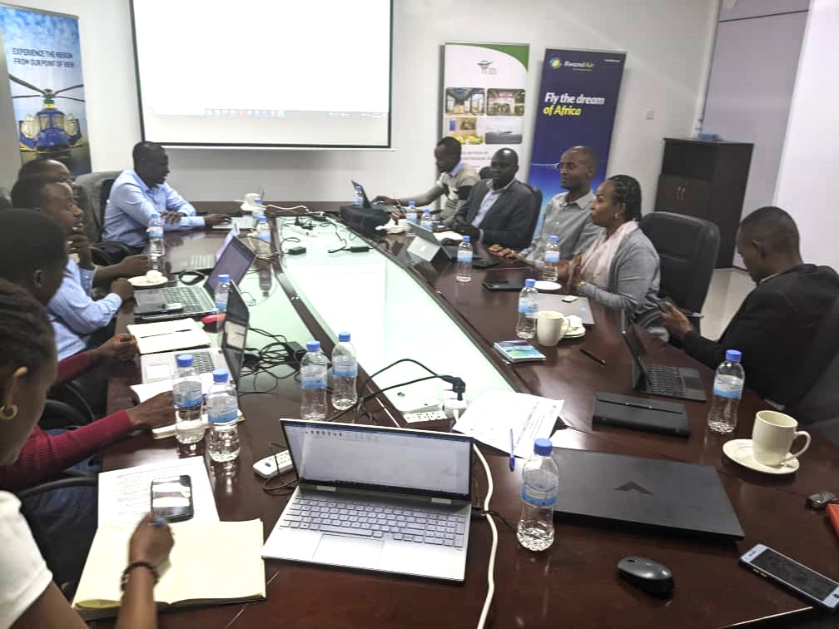
Figure 38: Photo of participants during the public consultation meeting

8.5.2 Formal meetings with high level stakeholders
On 8th, May 2023, a high-level stakeholder consultation for the CEAS project was held with the purpose of presenting information on the project to a group of stakeholders, allowing stakeholders to comment, give opinions and views to be considered and incorporated in the project design and implementation; build impersonal relation with high level stakeholders; disseminate technical information; and record discussions. Different concerns and opinions were raised and responded to, and care was taken to avoid the omission of any impact issues or concerns. During this consultation, the stakeholders were assured that stakeholder engagement would be a continuous process throughout the project construction and operation phases, so that their concerns and views are taken into consideration.
Table 12: Participants in the first-high level consultation
Attendants | Number of participants
Women | 4
Men | 11
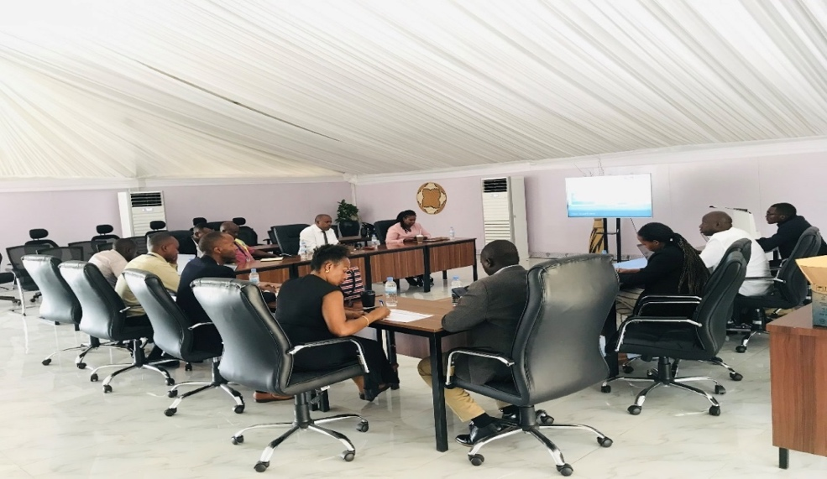
Figure 39: Photo of participants in the high-level consultation meeting
On 15th May, a second high level consultative meeting was held with the purpose of collecting comments on the draft ESIA report that was shared by email with the representatives of the identified stakeholders that are able to comment on the ESIA report and provide inputs.
The table below shows participants in the second high level stakeholder consultation.
Table 13: Participants in the second-high level consultation
Attendants | Number of participants
Women | 4
Men | 8

On 12th February 2025, another high-level stakeholder meeting was convened with the primary objective of gathering opinions and perspectives from key stakeholders. This meeting was particularly significant as it followed modifications to the project design, necessitating further engagement to ensure that all relevant concerns, expectations, and recommendations were adequately captured. Participants included government representatives, development partners and other relevant stakeholders, all of whom provided valuable insights to help align the project with stakeholder interests while addressing any potential impacts arising from the design changes.

8.5.3 Consultation results
The results (concerns/impact issues) of all consultations are summarized and presented in Annexes.

8.6 Stakeholder’s Engagement during Project Implementation
The developer shall continue to engage with, and provide information to, project-affected parties and other interested parties throughout the life cycle of the project, in a manner appropriate to the nature of their interests and the E&S risks and impacts of the project. The developer shall continue to conduct stakeholder engagement in accordance with the SEP and will build upon the channels of communication and engagement already established with stakeholders. The developer shall seek feedback from stakeholders on the E&S performance of the project and the implementation of the ESMP. As such, safeguard measures will be continuously updated through meaningful consultations and stakeholder engagement activities. All updates will be disclosed appropriately to the public in general and to the project stakeholders in particular. Stakeholder engagement activities will involve community consultations, consultations with workers on site, and high-level consultations. These consultations will be planned and organized to ensure that all views, concerns, and opinions are considered, contributing to the sustainable development of the project.

8.7 Integration of Stakeholder Feedback

Stakeholders raised several concerns which were thoroughly analyzed and directly informed project mitigation measures. For instance:
- Traffic congestion: Stakeholder concerns about increased traffic led to adjustments in site access plans and the inclusion of designated entry and exit points to minimize disruptions.
- Noise pollution: Stakeholders identified potential noise impacts from construction and operation. This informed decisions to include noise barriers and to limit high-noise activities to designated times.
- Air quality: Concerns about dust and air pollution resulted in mitigation strategies such as regular sprinkling of water during construction and using low-emission equipment.
- Job creation and local involvement: Stakeholders emphasized the importance of employment opportunities for local workers. This feedback influenced the inclusion of hiring preferences for local labor and skills training programs in the project.
- Environmental impact on vegetation and wildlife: Concerns about biodiversity loss led to commitments to minimizing vegetation clearance and implement replanting post-construction.

Stakeholder inputs were also vital in shaping the Environmental and Social Management Plan (ESMP), which addressed site-specific concerns and ensured compliance with national regulations and African Development Bank (AfDB) guidelines.
Stakeholder consultations were not limited to the ESIA phase; continuous engagement has been planned throughout the construction and operational phases to ensure emerging issues are promptly addressed.

9.0 GRIEVANCE REDRESS MECHANISM (GRM)

9.1 Introduction
The Grievance Redress Mechanism (GRM) for the CEAS Project provides a transparent, inclusive, and culturally sensitive framework for addressing grievances raised by workers, and other stakeholders. This mechanism is central to promoting stakeholder trust, ensuring accountability, and mitigating risks during project implementation. The GRM complies with African Development Bank (AfDB) Integrated Safeguards System guidelines and incorporates elements of Rwandan cultural practices, such as traditional mediation methods. It is operational throughout all project phases, including planning, construction, and operation.

9.2 Objectives
The GRM aims to provide a reliable, timely, and transparent platform for grievance resolution, accessible to all, especially marginalized and vulnerable groups; prevent the escalation of grievances by addressing them promptly and fairly; ensure compliance with AfDB’s Operational Safeguards (OS1 and OS10) and applicable Rwandan legal frameworks; enhance community relations and build trust through open communication and engagement; generate insights for continuous improvement in project implementation and management.

9.3 Scope of the GRM
The GRM is designed to address grievances related to environmental impacts (noise, air pollution, dust, and habitat disturbance), labor issues (working conditions, health and safety violations, discrimination, and contract disputes), sensitive cases (Gender-Based Violence (GBV), Sexual Exploitation and Abuse (SEA), and Sexual Harassment (SH).
The GRM also supports workers employed by contractors and subcontractors, ensuring they can lodge complaints related to workplace grievances.

9.4. GRM Design and Features
- Accessibility and inclusivity: The GRM is free and available to all stakeholders, including disadvantaged groups. Submission channels are tailored to ensure ease of access and cultural appropriateness.
- Transparency and confidentiality: Procedures and timelines are clearly communicated to complainants, while sensitive issues, such as GBV/SEA/SH cases, are handled confidentially.
- Timeliness: Grievances are addressed within predefined timelines to prevent escalation or delays in resolution.
- Cultural sensitivity: Rwandan customs, including the use of community mediators (Abunzi), are integrated into grievance handling procedures where appropriate.

Grievance submission channels
- Physical reporting: Complaints may be lodged directly with the Grievance Manager or submitted at suggestion boxes located at project sites.
- Digital platforms: Grievances can be submitted via email, SMS, or hotlines.
- Anonymous submissions: Special provisions are made to allow anonymous complaints, particularly for sensitive cases.

9.5 GRM Process

9.5.1 Steps in the Grievance Process
Step 1: Submission of grievances
- Workers or stakeholders may lodge complaints through any of the designated channels. Verbal complaints are recorded in written form by the recipient for documentation.
- Anonymous complaints are also accepted and logged without the complainant’s details.

Step 2: Acknowledgment of receipt
- All grievances are acknowledged within 7 days of receipt.
- The acknowledgment includes a tracking number, an explanation of the grievance process, and an estimated resolution timeline.

Step 3: Registration and categorization
- Grievances are recorded in the Grievance Register Book, which includes:
  - Case reference number.
  - Name of the complainant (if available).
  - Date of submission.
  - Nature and the category of grievance.

- Grievances are categorized as:
  - Category 1 (Simple): Issues resolvable on-site by the contractor. (e.g., environmental impact-related grievance)
  - Category 2 (Moderate): Cases requiring further investigation or input from multiple stakeholders. (e.g., social concerns and labor issues)
  - Category 3 (Sensitive): GBV/SEA/SH cases requiring specialized handling by institutions such as the Isange One Stop Centre.

Step 4: Investigation and resolution
- The Grievance Redress Committee (GRC) investigates grievances through site visits, consultations, and evidence collection.
- Resolutions are developed in collaboration with the complainant and relevant stakeholders.
- The resolution is implemented within 15–30 days, depending on complexity.

Step 5: Feedback to complainants
- Complainants are informed of the resolution through their preferred communication channel.
- Grievance is considered closed once the complainant agrees to the proposed resolution.

9.5.2 Appeals Process
If the complainant is dissatisfied with the proposed resolution, they can escalate their grievance through the following levels:
  - Project-Level Grievance Redress Committee (PGRC): Escalated cases are reviewed by senior project staff, contractor’s representative, local authorities, and Isange One Stop Centre. The PGRC investigates the grievance further, consulting additional stakeholders if needed. Resolutions are provided within 15 days of escalation.

  - Traditional mediation (Abunzi): For cases requiring arbitration, community-level mediators (Abunzi) may be engaged. This traditional mechanism is culturally appropriate and often trusted by local communities.

  - AfDB independent recourse mechanism (IRM): In cases where complainants believe the project violates AfDB safeguards or policies, they may lodge a complaint with the IRM. The IRM provides an independent review and facilitates dialogue between the complainant and the Bank.

Complainants are informed of their right to escalate grievances at any stage and provided with necessary guidance to navigate the appeals process.

9.6 Institutional Roles and Responsibilities

9.6.1 Grievance manager:
- Act as the primary point of contact for grievance submission.
- Ensure grievances are logged, categorized, and forwarded to the appropriate level.
- Provide regular updates to complainants on the status of their grievances.

9.6.2 Grievance Redress Committees (GRCs):
The following make up the grievance redress committee:
Table 14: Members of the Grievance Redress Committee (GRC)
No. | Nonko Cell for academic block in Nyarugunga Sector | Rubirizi Cell for Academic in Nyarugunga Sector block | Rwimbogo Cell for Hangar in Kanombe Sector
1. | Cell Executive Secretary | Social Affairs Sector level | Cell Executive Secretary
2. | Youth representative Cell Level | Youth representative Cell Level | Youth representative Cell Level
3. | Women Representative Cell Level | Women Representative Cell Level | Women Representative Cell Level
4. | Representative living with Disabilities | Representative living with Disabilities | Representative living with Disabilities
5. | Social Affairs Sector at level for Nyarugunga
Total | 6 | 4 | 5

They will be established at community and project levels to handle grievances according to their complexity as well as conduct investigations and develop resolutions collaboratively.

9.6.3 Specialized GBV/SEA/SH Support:
Sensitive cases are referred to the Isange One Stop Centre, which provides psychosocial, legal, and medical support.

9.6.4 Logistics and allowance
All costs associated with transport and per diem for Grievance Redress Committee (GRC) members are estimated at 10,000 RWF per person per month. This budget covers travel to project sites, community outreach sessions, and participation in grievance hearings, ensuring that committee members can perform their roles effectively and consistently throughout the project implementation period.

9.7. Monitoring, reporting, and learning
Monitoring, reporting, and learning under the GRM are structured to ensure effectiveness and continuous improvement. Grievances are systematically tracked through a database to identify trends and recurring issues, using key indicators such as resolution rates, response times, and types of grievances. Regular reports are prepared and shared with stakeholders and the AfDB, detailing the number of grievances received and resolved, categories of grievances, resolution outcomes, and key insights to inform project improvements. In addition, the GRM is periodically reviewed and updated to incorporate lessons learned and enhance its efficiency and responsiveness.

9.8 Communication and Awareness
To ensure accessibility, the GRM will be promoted through community consultations during regular meetings to explain the GRM process and collect feedback; and digital platforms such as use of project websites, SMS alerts, and social media for GRM awareness.

9.9 Timelines for Grievance Handling
Step | Timeline
Acknowledgment of grievance | Within 7 days
Investigation and resolution | Within 15–30 days
Appeals process resolution | Within 10–15 days

10.0 CONCLUSION AND RECOMMENDATIONS

10.1 Conclusion
The ESIA for the Center of Excellence for Aviation Skills (CEAS) project outlines project features, assesses potential environmental and social impacts, and proposes mitigation measures across all project phases, recognizing both its national importance and environmental implications. The project is expected to deliver significant benefits, including job creation, economic growth, gender equality support, tourism and local business promotion, technological advancement, attraction of foreign investment and trade, infrastructure improvement, enhanced aircraft maintenance, capacity building, and increased skilled labor.
However, it may also result in adverse impacts such as biodiversity loss, increased runoff and soil degradation, pollution (air, noise, waste), occupational and community health and safety risks, labor and social issues (including gender and child protection concerns), damage to utilities, microclimate changes, increased resource consumption, traffic congestion, disease spread, bird strike risks, and safety concerns related to facilities like the swimming pool. To address these, the project incorporates mitigation measures including vegetation management and revegetation, dust and erosion control, OHS enforcement, noise and spill control, proper campsite and waste management, wildlife hazard mitigation, fire and electrical safety measures, gender-sensitive practices, and emergency preparedness. During operation, hazardous materials will be safely managed, and community health and safety will be maintained through ongoing controls and maintenance.
The project also aligns with the Rwanda Green Building Minimum Compliance System and promotes sustainable environmental management to protect natural resources and ensure the health and safety of workers, the public, and surrounding communities.
A management framework will be instituted during the operation phase of the project to ensure that the management of resources and wastes is carried out according to the guidelines provided within the Environmental and Social Management Framework and in tandem with the requirements of Rwanda Environment Management Authority standards. An Environmental Audit exercise will be undertaken after the first year of implementation to ensure that recommendations of the EMP developed have been followed and any unforeseen impacts are addressed and adequately mitigated.
According to the study, most potential environmental impacts are of medium to low risk and can be effectively mitigated and managed without causing significant harm to the surrounding environment. The study emphasizes that the socio-economic benefits far outweigh the associated costs and negative impacts. Therefore, it is recommended that the project be permitted to proceed, provided that the proponent adheres to all proposed mitigation measures and secures the necessary approvals from relevant authorities.

10.2 Recommendations
The report insists that the project must adhere to the Management Prescriptions (MPs), but it also suggests that the project be carried out with the suggested countermeasures in place to lessen some of the impacts mentioned above. According to the report, the following recommendations are made:

- The developer is required to implement recommended countermeasures to mitigate the outlined impacts as outlined in the Environmental and Social Management and Monitoring Plan.
- Construction activities should commence only after issuance of the ESIA Certificate by RDB.
- Obtain all necessary permits required by the various relevant authorities prior to project implementation.
- Ensure alignment and compliance with the legal requirements of all relevant laws and policies applicable to the project.
- Stakeholder engagement is a continuous process that should be carried out throughout the lifecycle of the project, to ensure sustainable development of the project.
- Adhere to the requirements of the Rwanda Green building minimum compliance system during the establishment of the proposed project facilities.

REFERENCES
- Benton and Werner 1966 Field Biology and Ecology. Mc Gray-Hill book Company, New York.
- Biwas A. K. et Agarwala S.B.C, 1992. Environmental Impact Assessment for Developing countries, Oxford.
- La Banque Mondial, 1990. Manual of environmental Assessment Policies and Procedures.
- California State University, 2001. Draft Environmental Impact Report.
- Guillermo Espinoza et Barbara Richards, 2002. Fundamentals of Environmental Impact.
- Rwanda Vision 2050 (Abridged Version) - Ministry of Finance and Economic Planning
- National Strategy for Transformation (NST1) - National Institute of Statistics Rwanda
- Rwanda National Environment and Climate Change Policy 2019 - FONERWA
- Rwanda Health Sector Policy - Ministry of Health
- Rwanda Green Growth Strategy - Rwanda Environment Management Authority (REMA)
- Rwanda Energy Policy - Rwanda Utilities Regulatory Authority (RURA)
- Rwanda's Updated Nationally Determined Contribution (NDC) - UNFCCC
- Rwanda Biodiversity Policy - REMA
- Rwanda Constitution 2015 - Official Gazette
- Rwanda Water Law - Rwanda Water Resources Board
- Rwanda Forestry Policy - FAOLEX
- Catchment Management Committee - Rwanda Water Resources Board
- Government Gazette No. Special of 2021-11-11 - Official Gazette
- Rwanda Land Law - REMA
- Rwanda Labour Law - Rwanda Development Board (RDB)
- Mining Law - Rwanda Development Board (RDB)
- Rwanda Urban Planning Code - Housing Finance Bank of Rwanda
- Air Pollution Law - Rwanda Environment Management Authority (REMA)
- Ministerial Order No. 00316.01 of 15.07.2010 - Rwanda Meteorology Agency
- Rwanda Meteorology Agency - Website
- High Level Environmental and Social Impact Assessment (ESIA) - Environmental Resources Management (ERM)
- Climate Fact Sheet - GERICS (2016)
- Kicukiro District - Best Travel Months
- Weather Averages - World Weather Online
- Nabahungu, N., 2013. Rwandan Soil Health Status for Sustainable Food Security and Economic Growth. Rome : Food and Agriculture.
- Nzeyimana, I., Hartemink, A. E., & de Graaff, J, 2013. Coffee farming and soil management in Rwanda. Outlook on Agriculture, 42.
- Rwanda State of Environment and Outlook Report Chapter 2. Population, Health, and Human Settlements, 2009.
- Benton and Werner 1966 Field Biology and Ecology. Mc Gray-Hill book Company, New York.
- Boggan, J., Funk V., hoff M., Cremmers G., and Feuilet C.1 997. Checklist Of The Plants of The Guianas. Biological Diversity of the Guianas Programm, Department of Botany, NHSI, SI, Washington, DC.
- Brawn, Finch, Robbin, Schmidt 2000. A Field Checklist of the Birds of Guyana.
- California State University, 2001. Draft Environmental Impact Report. Faculty and Staff Housing.
- State of the Environment Report, Chapter 7: Water and Wetlands Resources - Rwanda Environment Management Authority (REMA)
- General Geology of Rwanda - Sinanana News Rwanda
- Inventory of Sources of Air Pollution in Rwanda - Rwanda Environment Management Authority (REMA)
- National Risk Atlas of Rwanda - Global Facility for Disaster Reduction and Recovery (GFDRR)
- Noise Levels Associated with Urban Land Use Types in Kigali, Rwanda - ScienceDirect
- Rwanda Population and Housing Census 5 (RPHC5) Main Indicators Report - National Institute of Statistics Rwanda
- EICV5 Main Indicators Report 2016/2017 - National Institute of Statistics Rwanda
- EICV5 District Profiles - National Institute of Statistics Rwanda
- Kicukiro District Development Strategy 2018-2024
- Traffic Report Kigali Master Plan 2050 - Kigali City Council GIS Portal
- Emmons, L. H. 1990. Neotropical Rainforest Animals. Chicago Press Pg. 281.
- La Banque Mondial, 2001. Bank Operational Policies 4.01 on Environmental Assessment.

ANNEXES

Annex 1: Emergency Response Plan (ERP)
Kigali International Airport has a well-established emergency response plan in place to handle any unforeseen incidents that may occur during its operations. This plan is designed to provide assistance and support services in a uniform manner, ensuring that all specifications are met.
As emergencies and disasters can happen at any time without warning, it is essential for construction sites to prepare for them to minimize panic and confusion. Therefore, Emergency Response Plans (ERP) will be instituted throughout the proposed project cycle.
To ensure effective emergency management during the project's operational phase, the proponent will adhere to the existing emergency response plan for KIA. The regular operational documents contain information on how the proponent will respond to different incidents that may occur during the project.
The airport emergency plan addresses the following hazards: Aircraft accidents and incidents as follow:
- Terrorism incidents.
- Structural fires, fuel farms and fuel storage area.
- Natural disasters.
- Hazardous material incidents.
- Sabotage, hijack and unlawful interference with operation.
- power failure in movement area lighting.
Since the proposed project is likely to encounter some of these hazards during its operation phase, it can only be successful if it adheres to the existing emergency plan for KIA. Therefore, the project must be harmonized with the emergency response plan to ensure effective emergency management.
Emergency Response Plan Objectives
The aim of the emergency response plan is to ensure that personnel are capable of coping with any emergency situation. The primary concern is for the safety of workers, visitors, contractors and the community. Vital records, property and other assets should also be protected.
The proponent must ensure that these procedures are kept in a prominent position and that all personnel are made aware of the contents. It is also essential that this document is amended when there are site or personnel changes that impact on the procedures herein.
All personnel must make themselves aware of the location of all emergency alarms, exits and fire appliances within or near their work area and location of the external Safe Assembly Areas.
The effectiveness of these procedures depends on the willingness of all personnel to make themselves aware of the immediate actions they must take in an emergency so that they are capable of acting promptly, calmly and efficiently.
The following elements of a conventional emergency response plan are recommended as summarized in table below.

Emergency Response Plan
Position or Description | Responsibilities for Aircraft Hangar Emergency Response
Airport Manager | - Serve as Emergency Coordinator.  - Assume Incident Command responsibility for all response and recovery operations, as appropriate.  - Establish, promulgate, coordinate, maintain, and implement the Airport Emergency Plan (AEP).  - Monitor Police and Fire radio for updates in case of fire situation as well as provide appropriate alerts and notifications. Coordinate the closing of the airport when necessary and initiate the dissemination of relevant safety-related information to aviation users.  - Notify appropriate KIA personnel in case of emergency
DAir Carrier/Aircraft Operator | - Provide full details of aircraft-related information, as appropriate, to include number of persons, fuel, and dangerous goods on board.  - Coordinate transportation, accommodations, and other arrangements for uninjured passengers.  - Coordinate use of air carrier/aircraft personnel and other supplies and equipment for all types of emergencies occurring at the aircraft hangar.
Akagera Aviation Fire Chief/ Department | - Manage and direct firefighting and rescue operations.
Akagera Aviation Fire Chief/ Department | - Manage and direct firefighting and rescue operations.  - Direct search and rescue or hazardous materials response.  - Coordinate mutual aid resources through Incident command System.  - Assist with search and rescue or evacuations. Assume Incident Command as appropriate.
Airport Police | - Manage and direct police operations.
Chief/Department | - Assist with traffic control and scene security.  - Assist with search and rescue or evacuations.  - Respond as needed for activities involving crowds or assemblies of people.  - Respond to bomb threats or acts of terrorism.  - Assume Incident Command as appropriate.  - Respond to the scene with all appropriate personnel, protective equipment, secure the area, then ascertain the nature and severity of the threat.  - Establish primary and secondary perimeters after a thorough search and assessment has conducted.  - In the event of a biological/chemical release it may became necessary to secure and evaluate a large downwind area in order to prevent further potential civil causalities.
Akagera aviation emergency management officer | - Assist Aircraft Hangar with obtaining all resources offered by the state or board governments.  - Assist the county in obtaining any state or federal government resources that may be needed as a result of an emergency situation.
Kanombe Military Hospital | - Provide emergency medical services to the aircraft hangar during emergency conditions to include triage, stabilization, first aid, medical care, and transportation of the injured.  - Coordinate planning, response, and recovery efforts with hospitals, fire and police departments, airport operator, etc. Coordinate the hospital disaster plan with the airport and com- munity Emergency Operations Plan (EOP).
Akagera Aviation Operators | - Coordinate the use of their available equipment and supplies.
County security guard | - Provide primary law enforcement for off-airport events. Coordinate scene security.  - Assist with investigations.  - Assist with search and rescue efforts.
Public Works section | - Provide primary law enforcement for off-airport events. Coordinate scene security.  - Assist with investigations.  - Assist with search and rescue efforts.

Activation of the Aircraft hangar Response Plan:
The plan will be activated if unit aircraft are involved in an emergency situation. An emergency situation exists if any of the following criteria are met:
    - The aircrew does not answer a status check from Communications for ten minutes.
    - The aircrew is more than 30 minutes past due on cross country, maintenance, or administrative type flight.
    - Aircraft Emergency Locator Beacon is activated (this will be advised by an air traffic control or federal search and rescue source)
    - Aircrew advises via law enforcement or aviation radio that they are in an emergency situation.
    - Police call advises agency aircraft is in an emergency situation (and unable to confirm otherwise with aircrew).
Safety Officer:

During the initial stages of the incident response, the Safety Officer will concentrate his efforts on locating the missing aircraft and assisting in facilitating any emergency medical assistance needed by the flight crew. The Safety Officer will take direction from the Aviation Unit Commander and Chief Pilot in order to fill the operational needs of the search and response. If the Safety Officer arrives at the command post before the Aviation Commander or Chief Pilot, he will assume command of the operation until they arrive. Once the aircraft has been located and the crew tended to, the Safety Officer will assist the Chief Pilot in the incident investigation at the scene. If necessary, the Aviation Commander may recall the Safety Officer for other tasks (for family contact, to go to the hospital with the crew, etc.). After the aircraft incident, the Safety Officer will complete a safety report on the incident, possible causes and/or contributing factors and proposed response to prevent a reoccurrence. The report will be completed as soon as possible, but the Safety Officer should consult with other accident investigation experts before documenting possible causes of the incident. The report should be factual and not speculative, aimed at enhancing safety, not placing blame.

Chief Mechanic

The Chief Mechanic’s knowledge of the aircraft components and systems make him an extremely valuable asset in any operation following an aircraft incident. During the search, the Chief Mechanic will take fuel samples from the fuel storage tanks and the other aircraft to ensure any possible contamination will not cause further loss of equipment or injury. He will then be available to the Division Commander for any operational tasks needing to be completed. The Chief Mechanic may be utilized as a crew member (Observer) on the search aircraft. The Chief Mechanic will respond to the incident site with any equipment that may be required. The Chief Mechanic will assist the Chief Pilot in making the aircraft ‘safe’ (engine/power secured) and then in the initial investigation that follows. In the event of an aircraft incident, the vast amount of work needed to find the aircraft, care for the crew and conduct a follow-up investigation will be best facilitated by having as many Aviation staff members on the job as possible. Responding Aviation staff members not already assigned a task by this response plan will first go to the command post at the Aviation Unit office and report to the Aviation Commander (or designee).
In order to ensure public health and safety, and to prevent accidents or emergency situations at construction, operation or decommissioning phases, the following action plan shall be incorporated in the project cycle.
Health, Safety and Accident Prevention Plan

Issue | Specific measures | Responsibility
Project design | - Incorporation of environmental, health and safety (EHS) measures in the process. | - Project manager  - Developer
Organization and cleanliness at the workstation | - Keep materials in correct place.  - Maintain cleanliness at the workstation. | - Project manager
Fire safety | - No storage of inflammables at the site  - Fire safety awareness  - Keep firefighting facilities at the site.  - Safe handling of fire  - Ensure functionality of fire detection and suppression system | - Facility manager
Accident prevention | - Safe handling of tools and machinery  - Use of appropriate PPE  - Engagement of qualified personnel | - Worker’s facility manager
Waste disposal | - Provision of adequate waste disposal facilities at the facility  - Engagement of REMA licensed waste disposal company  - Separation, re-use and recycling of packaging materials  - Proper maintenance and connection of sewerage/drainage system to ensure that there are no leakages | - Contracted waste disposal company facility manager
Tools and machinery  safety | - Use of tools and machines for designated job  - Regular servicing of machinery  - Proper storage and handling of tools. | - Facility manager
Emergency preparedness | - Keeping passages clear  - Marking emergency exits  - Training staff in emergency preparedness and response  - Keeping a well-equipped first aid kit on site | - Facility manager
Site security | - 24-hour security at site  - Control of visitor entry into the hangar | - Security company

Annex 2: Stakeholder Grievance Log

GRIEVANCE RECORD FORMAT
To be completed by AKAGERA AVIATION LTD personnel (if grievance being submitted in person) or person submitting complaint.
Grievance Record
Reference No:
(for official use)
Anonymous: | Yes | No
Full Name:
Contact Information: |  |  | Address/village/traditional authority and ward:  Telephone: E-mail:
Please mark how you wish to be contacted.
(Letter, telephone, e-mail).
Preferred Language for communication
Description of Incident or Grievance: |  |  | What happened? Where did it happen? Who did it
 |  |  | happen to? What is the result of the problem?
Date of Incident/Grievance
One time incident/grievance
(date )
Happened more than once.
(How many times? )
 |  | On-going (currently experiencing problem)
What would you like to see happen to resolve the problem?
Additional Comments:

GRIEVANCE RECORD – TO BE USED AS PART OF THE DATABASE
Grievance Record
Grievance Number: |  |  | Date Submitted: |  | Target Date for Resolution:
Name:
Address and Contact Details
Grievance Received By:
Name of Grievance
Coordinator:
Description of Grievance:
Assessment of Grievance  Level: |  |  |  |  | Notification to CEO or other senior management? | Y/N
Actions to Resolve Grievance
Delegation to:
Action |  |  | Who |  | When | Completed  Y/N/Date
Response/Resolution:
Strategy to Communicate Response:
Sign-Off:
Date:
Conclusion
Is complainant satisfied? | Y/N | Comments from  Grievance Coordinator
Grievance Closed? | Y/N | Grievance Resubmitted? |  | Y/N
Signature of CEO: |  | Date:
Date: |  | New Grievance Number:

Annex 3: Minutes of the High-Level Stakeholder Meeting

STAKEHOLDER CONSULTATIONS MEETING FOR CEAS PROJECT
Meeting Proceedings
Opening
Venue: Kigali international airport
Date: 08th, May 2023
Time: 10:00 am – 12:00 pm
Attendants | Number of participants
Women | 4
Men | 12

Meeting agenda
- Opening remarks
- Rationale for Stakeholder Consultations/ Stakeholder Engagement and Information Disclosure
- Project Description/ Description of the Project Environment
- Impacts Evaluation
- Views and Opinions/ Issues raised.
- Way forward on Stakeholder Consultations
- Closing remarks.
Rationale
Effective stakeholder engagement is crucial for ensuring the environmental and social sustainability of projects and enhancing their acceptance and successful implementation. This engagement is required by both the National EIA guidelines and The AfDB Operational Safeguard 1: Environmental and social assessment for carrying out an effective Environmental and Social Impact Assessment of proposed projects. The consultation process is free and transparent, and all views and opinions are discussed to contribute to the ESIA process and the sustainable development of the project.
The stakeholder engagement process is an inclusive one, initiated early in the project development process and conducted throughout the project life cycle. This process is an integral part of early project decisions, as well as the assessment, management, and monitoring of the project’s environmental and social risks and impacts. By incorporating stakeholder input, project design can be optimized, and potential negative impacts can be mitigated, resulting in a more sustainable and socially responsible outcome.
The ESIA process requires the consideration of views and inputs from all stakeholders and relevant experts. During the consultative meeting for the aviation hangar and academy training center project, the consultant presented and disclosed anticipated issues with the project's construction, operation, and decommissioning. Effective stakeholder engagement can improve the environmental and social sustainability of projects, enhance project acceptance, and make a significant contribution to successful project design and implementation.
At the beginning of the meeting, Akagera Aviation Ltd expressed their gratitude to all participants for their time and willingness to contribute to the success of the proposed project. The opening remarks were followed by a presentation from the consultant team.
Project Description
- Developer and project background
- Project objectives
- Project cost
- Project components
- The connection between the proposed hangar and Kigali International Airport.
- Current condition at the airport site
- Project phasing and activities
Brief description on the project environment
positive anticipated impacts
Impact evaluation/ negative anticipated impacts
The floor was then opened for discussions whereby views, opinions and concerns from stakeholders were collected and discussed.
No | Views and opinions/ concerns | Response provided
1 | The proposed project is a fantastic project which will benefit the aviation industry as well as the country.  Could you provide more specific details regarding the proposed project's phase-wise timeline and the anticipated implementation planning? | Prior to commencing the implementation of the proposed project, several prerequisite procedures need to be carried out. Notably, the Environmental and Social Impact Assessment (ESIA) is being conducted concurrently with the feasibility study. The target timeline for executing the project is set for 2024, and it is expected that within two years of its launch, the project will be operational. It is worth mentioning that the training activities will persist until the completion of the center of excellence.
2 | I'd like to know if the mandatory internal training programs that all companies operating in KIA have will be consolidated into the proposed academy, or if they will remain separate. | As part of the ATL establishment, Akagera Aviation Ltd has been designated as the training provider for aviation in the country. Currently, they offer flight operation training, but over the next decade, they will expand to provide all types of training.
3 | Who will be managing the proposed project? | Akagera aviation Ltd.
4 | What are the operational impacts that the assessment has identified as likely to occur on a daily basis, and what steps will be taken to manage and mitigate those impacts? | During the presentation, the anticipated impacts were discussed, and we would like to hear your opinions and comments regarding these impacts. Some of the impacts mentioned were bird strikes, air and noise pollution, fire and electrical hazards, waste generation, accidental spills, insecurity, micro-climate modification, and disturbance to the natural environment.  In the ESIA perspective, all project components, including those that will be linked to the existing KIA, were considered. For example, the report recommended the construction of a wastewater treatment plant for the proposed academy since it is not within the KIA.
5 | Can you clarify whether the fire protection system being proposed for the new project will be integrated with the existing firefighting and brigade at KIA, or will it be a separate system not connected to the airport? | It is not intended to have a separate fire protection system for the proposed project. Instead, the plan is to install automatic firefighting systems on the site, which will be supported by the existing KIA fire brigade in case the system is unable to effectively manage a fire incident.
6 | The ESIA should showcase the Rwanda Green Building Minimum Compliance System, which is mandatory for new educational structures and a recommended approach, as well as the project’s alignment with the SDGs. Additionally, detail the effects of the project on the neighboring communities. | The study has taken into account the requirements of the Rwanda Green Building Minimum Compliance System, and as a result, suggests environmentally friendly building practices and technology that the developer should incorporate into the design.
7 | It is important to consider how the management of birdlife and wildlife will be approached at the construction site, as construction areas typically attract birds. | The effective management of birds is a vital aspect for airport facilities. The potential threat of bird strike hazards is currently being evaluated, and various measures to mitigate this risk have been suggested. It is recommended that the management methods already in place at the present KIA should be shared and incorporated into these mitigation measures.
8 | In the assessment, it is essential to give careful attention to the management of soil erosion during construction and dust control during aircraft takeoff and landing. | The study proposes several measures to mitigate soil erosion, including the implementation of silt fences, retaining structures, and other appropriate techniques.  The study has given consideration to the issue of dust generation during aircraft takeoff and landing and will suggest several measures for control and mitigation.
9 | Will the project facilities be dependent on the power and water supply of the existing KIA, or will they have their own separate supply? | The project has examined two options for its power and water supply. The first option involves connecting both the hangar and academy to the existing water tank and substation at KIA for their respective water and power needs. The second option involves connecting only the hangar to KIA's water tank and substation, while the academy connects directly to the public municipal distribution system (REG for power and WASAC for water).  However, it is recommended that the most cost-effective option would be to connect the hangar to the existing water tank for water needs and the existing substation for power needs, while the academy connects to the public electricity distribution system (REG) and water distribution system (WASAC).

Recommendation
- The emergency response procedures at the proposed project will be aligned with the existing emergency response plan at Kigali International Airport.
- Once the report is completed, it will be shared with all key stakeholders for their input and comments to ensure the sustainability and success of the project.
- During the assessment, safety, reliability, and security will be the main focus to ensure a safe and successful operation.
- As the existing runway will be utilized by both commercial and training aircraft, potential risks of air traffic and collisions arise. As a result, it is advisable for all parties and agencies involved at the airport to work together to develop a thorough safety risk assessment in this matter.
Way-forward
- Stakeholder Engagement is going to be a continuous process throughout the life cycle of the Kigali FSTP Project.
- Stakeholders will share additional inputs and comments on the draft ESIA Report.
- The consultant will provide a description on how costs in the ESMP were estimated.
Closing remarks
The representative from the developer Akagera aviation ltd, appreciated all participants for their active engagement in the meeting.

Minutes prepared by: Aline Uwera and Patience Uwera/ ED&P Associate consultants.
Kigali, 08th May 2023.

Annex 4: Minutes of the Second High-Level Stakeholder Consultation

SECOND STAKEHOLDER CONSULTATIVE MEETING FOR THE CEAS PROJECT
Meeting Proceedings
Opening
Date: Monday 15th May 2023
Time: 2:00 pm- 5:00 pm
Location: Aviation Travel and Logistics Holding Ltd
Attendants | Number of participants
Women | 4
Men | 8

Meeting agenda
- Introduction session and Opening remark
- Presentation of the draft ESIA project.
- Collection of opinions/views and concerns from the stakeholders
- Closing remarks
1. Introduction session.
The meeting started with a short introduction of all participants followed by opening remarks by Joseph Ndayishimiye director of Operations at Akagera aviation ltd thanking and welcoming all the stakeholders of the project.
2. Presentation the draft ESIA report of the project
The environmental specialist provided an overview of the various components included in the Environmental and Social Impact Assessment (ESIA), which encompasses the following sections:
- Introduction
- Project Description
- Description of the project Environment
- Policy, Legal and Institutional Arrangements
- Alternatives analysis
- Impacts Evaluation
- ESMP
- Stakeholder Engagement Plan
- Conclusions & recommendations
3. Views and opinions/ Issues raised
The floor was then opened for discussions whereby views, opinions, and concerns from stakeholders were raised and discussed.
Some key concerns and issues raised through discussion were then clarified.
No | Views and opinions/ concerns | Response provided
1 | How will the issue of radiation reflection, which could potentially cause disruptions due to the presence of solar panels on the roof of the facilities, be addressed to prevent harm to the pilot's eyes and lead to accidents? | While the adoption of renewable energy is highly desirable, it is crucial to ensure that the installation of solar panels does not interfere with the pilot's vision due to any reflections they might produce. Therefore, additional studies will be conducted to guarantee the use of solar panels in a way that do not pose a problem.
2 | With different activities being undertaken in facilities there may be risk of fire hazards, how would it be dealt with? | A fire suppression system has been proposed for both the aircraft hangar and the center of excellence aviation training center to address fire incidents. This system involves the release of fire foam and water, which will effectively suppress and prevent the spread of fires.  The facilities with also be equipped with firefighting equipment such as fire extinguishers and others.
3 | In order to prevent any form of harassment, how will the design of the center of excellence ensure a safe environment for both girls and boys? | The design has made sure to provide different accommodations for boys and girls at the center of excellence aviation training center.
4 | Given the scale of the project and the heightened security requirements at the project location, how will security measures and the management of facilities be effectively addressed and handled? | As the aircraft hangar is situated within Kigali International Airport and the center of excellence aviation training center is in close proximity with access to the airport, the security arrangements for both facilities will be integrated into the overall security plan of the airport.
5 | Considering the critical requirement for continuous power supply at the aircraft hangar and the center of excellence aviation training center, how will this need be effectively addressed and ensured without any interruptions? | To ensure a reliable power supply for the aircraft hangar and the center of excellence aviation training center, both facilities will be connected to the substation of Kigali International Airport, where a backup generator is in a place in case of a power cut.
6 | How will the continuous supply of water be guaranteed at the aircraft hangar and the center of excellence aviation training center, given the critical importance of this resource for their operations? | In order to maintain a consistent water supply, the aircraft hangar will be linked to the current water supply system at Kigali International Airport or nearby WASAC tanks. Similarly, the center of excellence aviation training center will be connected to the public water supply system in the surrounding region, ensuring uninterrupted access to water for both facilities.
7 | In order to attain its objective of becoming a prestigious aviation school, how will the center of excellence aviation training center ensure the quality and comprehensiveness of the qualifications it will provide? | To establish itself as a highly reputable institution, the center of excellence aviation training center will possess ample training facilities. Additionally, the school will form partnerships with esteemed higher learning institutions like Coventry University to deliver diverse aviation courses to trainees, thereby solidifying its position as a provider of top-notch qualifications in the aviation sector.
8 | When it comes to stormwater management, how will the proposed facilities ensure proper handling of the drainage system to prevent any mismanagement that may result in potential disasters? | As a recommended approach, it is proposed that the upcoming facilities be connected to the existing drainage system in the vicinity of Kigali International Airport (KIA). This is due to the well-designed nature of the current drainage system, which effectively channels water down to the Rubilizi wetland. Therefore, establishing a connection to this system is considered a preferable solution.
9 | Considering the inevitability of noise generation from the operations of the aircraft hangar and the center of excellence aviation training center, which are located in close proximity to flight activities, how will measures be implemented to mitigate the potential impacts of noise? | Akagera Aviation stated that the aircraft used for pilot training are expected to have minimal noise emissions due to their small size. Furthermore, as part of their ambitious objective, they plan to acquire aircraft models that produce reduced or no noise at all.

Way forward
- Finalize and share the final ESIA report with relevant stakeholders.
- Effective project management of the CEAS requires collaborative efforts among all institutions involved, with clearly defined roles and responsibilities for each institution. This collaborative approach is crucial for the success of the project.

Kigali, 15th May 2023

Annex 5: Minutes of the Third High level stakeholders Meeting

Meeting Proceedings
Opening
Date: Tuesday 11th, February 2025
Time: 11:00 am- 01:00 pm
Location: Virtual meeting
Meeting agenda
- Opening remarks
- Rationale for stakeholder consultations
- Objectives of the ESIA
- Project description
- Description of the project environment
- Description of Impact identification
- Description of the ESMP
- Description of the Grievance Redress Mechanism
- Collection of questions, opinions/views and concerns from the stakeholders
- Way forward on Stakeholder Engagement Plan
- Closing remarks
1. Introduction session.
The meeting started with a short introduction of all participants followed by opening remarks delivered by Marc Mupenzi SPIU coordinator at RDB and Patrick Nkulikiyimfura, MD of Akagera aviation ltd, thanking and welcoming all the stakeholders.
2. Rationale for stakeholder consultations
The section was presented by the ESIA study consultant, Eco design and Protection LTD. The consultant described the rationale for conducting stakeholder consultations:
- Requirements, national EIA guidelines and international standards.
- Disclose the project.
- Ownership and responsibilities of the stakeholders.
- Collect views, opinions and concerns on the project.
- Integrate the views, opinions and concerns in all phases of the project.
- Inform the ESIA process.
- Early stage and all phases of the project.
3. Objectives of ESIA
The consultant elaborated on the objectives of ESIA which is to predict any significant impacts of the proposed project on the environment and, where applicable, propose measures to avoid, reduce, or remedy them. This objective would be achieved by:
- Understand the national and international legislations governing the project.
- Understand the project areas’ socio-economic and biophysical environment (through field visits, literature review)
- Conduct stakeholder consultations.
- Identify anticipated environmental and social impacts.
- Develop appropriate enhancement and mitigation measures for each identified positive and negative impacts, respectively.

4. Background and a short description of the Centre of excellence for aviation skills project
The section was presented by the ESIA study consultant, Eco design and Protection LTD.
- A brief overview of the project background
- Project objectives
- Key CEAS components
- Support facilities and services
- Project cost and staffing
5. Description of the Project Environment
The section was presented by the ESIA study consultant, Eco design and Protection Ltd.
A short description of the baseline conditions of the proposed project site was presented, mainly highlighting:
- Current/ existing facilities and structures on site
- Bio-physical environment conditions including topography, weather patterns, soil type, land cover, vegetation, etc.
6. Description of Impacts Identification
In this section, the consultant presented both the positive and negative impacts identified during the assessment, accompanied by an impact matrix that analyzed each impact in terms of its significance.
7. Environmental and Social Management Plan (ESMP)
The ESMP outlined the proposed mitigation measures for each identified impact, along with corresponding monitoring indicators and associated costs. Additionally, an environmental monitoring plan was included, specifying benchmarks, targets, and the frequency of monitoring for each impact. This comprehensive approach ensured that all impacts are effectively managed and tracked throughout the project lifecycle.
8. Grievance Redress Mechanism (GRM)
The GRM provided a structured process for addressing grievances, allowing stakeholders to raise concerns and seek resolution in a transparent and timely manner.
9. Concerns and opinions/ Issues raised
The floor was then opened for discussions whereby views, opinions and concerns from stakeholders were raised and discussed.
The table below details the key concerns and issues raised through discussions and the feedback provided.
Stakeholder Views and Concerns
Persons | Concern/Opinion Raised | Feedback Given
Mr Marc from RDB | Should labor and working conditions be governed by national labor laws or the regulations set by the International Labor Organization (ILO)? | Labor and working conditions should be governed by national laws, as well as the African Development Bank (AfDB) Operational Safeguard (OS) 2 on working conditions and labor rights.
Mr Marc from RDB | How can the availability of Grievance Redress Mechanism committee members be ensured, considering that some are ordinary citizens with daily responsibilities? | The contribution of the Grievance Redress Committee (GRC) is not a daily task. The committee will convene only when a grievance arises, allowing members to coordinate and agree on a suitable time to address and resolve the issue promptly without interrupting the GRM time process.
Mr Marc from RDB | How can you promote gender equality in the project especially during the construction phase? | It is essential to employ women with diverse skills to enhance their capacity, even during the construction phase, where they can actively contribute to various on-site activities. It is also emphasized by the AfdB to increase women participation in various projects.
Madam Jackie | During construction of the hangar, is it necessary to use ecosan toilets given that there are facilities already present within the KIA? | The use of ECOSAN toilets were suggested in order to cope with the waste management at the campsite and at the hangar during construction. Ecosan toilets will not impact activities at the airport. It’s a temporary solution to manage the wastewater.
Madam Jackie | What type of hazardous waste should we expect from the project operations? How should the client manage hazardous materials before the designated company takes over? | Oil, solvents, batteries, etc are some of the hazardous wastes to be generated from the proposed project construction and operation activities. The developer should establish and implement hazardous waste management strategies to ensure the safe handling, storage, transportation, and disposal of hazardous materials in compliance with regulations. Hazardous waste should be securely stored in labeled, segregated containers to prevent leaks, with regular inspections and environmental monitoring conducted to detect potential risks and ensure proper handling. Additionally, sustainable waste management practices, including waste reduction, reuse and recycling, and spill response planning, should be implemented to minimize environmental impact.
Madam Irene from RTDA | Given that you have involved the impact heritage, have you incorporated chance find procedures within your report? | A chance-finds procedure is a project-specific procedure that will be followed if previously unknown cultural heritage is encountered during project activities. I confirm, chance find procedures has been incorporated in the ESIA report..
Madam Irene from RTDA | Do you have Memoranda of Understanding (MOUs) in place with the various stakeholders mentioned in the report to ensure smooth collaboration and avoid any potential issues? Stakeholder such as Nduba dumpsite where waste is treated is considered as such and consulted. | We have identified and mapped all the potential stakeholders involved in each phase of the project and informed them accordingly. They are invited to participate in various consultations to share their views and opinions.  Not all stakeholders have the same influence on the project, are affected the same and have the same interest in a specific project. The Nduba landfill is a stakeholder in various projects, but at a different level of interest and influence. It is there to waste handling and treatment, regardless of the design of the project or any other alternative.
Mr Fidele Muhirwa from REMA | Are you considering the national standards or international standards for the effluent wastewater? Will the capacity of the wastewater treatment plant be sufficient to meet the national requirements based on its planned capacity? And what will the recycled water be used for? | The wastewater recycling system follows a grey and black water recycling approach using Membrane Bioreactor (MBR) technology. The use of the system will meet the national requirements and standards for wastewater treatment plants, it was also suggested that they use one that can be maintained locally to avoid any large costs for their maintenance. The recycled water will be used for irrigation, cleaning and other activities
Mr Fidele Muhirwa from REMA | Was the green building minimum compliance system followed in the design of the CEAS? What will the energy and water efficiency of the facility? | The report outlines how the facility will comply with the green building minimum system under the policy, legal, and institutional framework. To ensure energy and water efficiency, measures have been implemented that will result in an annual energy savings of 61.10 MWh and a reduction in water consumption by 33,517.91 m³ per year.
Mr Fidele Muhirwa from REMA | Given that National Determined contributions outline that there will be reduction of emissions significantly how will the project contribute to that? | The design of the CEAS has proved the reduce of carbon emissions where the offset of carbon emissions is -163.9 tCO₂e/Year, contributing to reduction of emissions aligning with the NCDs.
Mr Fidele Muhirwa from REMA | Were the impacts related to fire, hazardous materials storage, and other associated risks included in the Environmental and Social Management Plan (ESMP)? | Yes, the impacts related to fire, hazardous materials storage, and associated risks are thoroughly detailed in the ESMP.

10. Way forward
- The Consultant will finalize and share the ESIA report with consultative meeting participants or project stakeholders for their review and comments if any.
- Stakeholder consultation is a continuous process throughout the project phases, with opinions and concerns taken into consideration and incorporated in the assessment.
Minutes prepared by: Loick Divin NKANGURA/ ED&P
Kigali, 11th February 2025

Annex 6: Summary of views, concerns, and opinions raised during public consultations
Stake Holder’s  Name, Institution  & Role | Concerns, opinions, and recommendations | Comments on Public Consultation and Technical Processes
Joseph Murinda  Engineer  Akagera Aircraft | What measures can be taken to ensure that the site remains easily accessible despite the traffic patterns in Kanombe? | A study was conducted to analyze the traffic patterns around the project site and appropriate measures will be put in place during both the construction and operation phases to prevent any potential problems.
Joseph Ndayishimiye  Akagera Aircraft | What measures will be taken to ensure security in the project area considering the magnitude and sensitivity of the project? | The project development will be secured similarly to the existing KIA, during both the construction and operation phases to guarantee the presence of adequate security measures for the surrounding areas.
Faustin Muhunde  Akagera Aircraft | Further information on the job opportunities that will be generated by the proposed development project was provided.  There were recommendations made to install road safety signs so that people approaching the project site can be aware of its proximity. | As per the suggestion, there will be road signs installed to indicate that there is an ongoing development in the area and that the necessary construction site regulations should be implemented.
Ms Cyineza Bora Josiane  Nyarugunga social affair officer | What steps will be taken to address noise pollution, considering the operations of aircraft in the area? | The potential noise issues were taken into consideration during planning, for example placing the hostels on the lower level of the academy to reduce the noise level.  To ensure minimal noise emissions, there will be an emphasis on maintaining the aircraft, and the planes used by Akagera Aviation will have efficient systems in place to limit noise levels.
Ms Cyineza Bora Josiane  Nyarugunga social affair officer | Given the sensitivity of the project and the increased security measures, will the residents and road users continue to use the roads passing through the project area as they used to? | The existing roads will remain open, and residents can continue accessing them for their daily activities.
Ms Cyineza Bora Josiane  Nyarugunga social affair officer | Will the proposed project affect the accessibility of essential amenities such as water and power supply for the residents of Nyarugunga sector? | The development project will not have any significant adverse effects that cannot be addressed, particularly with regards to the accessibility of basic amenities for the neighboring residents, such as water. The project will have its own water storage tanks, and this will minimize reliance on public water supply systems. Additionally, the project will incorporate rainwater harvesting to supplement the water supply on the site.
Uwera Annah | What measures will be taken to address the destruction of vegetation on the project site? | The project will implement re-vegetation practices to restore the vegetation as much as possible.
Habyarimana Jean Callixte  engineer | It was emphasized that the current road leading to the academy project site would be constructed to high standards and made accessible to both pedestrians and vehicles. | It was mentioned that in addition to the existing well-built roads that provide access to the project site, a new road will be constructed to connect the hangar and academy.
Nkunzi Nicolas | It was emphasized that the establishment of a project of such magnitude would have positive impacts, such as improved security and the opening of local businesses. | The suggestion was received positively, and examples were provided to illustrate how large-scale projects such as this one can stimulate the local economy by creating business opportunities.
Mutabazi Augustin | What enhancement measures will be taken to ensure the project development continues to create job opportunities for future generations? | There is room for expansion, therefore as the project facilities grow, there will be more opportunities for employment and better facilities for future generations.
Habonimana Pascal  Sanitation officer | Considering that the proposed project will lead to an increase in population, what measures need to be taken to prevent an increase in demand and pressure on essential resources such as water and power? | To address the potential increase in population due to the proposed project, measures have been put in place to avoid adding pressure to essential resources such as water supply. Rainwater harvesting and wastewater treatment for re-use will be incorporated in the project to manage water usage. This will reduce the demand for water from external sources and decrease the pressure on the existing water supply.  Additionally, power-saving measures will be implemented to reduce the energy consumption of the project, and where possible, renewable energy sources will be utilized. These measures aim to ensure that the development does not put undue strain on essential resources while catering to the growing population.
Patrick Nkulikiyimfura  Managing Director | Are there any suggested measures to mitigate the impact of solid waste management resulting from the proposed project? | The proposed project includes a waste management plan that aims to separate solid waste into biodegradable and non-biodegradable components. This will enable the project to maximize reuse and recycling of waste materials and minimize the amount of waste that ends up in landfills. The project team will also explore opportunities to repurpose waste materials for other uses.
Patrick Nkulikiyimfura  Managing Director | Has the impact of traffic trends during the construction and operation phase been considered, and how will it be managed to ensure that the local community is not negatively affected? | The impact of traffic trends during the construction and operation phase has been considered, and measures have been taken to ensure that the local community is not negatively affected. Flying lessons will be conducted in less residential areas, and the trainees will be accompanied by highly qualified trainers to minimize the risk of accidents. In addition, traffic management plans will be put in place during the construction and operation phases to minimize disruptions to the local community.
Mrs Rwigema Francine  Local citizen | Will the increase in noise generated during the implementation cause more discomfort for the local community due to the higher levels of noise in the area?" | The potential noise issues were taken into consideration during planning, for example placing the hostels on the lower level of the academy to reduce the noise level.  To ensure minimal noise emissions, there will be an emphasis on maintaining the aircraft, and the planes used by Akagera Aviation will have efficient systems in place to limit noise levels.
Bamurange Beatrice  Cell leader | What are the potential benefits of the proposed development in the area, and how will the local population be able to benefit from these developments? | The proposed development in the area is expected to bring about several benefits to the local population, such as employment opportunities during the construction phase and the opening of certain facilities to the public, including a swimming pool during the operation phase. These benefits will not only enhance the quality of life for the local population but also contribute to the growth of the local economy
Ntakirutimana Jefferson | In the Environmental Impact Assessment (EIA) process, how is the issue of air pollution generated by the proposed project being addressed?  How will the drainage system be designed to ensure that the needs of both the local population and the proposed development are met? | In the case of air pollution, the EIA process may involve assessing the potential sources of pollution associated with the proposed project (such as emissions from aircraft or ground vehicles) and proposing measures to minimize or mitigate these impacts (such as improving air quality monitoring or implementing pollution control technologies).  Regarding the drainage system, it will be important to design a system that can accommodate the needs of both the local population and the proposed development. This may involve assessing the capacity of existing drainage infrastructure in the area and proposing modifications or additions to ensure that the system can handle increased demand.
Egide Mbane  Helicopter pilot | What is the potential impact of the proposed development on the aesthetic value of the surrounding region? | The proposed development aims to provide high-quality infrastructure that is harmonious with the surrounding environment. Therefore, it is anticipated that the impact on the aesthetic value of the region will be positive. The development will be designed with careful consideration to the existing landscape and architecture, and efforts will be made to minimize any negative impact on the natural scenery. Additionally, the development will aim to enhance the beauty of the region by incorporating green areas and landscaping features.
Umurerwa Agnes  Local Citizen | What measures will be taken to address the loss of flora and fauna during the construction phase of the proposed project? | As part of the proposed project, measures will be taken to address the loss of flora and fauna during the construction phase. This includes replanting trees, especially endangered species that may be impacted by the construction. The replanting will aim to restore the natural habitat and biodiversity of the area. Additionally, measures will be taken to minimize the disturbance to wildlife during the construction process, such as implementing designated areas for construction activities and avoiding sensitive habitats.
Jean Pierre Ndayisenga  Project Manager | How is the management of solid and liquid waste addressed in the proposed project?  What are the necessary processes for project approval and development to proceed? Can you provide more information on the steps and requirements involved in this process? | The management of solid and liquid waste in the proposed construction of the hangar and academy training center, there should be a comprehensive waste management plan in place that outlines the procedures for waste handling, storage, transportation, and disposal. This plan should also include measures to minimize waste generation, separate and sort waste, and promote recycling and reuse where feasible.  There will be EIA report to be submitted to RBD for approval.

Annex 7: Attendance Lists of Stakeholder Consultations

Public consultation attendance list
N0 | NAMES | INSTITUTION | POSITION
1 | Patrick Nkulikiyimfura | Akagera Aviation | Managing Director
2 | Matt Twahirwa | Akagera Aviation | Flight Instructor
3 | Joseph Ndayishimiye | Akagera Aviation | Director, Flight Operations& Training
4 | Egide Mbane | Akagera Aviation | Helicopter Pilot
5 | Kellen Kayesu | Akagera Aviation | Executive Assistant
6 | Faustin Muhunde | Akagera Aviation | Manager Quality Safety
7 | Joseph Murinda | Akagera Aviation | Engineer
8 | Uwamahoro Genevieve | Nyarugunga Sector | Executive Secretary
10 | Habyarimana Jean Callixte | Nyarugunga Sector | Land manager & Infrastructure officer
11 | Cyineza Bora Josiane | Nyarugunga Sector | Social Affairs Officer
12 | Habonimana Pascal | Nyarugunga Sector | Community health and Sanitation Officer
15 | Sebarindwi Sylvestre | Kamashashi Cell | Executive Secretary
16 | Bamurange Beatrice | Kamashashi Cell | SEDO
17 | Ntakirutimana Jefferson | Rwimbogo Cell | Executive Secretary
18 | Mutabazi Augustin | Rwimbogo Cell | SEDO
19 | Umurerwa Agnes | Rwimbogo Citizen | Local Citizen
20 | Sekigera Nduwayo Mathias | Rwimbogo Citizen | Local Citizen
21 | Munyengabe Tharcisse | Rwimbogo Citizen | Local Citizen
22 | Mukantwari Stephanie | Rwimbogo Citizen | Local Citizen
23 | Uwera Annah | Rubirizi Citizen | Local Citizen
24 | Nkunzi Nicolas | Rubirizi Citizen | Local Citizen
25 | Nyiraneza Philomene | Rubirizi Citizen | Local Citizen
26 | Irafasha Felicien | Kamashashi Citizen | Local Citizen
27 | Kayiranga Patrick | Kamashashi Citizen | Local Citizen
28 | Rwigema Francine | Kamashashi Citizen | Local citizen

First High-level stakeholder consultation attendance list

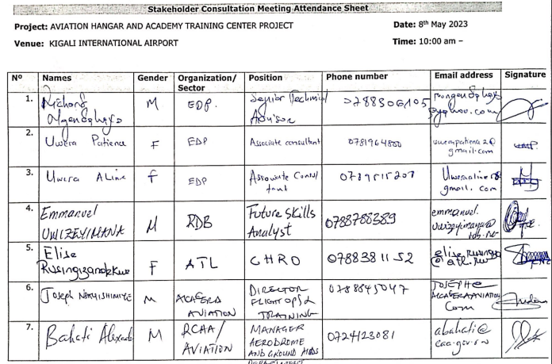
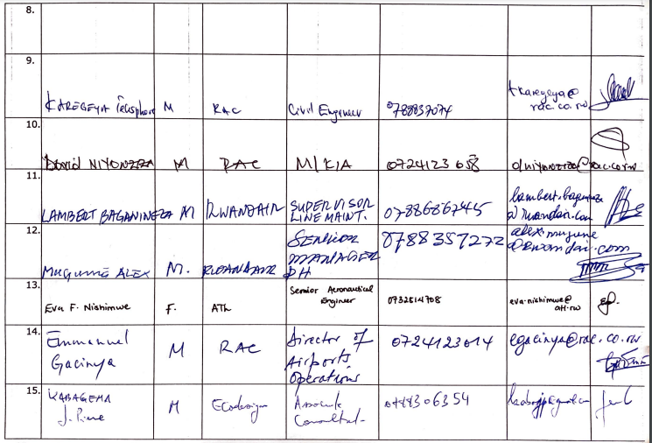
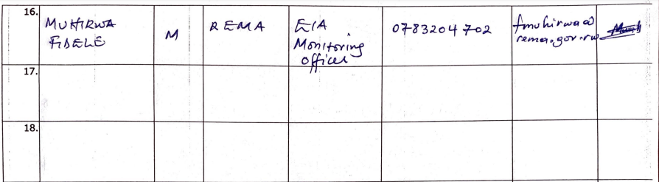

Second High-level stakeholder consultation attendance list
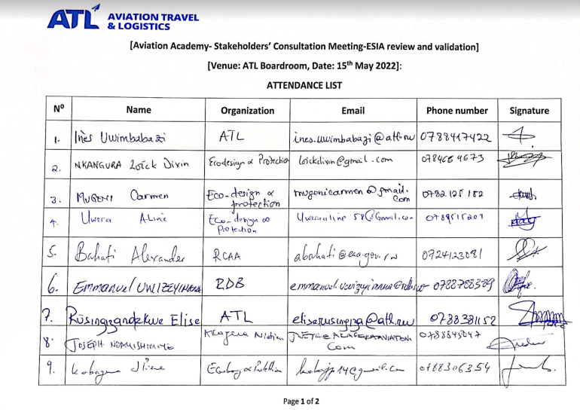
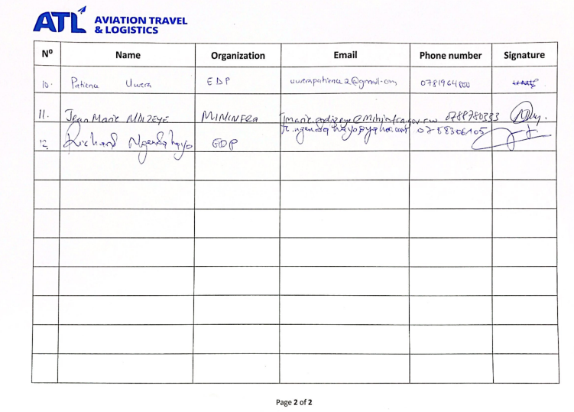

Annex 8: Waste Management Plan (WMP)

1. Introduction
This Waste Management Plan (WMP) outlines the waste management strategies for the construction and operational phases of the Center of Excellence for Aviation Skills (CEAS) Project. It aims to minimize waste generation, promote sustainable waste management practices, and mitigate environmental impacts from waste disposal.
2. Objectives
The key objectives of this WMP are:
- To minimize waste generation during construction and operational phases.
- To promote waste reduction, reuse, recycling, and safe disposal.
- To comply with all relevant environmental regulations.
- To prevent air, soil, and water contamination due to improper waste handling.

3. Scope
This WMP applies to all actors involved in the CEAS Project implementation and subsequent operations, including the developer, construction workers, material suppliers, and other stakeholders. It covers the management of:
- Construction waste (e.g., sand, construction debris, gravel, untreated wood, concrete, asphalt, pipes, conduits, light steel material, stone, bricks, metal, ceramic tiles, glass and plastics, paper, food items).
- Hazardous waste (e.g., chemicals, oils, paints, thinners, sewage, batteries, machinery fuel and lubricants, waste oil filters and oily rags and cables containing substances).
- Organic and general waste (e.g., food waste, paper, plastics) generated during facility operations.
- Waste specific to aircraft hangar operations (e.g. waste oil, hydraulic fluids, brake pads, tires, fluorescent bulbs, electronic waste, batteries).

The project is expected to generate various types of waste due to the estimated daily presence of students, additional staff, and visitors. Solid, liquid, and electronic waste are significant concerns if not properly managed. These wastes include those from vegetation clearance, human consumption, construction activities, and aircraft maintenance.
4 4. Waste Categories and Management Strategies
4.1 Construction phase waste
a. Excavation waste:
- Management strategy:
  - Reuse excavated soil for backfilling and landscaping.
  - Stockpile soil away from water sources to prevent erosion.
  - Dispose of excess soil in approved areas.

b. Construction debris:
- Management strategy:
  - Reuse materials such as wood and bricks where possible.
  - Separate recyclable materials (e.g., metals, plastics) for recycling.
  - Dispose of non-recyclable debris in designated landfills.

c. Hazardous waste:
- Management strategy:
  - Store hazardous materials securely in labeled containers.
  - Use licensed hazardous waste handlers for proper disposal.
  - Train workers on hazardous waste handling and spill response.

d. Packaging waste:
- Management strategy:
  - Minimize packaging waste by bulk ordering.
  - Recycle segregated materials (e.g., cardboard, plastics).
  - Dispose of non-recyclable waste in approved facilities.

e. Sanitary waste:
- Management strategy:
  - Use temporary ecosan toilets for sewage handling.
  - Regularly maintain sanitation systems to prevent leaks.

4.2 Decommissioning phase waste
a. Waste types:
- Debris (concrete), nails, metal scrap and cut-off, building blocks/bricks and concrete rubble, waste timber, wire, piping, plastic, roofing tiles, reinforcement bars.
b. Management strategy:
- Reuse and recycle materials where feasible.
- Use certified waste disposal services for hazardous and non-recyclable waste.
- Safely dismantle and segregate materials to minimize environmental impacts.

4.3 Operational phase waste
a. General waste:
- Waste types: Scrap metal, putrescible waste (including food waste), wooden pallets, vehicle tires, plastic, paper/cardboard, municipal waste, glass, sewage, waste electrical equipment, grease and cooking oil, batteries, medical waste.
- Management strategy:
  - Segregate waste at generation points using labeled bins for recycling and composting.
  - Compost food waste for use in gardening.
  - Recycle paper and plastics through local programs.

b. Aircraft Hangar- specific waste:
- Waste types: Waste oil, hydraulic fluids, plane fuel and lubricants, waste oil filters and oily rags, sludge from runway oil/water interceptors and wastewater treatment facilities, fluorescent bulbs, electronic waste, cables containing substances, chemicals.
- Management strategy:
  - Use licensed facilities for hazardous waste disposal.
  - Store waste oil and fluids in leak-proof containers with secondary containment.
  - Regularly inspect and maintain interceptors to prevent leaks.
  - Segregate and recycle electronic waste through certified recyclers.

c. Sanitary waste:
- Management strategy:
  - Utilize wastewater treatment plants designed for operations.
  - Ensure effective treatment and recycling of wastewater for reuse.
  - Regularly maintain treatment plants to ensure compliance.

5. General Management Measures during Construction
- Appropriate location /containers for separation and temporary storage of general wastes on site.
- Identify and segregate non-hazardous wastes for reuse, recycling, and disposal of hazardous wastes at appropriate treatment facilities.
- Establishment of regular disposal to licensed third party dumpsite or recycling where possible.
- All waste storage units should always be covered and spill kits available.
- Clean up exercises will be regularly undertaken at every end of the day to retain cleanliness within the construction site.
- The site supervisor should ensure that the washing of trucks, equipment and machinery at the site is done appropriately, draining the wastewater properly.
- Workers at site will also be clearly briefed on proper disposal of solid waste and the disposal area will be clearly marked.
- The contractor and the site supervisor should erect warning signs against littering and dumping within the construction site.
- Temporary ecosan toilets to be located within the construction area and offsite treatment recommended. There should be regular maintenance of the temporary ecosan toilets, including the emptying of effluent storage tanks.
- The Waste Management Plan (WMP) will be followed, with continuous monitoring and audits.
- Inventory control to reduce the number of wastes resulting from materials that are outdated, off-specification, contaminated, or damaged.
- Re-using materials on site wherever possible, especially the excavated materials. Topsoil and overburden must be kept nearby for eventual use as rehabilitation material once the spoil disposal sites are no longer required.
- Appropriate waste disposal site(s) for excavation material disposal, away from sensitive ground water features, community used land.

6. General Management Measures during Facility Operations
- Collection of garbage from the proposed project buildings before its decomposition and implement a waste management handling procedure.
- Identify a suitable separate temporary storage location for each waste stream that is adequately covered.
- Separate storage areas for hazardous and non-hazardous wastes will be organized in an appropriate way, and special segregation and treatment for electronic wastes.
- As much as possible, practices that minimize waste are to be practiced and encouraged.
- On-site composting organic waste could be explored as a viable option to minimize waste and possibly in connection with gardening.
- Wastewater treatment plants have been designed for treating sewage during operations of both the hangar and academy. Ensure effective water treatment plant for wastewater recycling and treatment and the greywater for further reuse.
- The project proponent will ensure that there are people responsible for the monitoring of efficient operations of the treatment plants.
- The design should ensure the wastewater treatment plants are placed to the lowest parts of the sites to benefit gravity.

7. Roles and Responsibilities
7.1 Site supervisor:
- Manage onsite waste generation.
- Maintain cleanliness by using designated bins.
- Oversee the washing of trucks and equipment to prevent contamination.
- Maintain waste records and liaise with licensed waste disposal vendors.

7.2 Environmental Health and Safety (EHS) Manager:
- Ensure proper waste segregation and labeling of hazardous materials.
- Maintain records for hazardous waste management and disposal.
- Monitor waste storage and handling practices for compliance.

7.3 Developer:
- Oversee compliance with environmental regulations related to waste management.
- Ensure safe waste transportation and disposal.
- Monitor waste management practices during construction and operations.

8. Monitoring and Reporting
8.1 Monitoring activities:
- Regularly inspect waste storage and segregation areas.
- Track waste generation quantities and report any hazardous waste spills or mismanagement.
- Conduct site audits to ensure compliance with the WMP.

8.2 Reporting:
- Submit monthly waste reports detailing waste volumes, handling, and disposal.
- Report incidents involving improper disposal or environmental damage immediately to the Environmental and Social Manager.

9. Emergency preparedness
Spill Response Procedures:

- Evacuate the area and secure the site of the spill.
- Notify the Environmental Manager.
- Contain the spill using appropriate materials.
- Dispose of contaminated waste according to hazardous waste protocols.
- Review and revise spill prevention measures as necessary.

Annex 9: Occupational Health and Safety Management Plan
1. Introduction
The Occupational Health and Safety Management Plan outlines procedures to protect workers from health and safety risks during the construction of the CEAS project. This plan aims to provide a safe working environment, prevent accidents and injuries, and ensure compliance with occupational safety standards.
2. Objectives
- To safeguard the health and safety of workers throughout the project lifecycle.
- To implement effective hazard identification, risk assessment, and control measures.
- To promote a culture of safety and health awareness on the worksite.
- To comply with relevant occupational health and safety laws and standards.

3. Management Strategies by Phase
3.1 Pre-construction phase
Hazard identification and risk assessment
- Conduct a comprehensive hazard assessment to identify potential risks related to site conditions, equipment, and work activities.
- Develop a risk management plan, with mitigation measures based on the identified hazards.

Health and safety training
- Provide health and safety training for all workers, covering hazard recognition, safe equipment use, and emergency response.
- Conduct a site safety orientation, emphasizing key risks, emergency procedures, and safe practices.

Site planning and setup
- Designate safe zones for equipment storage, waste disposal, and restricted areas where unauthorized personnel are not permitted.
- Set up first-aid stations and designate emergency assembly points.

3.2 Construction phase
Hazard prevention and control measures
- Personal protective equipment (PPE): Ensure that workers are equipped with necessary PPE (e.g., helmets, gloves, high-visibility vests, ear protection) based on task-specific risks.
- Fall prevention: Install guardrails, harnesses, and safety nets in areas where there is a risk of falls. Regularly inspect ladders and scaffolding.
- Machinery and equipment safety: Inspect all machinery and equipment daily before use to ensure they are in safe working condition. Provide training on proper use and ensure that only qualified personnel operate heavy machinery.
- Dust and noise control: Implement dust suppression measures (e.g., water spraying) and provide ear protection for workers in high-noise areas.
- Fire safety: Install fire extinguishers, conduct fire risk assessments, and provide training on fire prevention and response.
Emergency preparedness and response
- Emergency Action Plan (EAP): Develop and display an EAP that outlines procedures for fire, medical emergencies, hazardous spills, and severe weather events.
- First-Aid facilities: Ensure the site has accessible first-aid kits, a designated first-aid officer, and arrangements for emergency medical care if required.
- Evacuation drills: Conduct regular drills to prepare workers for various emergency scenarios.

Health and hygiene management
- Sanitation facilities: Provide clean, accessible toilets and handwashing stations for workers, with regular maintenance.
- Drinking water: Supply adequate drinking water and encourage hydration to prevent heat stress.
- Disease prevention: Implement health screening and enforce hygiene protocols, such as handwashing stations, sanitization of common areas, and social distancing where possible.

Worker health monitoring
- Health checks: Conduct periodic health assessments to monitor workers’ physical condition, particularly those handling heavy machinery or in high-risk tasks.
- Fatigue management: Set limits on work hours and ensure regular breaks to minimize the risk of accidents due to worker fatigue.

3.3 Post-construction phase
Site clean-up and hazard removal
- Remove all construction waste, equipment, and materials to eliminate any residual hazards from the site.
- Conduct a final health and safety inspection to ensure that the site is free from potential risks for the school community.

Debrief and review of safety performance
- Hold a final review meeting to discuss safety incidents, lessons learned, and the effectiveness of implemented safety measures.
- Document recommendations for improving health and safety practices on future projects.

3.4 Ongoing Health and Safety Management
Monitoring and evaluation
Regular safety audits and inspections
- Conduct weekly safety audits to verify compliance with health and safety standards and address any emerging risks.
- Use checklists to ensure that all safety protocols, PPE use, and equipment inspections are consistently adhered to.

Incident reporting and investigation
- Incident reporting protocol: Require workers to report any incident, near-miss, or unsafe condition immediately to their supervisors.
- Root cause analysis: Investigate all incidents thoroughly to identify root causes and implement corrective actions to prevent recurrence.

Worker feedback mechanism
- Establish a feedback system that allows workers to report hazards anonymously and suggest improvements to health and safety practices.
- Conduct monthly safety meetings where workers can raise concerns and discuss recent safety issues.

Training and continuous improvement
Ongoing safety training
- Provide refresher training on health and safety topics every three months, focusing on hazard recognition, safe lifting techniques, and emergency response.
- Train workers on site-specific risks as new phases of construction begin.

Performance review and continuous improvement
- Assess the overall safety performance of the project against key metrics (e.g., incident rates, compliance with PPE use) to identify improvement areas.
- Update the health and safety management plan regularly based on feedback and lessons learned from inspections and incident reports.

Annex 10: Community Health Safety and Security Management Plan
1. Introduction
This Community Health, Safety, and Security Management Plan outlines measures to mitigate risks associated with the construction of the CEAS. It aims to ensure the health and safety of the surrounding community while addressing potential security concerns.
2. Potential community health, safety and security risks and mitigation measures
Potential Risk | Mitigation Measures | Responsible party
Spread of communicable diseases | Conduct awareness campaigns on hygiene, sanitation, and disease transmission prevention. | Sectors, Districts
Dust and air pollution from transportation and machinery | Enforce speed limits; ensure haul trucks are covered and not overloaded; conduct regular air quality monitoring. | Site environmental and social personnel
Road accidents | Implement speed restrictions; install speed control signs; promote community awareness about road safety. | Site construction engineers
Surface runoff containing pollutants | Construct ditches to channel runoff; maximize reuse and recycling of process wastewater; conduct regular water quality monitoring. | Site construction engineers
Noise pollution during construction | Monitor noise levels; restrict construction activities to daylight hours; use noise-reducing equipment and install sound barriers. | Site environmental and social personnel
Gas emissions from vehicles and machinery | Implement constant emission control measures; ensure vehicles have valid inspection certificates; promote vehicle maintenance. | Site environmental and social personnel, District Environmental Officer
Dust from construction activities | Use water sprays to minimize dust; provide appropriate PPE to workers. | Site environmental and social personnel, District Environmental Officer
Interactions between the community and construction workers | Establish strict security protocols; keep construction sites fenced; educate the community on safety measures; enforce no-go zones around construction areas. | Local government institutions, Environmental and Social Officer, Site supervisor
Site intrusion, theft, and insecurity | Install warning tape around the construction perimeter; hire security staff to monitor the site until project completion. | Site supervisor, Security Personnel

3. General management measures for community health, safety and security risks during construction
- Site inspections:
  - Carry out daily inspections of construction site to identify hazards.
  - Address any safety issues immediately, ensuring a safe working environment.

- Noise management:
  - Utilize sound barriers and low-noise construction equipment.
  - Schedule noisy activities during off-peak hours to minimize disruption.

- Waste management:
  - Establish clear protocols for the safe disposal of construction waste.
  - Use designated waste containers and ensure regular collection by licensed waste handlers.

- Community engagement:
  - Hold regular community meetings to inform residents about construction schedules and potential hazards.
  - Distribute informational materials on safety measures and emergency contacts.

- Emergency response plans:
  - Develop and communicate an emergency response plan to address accidents or incidents promptly.
  - Conduct regular drills to ensure readiness among workers and the community.

- Regulatory compliance:
  - Collaborate with local authorities to ensure compliance with health and safety standards.
  - Keep up to date with any changes in regulations and adopt practices accordingly.

4. Monitoring and Reporting
- Monitoring:
  - Implement a monitoring system for air quality, noise levels, and community health impacts.
  - Regularly review safety protocols and update them as necessary based on site conditions.

- Reporting:
  - Provide monthly reports to the project manager detailing health and safety incidents, mitigation measures taken, and community feedback.
  - Document any accidents or near-misses and analyze them to improve safety practices.

Annex 11: Standardized Incident Report Form

INCIDENT REPORT FORMAT
To be completed by implementing agency/construction staff within 24 hours of incident/accident
Incident date: ………………………………………………………………. Incident Time: ………………………………
Incident’s place (District, Sector, Cell, Village): ……………………………………………………………………………….
Injured/dead person name: ……………………………………………………………………………………………………………….
Address: ……………………………………………………………………………………………………………………………………………
Phone number: ………………………………………………………………………………………………………………………………….
Male/Female………………………………………………………. Date of Birth
Incident category:
Category 1: "Minor or negligible, no one was injured"
Category 2: Moderate, injuries with short term impairment
Category 3: Critical/ major, susceptible to lead to serious illness or death
Details of incident: …………………………………………………………………………………………………………………………………………………………… …………………………………………………………………………………………………………………………………………………………………………………………………………………………………………………………………………………………………………………………
Who was the injured person? …………………………………………………………………………………………………………………
Injury type: …………………………………………………………………………………………………………………………………………
Does injury require hospital/Physician? Yes: …………………No: ……………………………………………………….
Hospital name: ………………………………………………………………………………………………………………………………
Address: …………………………………………………………………………………………………………………………………………
Hospital phone number: ………………………………………………………………………………………………………………….
Injured person/party signature/ date: ………………………………………………/…………………………………………….
Important notes / instructions
…………………………………………………………………………………………………………………………………………………………………………………………………………………………………………………………………………………………………………………………
Prepared by: ……………………………………………, Signature: …………………………...Date and time: ……………….
Approved by: …………………………………………..., Signature: ……………………………, Date and time: ………….

Annex 12: Campsite Management Plan

1. Introduction
This Campsite Management Plan provides guidelines and measures to minimize the environmental and social impacts of the worker campsite during the construction phase of the CEAS Project. The plan addresses key issues such as site selection, waste management, sanitation, and decommissioning, ensuring compliance with environmental and social management standards.
2. Objectives
- To prevent environmental degradation due to campsite operations.
- To ensure the health, safety, and well-being of workers.
- To restore the campsite to its original condition after construction activities.

3. Site selection and layout
- The campsite will be located at the campus site close to the exit to minimize the footprint outside the area of influence.
- The camp site layout will include designated areas for:
  - Site offices
  - Storage
  - Eating areas
  - Sanitary facilities
- The campsite may be relocated within the campus site as construction progresses to limit environmental disturbance.

4. Environmental management
4.1 Soil and water protection
- Train workers on proper storage and handling potentially hazardous materials (e.g., fuel, oils, and chemicals).
- Store fuel and oil in secondary containment systems to prevent leaks and spills.
- Establish spill response protocols and provide spill kits at the campsite.
- Recover and reuse or safely remove used oils and lubricants.
- Prevent water contamination by ensuring proper wastewater handling and disposal.

4.2 Waste management
- Provide labeled waste bins to facilitate waste segregation (organic, recyclable, and hazardous waste).
- Dispose of waste at designated and approved disposal locations.
- Promote recycling and minimize waste generation.

4.3 Sanitation and hygiene
- Provide adequate, clean and well-maintained temporary sanitary facilities (e.g., toilets and washing areas).
- Always provide clean drinking water supplies.
- Conduct hygiene training for workers, emphasizing proper waste disposal and personal cleanliness.

4.4 Pest and disease control
- Prevent the formation of stagnant water to eliminate breeding grounds for insects.
- Provide medical facilities on site for addressing health concerns.

5. Site restoration and decommissioning
- Remove all wreckage, rubbish, or temporary structures no longer required for construction activities.
- Ensure waste from decommissioning is disposed of at approved locations.
- Restore the campsite to its pre-project condition, including:
  - Removal of compacted soil or debris.
  - Replanting vegetation if necessary.
- Obtain written confirmation from the contractor that the site has been vacated and restored.

6. Monitoring and reporting
- Conduct regular inspections of the campsite to ensure compliance with this plan.
- Require the contractor to submit monthly reports on campsite management, including:
  - Waste disposal records.
  - Training conducted.
  - Maintenance of sanitation facilities.
- Submit a final decommissioning report verifying that all mitigation measures have been implemented before project handover.

7. Responsibilities
- Contractor:
  - Implement the mitigation measures outlined in this plan.
  - Train workers in environmental protection and hygiene practices.
  - Maintain records of waste management, sanitation, and decommissioning activities.

- Contractor E&S :
  - Monitor the implementation of this plan.
  - Review monthly contractor reports and conduct regular site audits.
  - Ensure site restoration and compliance before project closure.

Annex 13: Chance Finds Procedures
Purpose of the chance find procedure
The chance find procedure is a project-specific protocol detailing necessary steps in case previously unknown heritage resources, especially archaeological ones, are discovered during project construction or operation. This process, as outlined in AfdB 0S 8 and cultural heritage laws, recognizes the importance of safeguarding cultural heritage for its historical, scientific, economic, and social value. It is integral to environmental and social sustainability, emphasizing the need for a chance finds procedure. The primary goal is to avoid disturbing cultural heritage until a qualified specialist assesses the findings, ensuring that subsequent actions adhere to the established requirements. The project design suggests that there will be no impacts on physical cultural Resources. However, public works could have an impact on unknown cultural heritage such as grave sites and sacred sites.
Therefore, the purpose of this chance find procedure is to provide MINEDUC and construction workers with the appropriate response guidelines to be applied if previously unknown cultural heritage is encountered. The Procedure applies to potential cultural heritage objects, features or sites identified because of construction activities in the project area and its surroundings.
Chance finds definition.
A chance find procedure is a project-specific procedure that outlines the actions to be taken if previously unknown cultural heritage is encountered. It is also defined as potential cultural heritage (or paleontological) whether movable or immovable objects, sites, structures, group of structures and natural features and landscapes that have archaeological, historical, religious, and other cultural significance. Cultural heritage resources may include:
- Artefacts, whole or partial, such as ceramic sherds, stone items, glass fragments, bone, shell, metal, textiles, and plant and animal remain.
- Features associated with human occupations such as trash dumps, middens, hearths, structural remains.
- Prehistoric or historic human remains found in formal graves, cemetery, or as an isolated occurrence.

Non-Cultural Heritage Chance Finds may include modern objects, features, and burials and the decision about whether a Chance Find is a cultural heritage resource requiring additional treatment will be made by Districts in consultation with Ministry of Youth and Culture and the Rwanda Cultural Heritage Academy where necessary.
Scope of the chance find procedure.
This procedure is applicable to all activities conducted by the personnel, including construction workers, that have the potential to uncover a heritage item/site. The procedure details the actions to be taken when a previously unidentified and potential heritage item/site is found during construction activities. Procedure outlines the roles and responsibilities, and the response times required from both project staff, and any relevant heritage authority.
Induction/Training
All personnel, especially those working on earth movements and excavations, are to be inducted on the identification of potential heritage items/sites and the relevant actions for them with regards to this procedure during the Project induction and regular toolbox talks.

Chance finds procedure
Institute of National Museums of Rwanda (INMR) is responsible for recovering chance find items. If any person discovers a physical cultural resource, such as (but not limited to) archaeological sites, historical sites, remains and objects, or a cemetery and/or individual graves during excavation or construction, the following steps shall be taken:
- Stop all work in the vicinity of the find, until a solution is found for the preservation of these artefacts, or advice from the relevant authorities is obtained.
- Immediately notify the engineer. The engineer will then notify the Construction Manager and the Environment Officer (EO)/Environmental Manager (EM).
- Record details in the Incident Report and take photos of the find.
- Delineate the discovered site or area; secure the site to prevent any damage or loss of removable objects. In cases of removable antiquities or sensitive remains, a night guard shall be arranged until the responsible local authorities take over.
- Preliminary evaluation of the findings by archaeologists. The archaeologist must make a rapid assessment of the site or find to determine its importance. Based on this assessment the appropriate strategy can be implemented. The significance and importance of the findings should be assessed according to the various criteria relevant to cultural heritage such as aesthetic, historic, scientific or research, social and economic values of the find.
- Sites of minor significance (such as isolated or unclear features, and isolated finds) should be recorded immediately by the archaeologist, thus causing a minimum disruption to the work schedule of the construction workers. The results of all archaeological work must be reported to the Ministry/Agency, once completed.
- In case of significant findings, the Agency/Ministry (Agency for Protection of National Heritage or Archaeological Research Centre, should be informed immediately and in writing within 7 days of the find (ref.law on heritage protection).
- The onsite archaeologist provides the Heritage team with photos, other information as relevant for identification and assessment of the significance of heritage items.
- The Ministry must investigate the fact within 2 weeks from the date of notification and provide response in writing.
- Decisions on how to handle the findings shall be taken by the responsible authorities. This could include changes in the layout (such as when finding an irremovable remain of cultural or archaeological importance) conservation, preservation, restoration and salvage.
- Construction works could be resumed only after permission is granted from the authorities responsible.
- In case no response received within the 2 weeks period mentioned above, this is considered as authorization to proceed with suspended construction works.

One of the main requirements of the procedure is record keeping. All findings must be registered. Photolog, copies of communication with decision making authorities, conclusions and recommendations/guidance, implementation reports ± kept.
Chance finds documentation
The developer, District, contractor’s staff are required to maintain records of monitoring, Chance Finds, and Chance Find response measures executes. These will include:
- Daily monitoring records indicating areas and activities monitored; reported Chance Finds and the results of any evaluations.
- Weekly reports summarizing reporting period activities including Chance Finds, assessments and evaluations, internal and external communications and instructions and supporting photographic documentation (or other reference materials as appropriate). An additional report aimed at fulfilling any specific Ministry requirements is also anticipated.
- Monthly reports summarizing monitoring and evaluation results, status of any site treatment measures required instructions to foremen, and other internal and external communications. Additional monthly reporting may be required by the district.

Implementation arrangement
No | Stakeholder | Responsibility | Responsible person
1 | Akagera aviation Ltd | -Overall coordination.  -Lead consultation with relevant authorities and local communities.  -Implement the treatment plan and provide the required funds.  -Monitoring the implementation of chance finds procedures.  -Prepared required reports. | E&S specialist
2 | Contractor | -Stop the construction activities in the area of the chance find.  - Install temporary site protection measures.  - Inform the client and document chance finds. | Project manager/Site engineer
3 | Local authorities | -Verification of chance finds.  -Approval of the treatment measures in consultation with stakeholders.  -Provide the authorization to resume works in the chance finds area; | District, Sector and Cell Officials
4 | Local communities | -To attend consultation meetings.  -To provide required information;  - Participate in treatment measures. | Local Population

CHANCE FINDS REPORT FORM
Report Reference
Initial Detail

Location of Find: | Date of Find: | Person who identified find:

GPS Coordinates | Zone: | X: | Y:
Multiple coordinates in case of a polygon:
1.
2.
3.
4.

Description of initial find:

Photo Record:

Insert at least one Jpeg photo as example of cultural heritage site.

Was work stopped in the immediate vicinity of the find? | □ Yes  □ No
Was an archaeologist from the Department of Museums and Monuments contacted? | □ Yes  □ No
If yes, state the name of the reporting archaeologist?

Statement of Significance (scientific, spiritual, historic, aesthetic and emotive):

Detailed Description of Find: (e.g. approximate size of site (area, length, height), description of site and vegetation, description of artefacts and number amongst others)

1. IMPACT ASSESSMENT
Is site destroyed? | □ Yes  □ No
Can further impacts to the chance find be avoided? | □ Yes  □ No
Avoidance and mitigation measures discussed:
Outline the different avoidance and mitigation measures discussed.

Impact to find (avoidance and mitigation outcome):
Outline the course of action taken and the reason for choosing these measures.

Date completed form lodged: | Person who lodged form: | Signature:
Report form verified and validated by Environment Department.

Name: ---------------------------------------------------------
Position: -------------------------------------------------------
Date: ------------------------------------------------------------
Signature: ------------------------------------------------------

Annex 14: ESMP Implementation and Management Strategy
This annex defines the implementation and management strategy for the Environmental and Social Management Plan (ESMP) of the Centre of Excellence for Aviation Skills (CEAS) project. It establishes the framework for translating mitigation measures into actionable procedures, ensuring systematic implementation, monitoring, and continuous improvement across all project phases, in alignment with national regulatory requirements and the African Development Bank (AfDB) Operational Safeguards.
Institutional and Implementation Arrangements
The ESMP will be implemented through a clearly defined institutional structure with distinct roles and accountability mechanisms.
The Contractor will be responsible for the day-to-day execution of all environmental and social mitigation measures, including adherence to site-specific management plans (e.g., OHS, waste management, and emergency response). The Supervision Consultant (Engineer) will provide oversight through routine inspections, verification of compliance, and enforcement of corrective actions.
Akagera Aviation Ltd, as the Project implementer, will retain overall responsibility for ESMP implementation, coordination, and performance reporting. Regulatory oversight will be exercised by REMA and RDB through periodic inspections, audits, and compliance verification. Local authorities, including Kicukiro District, will support decentralized monitoring and ensure alignment with local environmental and social requirements.
Capacity Building and Competency Development
Effective ESMP implementation will be supported through a structured capacity building program.
All project personnel, including contractors and subcontractors, will undergo mandatory environmental and social induction training prior to site mobilization. Continuous capacity strengthening will be ensured through regular toolbox talks, refresher trainings, and targeted sessions on key risk areas such as occupational health and safety, hazardous materials handling, waste segregation, emergency preparedness, and gender-based violence (GBV) prevention.
Competency requirements for key personnel will be defined to ensure adequate technical oversight and compliance management.
Monitoring, Reporting, and Performance Tracking
A robust monitoring and reporting system will be established to track ESMP implementation and environmental and social performance.
Monitoring activities will include:
- Daily site inspections by the Contractor;
- Weekly environmental, social, and HSE reporting;
- Monthly ESMP compliance reviews by the Project Developer.
Performance will be assessed against defined indicators included in the ESMP and Environmental and Social Monitoring Plan (ESMoP). Non-compliance incidents, corrective actions, and key performance trends will be systematically documented and reported to relevant stakeholders.
Compliance Assurance and Audit Framework
Compliance with ESMP requirements will be ensured through a combination of internal controls and external oversight.
Internal compliance audits will be conducted periodically by the project team to evaluate adherence to mitigation measures and identify gaps. External audits and inspections will be carried out by REMA and other competent authorities in accordance with applicable regulations and safeguard requirements.
A corrective action tracking system will be implemented to ensure that identified non-compliances are addressed within defined timelines, with clear assignment of responsibilities and follow-up verification.
Stakeholder Engagement and Grievance Redress Integration
Stakeholder engagement will be operationalized in accordance with the Stakeholder Engagement Plan (SEP) to ensure continuous consultation and information disclosure throughout project implementation.
The Grievance Redress Mechanism (GRM) will be actively implemented to receive, record, and resolve complaints in a timely and transparent manner. Grievance data will be analyzed periodically to identify recurring issues and inform adaptive management measures.
Adaptive Management and Continuous Improvement
The ESMP will be implemented using an adaptive management approach to ensure responsiveness to evolving environmental and social conditions.
Monitoring results, audit findings, and stakeholder feedback will be systematically reviewed to assess the effectiveness of mitigation measures. Where gaps or inefficiencies are identified, mitigation measures will be revised, and corrective actions implemented accordingly.
This iterative process will ensure continuous improvement of environmental and social performance throughout the project lifecycle.

https://www.minecofin.gov.rw/fileadmin/user_upload/Minecofin/Publications/REPORTS/National_Development_Planning_and_Research/Vision_2050/English-Vision_2050_Abridged_version_WEB_Final.pdf
https://www.minecofin.gov.rw/index.php?eID=dumpFile&t=f&f=112650&token=cb55b3319372c3f73528c46433b587ef72e8d4eb
http://www.fonerwa.org/sites/default/files/2021-06/Rwanda%20National%20Environment%20and%20Climate%20Change%20Policy%202019.pdf
https://faolex.fao.org/docs/pdf/rwa206567.pdf
https://www.rema.gov.rw/fileadmin/user_upload/Rwanda_Green_Growth___Climate_Resilience_Strategy_06102022.pdf
https://rura.rw/fileadmin/Documents/Energy/RegulationsGuidelines/Rwanda_Energy_Policy.pdf
https://unfccc.int/sites/default/files/NDC/2025-11/Rwanda%20NDC3.0.pdf
https://rema.gov.rw/rema_doc/pab/RWANDA%20BIODIVERSITY%20POLICY.pdf
https://www.environment.gov.rw/fileadmin/user_upload/Moe/Publications/Policies/Revised_National_Land_Policy-Final_Version_2019.pdf
https://rura.rw/fileadmin/Documents/Water/Laws/NATIONAL_SANITATION_POLICY__DECEMBER_2016.pdf
https://en.unesco.org/creativity/sites/creativity/files/qpr/national_cultural_heritage_policy.pdf
https://www.mininfra.gov.rw/index.php?eID=dumpFile&t=f&f=118319&token=f2767b737f4a912d39b49c48093a0346e1837f88
https://masterplan2020.kigalicity.gov.rw/portal/apps/webappviewer/index.html?id=218a2e3088064fc6b13198b4304f3d35/
https://www.mifotra.gov.rw/index.php?eID=dumpFile&t=f&f=9142&token=e9d43922ec21049c4a2cca05c644293e367bd888
https://www.migeprof.gov.rw/fileadmin/user_upload/Migeprof/Publications/Guidelines/Revised_National_Gender_Policy-2021.pdf
https://www.mininfra.gov.rw/fileadmin/user_upload/Mininfra/Publications/Policies/Transport/NATIONAL_TRANSPORT_POLICY_AND_STRATEGY_APRIL_2021.pdf
https://ozone.rema.gov.rw/documents/National%20Cooling%20Strategy%2020190112.pdf
https://www.minecofin.gov.rw/index.php?eID=dumpFile&t=f&f=85852&token=bbf2750a8f262658fba1c14f006285a36818abdc
https://www.minijust.gov.rw/index.php?eID=dumpFile&t=f&f=139270&token=8954f22b0ca6e0f1b6782c54402dec06ae9a024c
Water law and Catchment Management Committee (rwb.rw)
https://gazettes.africa/archive/rw/2021/rw-government-gazette-dated-2021-11-11-no-special.pdf
https://www.rema.gov.rw/fileadmin/user_upload/5-Land_Law_2021.pdf
https://www.minijust.gov.rw/index.php?eID=dumpFile&t=f&f=69353&token=f50dfcf4a6d18318dc084568ce42d41b10011d67
https://rema.gov.rw/fileadmin/templates/Documents/rema_doc/Laws/Air%20Pollution%20Law.pdf
https://www.caa.gov.rw/index.php?eID=dumpFile&t=f&f=109928&token=dfecbc824117f6cb8a01656612e9b55895be8368
Rwanda green building minimum compliance system: https://gggi.org/wp-content/uploads/2019/07/Annex-3-Rwanda-Green-Building-Minimum-Compliance-System-REVISED.pdf
http://197.243.22.137/rhanew/fileadmin/user_upload/documents/General_documents/Laws_And_Regulations/rwanda_building_code_2019.pdf
https://housingfinanceafrica.org/app/uploads/Rwanda-Urban-Planning-Code-upc.pdf
https://www.meteorwanda.gov.rw/index.php?id=30
Rwanda meteorology agency
https://www.wikiwand.com/en/Huye_District
https://www.besttravelmonths.com/rwanda/kicukiro-3483009/
https://www.worldweatheronline.com/v2/weatheraverages.aspx?q=kgl&width=220&custom_header=gregoire%20kayibanda%20(kgl)%20weather,%20rwanda&title_bg_color=0202
Inventory of Sources of Air Pollution in Rwanda: Determination of Future Trends and Development of a National Air Quality Control Strategy. https://rema.gov.rw/fileadmin/templates/Documents/rema_doc/Air%20Quality/Inventory%20of%20Sources%20of%20Air%20Pollution%20in%20Rwanda%20Final%20Report.pdf
https://www.aviationfile.com/noise-pollution-levels-by-aircraft-types/https://www.aviationfile.com/noise-pollution-levels-by-aircraft-types/
National Risk Atlas of Rwanda: https://www.gfdrr.org/sites/default/files/publication/National_Risk_Atlas_of_Rwanda_electronic_version_0.pdf
https://www.statistics.gov.rw/publication/eicv5-district-profiles
Traffic Report Kigali Master Plan 2050: https://gis.kigalicity.gov.rw/portal/sharing/rest/content/items/664c4548e60541a5a99ce0cdb2cfd697/data
Mitigation measures embedded in the design, thus accounted for in the project budget. It includes vegetation clearing, landscaping (wildlife safe and bioengineering (erosion control).
Stormwater management during construction and operations accounted for in the design, thus in the project budget.
Includes slope stabilization with retaining structures
Repairs to damages to utilities, to be accounted for in the project budget.
Facemasks, helmets each, earmuffs, sets of gloves, reflective vest and first-aid kits are accounted for in the budget.
Zero cost. It is a matter of following instruction given as the mitigation measure.
Zero cost. It is a matter of planning and conducting training as usual for the contractor.
airs to damages to cultural resources to be accounted for in the project budget.
Any bird scarring and wildlife control to be covered by the project budget.
Campsite planned for, thus accounted for in the project budget.
Cost includes disposal of hazardous waste, recycling and special treatment, spill kits and coverage material
5 spill kits 50,000Rwf each; 5 drip pans 40,000 Rwf each; 2 units of oil interceptors at refueling area and maintenance bay 800,000Rwf each; 2 units of silt traps 300,000Rwf each.
The budget includes bunded storage areas, covered storage, labeling system and response drills
Earmuffs are budgeted
Water tank for dust suppression at 500,000 Rwf; labor during dust suppression and runway cleaning at 1,000,000 Rwf; air quality monitoring filters and simple tools at 150,000 Rwf; basic spill kits at 400,000 Rwf; fuel drip trays and containment barrels at 250,000 Rwf.
Zero cost. It is a matter of following instruction given as the mitigation measure.
Mitigation measures embedded in the sustainability plan, thus accounted for in the budget. The cost of building materials and the fencing are not considered.
Zero cost. It is a matter of following instruction given as the mitigation measure.
Cost for separate accommodation and sanitary facilities, are covered in the project budget.
Energy efficiency embedded in the design thus accounted for in the budget. The cost doesn’t include the purchase of light, solar system and any energy efficient item.
Water efficiency embedded in the design thus accounted for in the budget.
Design accounts for a comprehensive firefighting plan, thus included in the budget.
Security plan accounted for in the project budget. Cost related to fencing and lightning not included.
2 temporary road signs.
Sanitary facilities and wellness rooms provided in the budget. Others it is a matter of following instruction given as the mitigation measure.
Maintaining water quality are accounted for in the operational budget.
Anti-slip surfaces, training and drills, pool instructor, medical assistance and barriers, are accounted for in the budget.
Zero cost. It is a matter of following instruction given as the mitigation measure.

